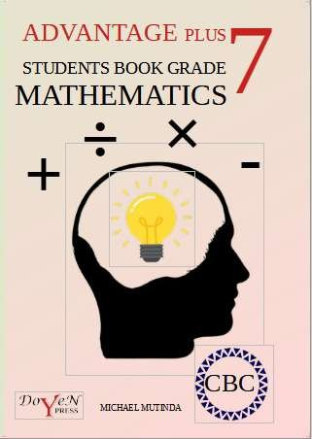

TABLE OF CONTENTS

* 1. NUMBERS 1
  2. WHOLE NUMBERS 2

Place value and total value 2

Rounding off of numbers 4

Even and odd numbers 6

Prime numbers 6

Operations on whole numbers 7

Numbers Sequences 10

* 1. FACTORS 12

Divisibility test 12

Factorization… 16

Greatest common divisor (GCD)… 17

Least common multiple (LCM)… 18

* 1. FRACTIONS 21

Comparison of fractions 22

Operations on fractions 25

Number sequences involving fractions 34

* 1. DECIMALS 37

Place value and total value in decimals 37

Operations on decimals 38

* 1. SQUARES AND SQUARE ROOTS 41

Squares 41

Square roots 42

* 1. ALGEBRA 48
  2. ALGEBRAIC EXPRESSIONS 48

Formation of Algebraic Expressions 49

Simplifying Algebraic Expressions 50

* 1. LINEAR EQUATIONS 51

Formation of linear equations 52

Solution to Linear equations 53

* 1. LINEAR INEQUALITIES 55

Inequality symbols 55

Inequalities 56

* 1. MEASUREMENTS 61
  2. PYTHAGOREAN RELATIONSHIP 61
  3. LENGTH 65

Units of length… 66

Perimeter of plane figures 67

Circumference 68

* 1. AREA 73

Units of area 73

Area of plane figures 73

Area of borders and combined shapes 78

* 1. VOLUME AND CAPACITY 81

Units of volume 81

Volume of objects 82

Relationship between volume and capacity… 85

* 1. TIME, DISTANCE AND SPEED 87

Time 87

Distance 88

Speed… 89

* 1. TEMPERATURE 94

Measurement of Temperature 94

Changes in temperature 96

* 1. MONEY 97

Profit and Loss 98

Discount 102

Commision… 103

Bills 105

Postal charges 107

Mobile money transactions 109

* 1. GEOMETRY 116
  2. ANGLES 116

Angles in a straight line 116

Angles at a point 117

Angles on a transversal 118

Angles in a parallelogram 122

Angle properties of polygons 123

* 1. GEOMETRICAL CONSTRUCTIONS 128

Bisecting angles 128

Construction of angles 128

Construction of triangles 129

Construction of circles 130

* 1. DATA HANDLING AND PROBABILITY 132
  2. DATA HANDLING 132

Data collection… 132

Organization of data 132

Data representation… 133

SAMPLE EXAMINATION PAPERS 146

ANSWERS 179

This document shows some pages of the book.

The complete book is available for sh. 600 only. We are currently doing print on demand.

The book contains,

* well summarized notes for grade 7 in line with the curriculum designs.
* Solved examples.
* Youtube links for the solved examples for reference in case the learner does not understand.
* Exercises at the end of every sub strand.
* Revision Exercises for all the work up to grade 7.
* Answers to all exercises.

To order yours, contact,

**0728318891**

Michael Mutinda, Author and Publisher.

You can also subscribe to our youtube channel on the link, [http://www.youtube.com/@masterstrokekenya](http://www.youtube.com/%40masterstrokekenya)

or,

Simply search “Master stroke kenya” on youtube. Thank you for your support.

MICHAEL MUTINDA 0728318891

K

ADVANTAGE PLUS MATHEMATICS GRADE 7

=

# NUMBERS

C **INTRODUCTION**

A **number** is an arithmetic value used for representing the quantity and

+ used in making calculations. A written symbol like “7” which represents

2 a number is known as numerals.

7 In this strand, we are going to deal with:

3 i. whole numbers,

. ii. factors

1. iii. fractions

5 iv. decimals

1. 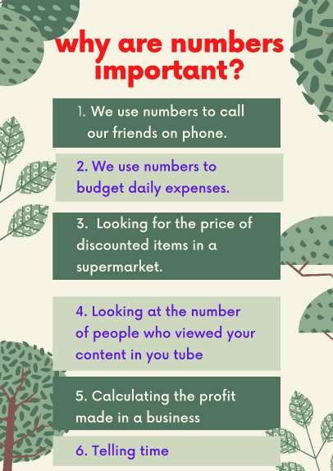squares and square roots.

# WHOLE NUMBERS

The **whole numbers** are the numbers without fractions. They include 0,1,2,3,4,5,6,7,8,9,10,11,12,13,14,15,…

Whole numbers are numbers that are commonly used in counting.

# PLACE VALUE AND TOTAL VALUE PLACE VALUE.

In math, every digit in a number has a place value. Place value can be defined as the value represented by a digit in a number on the basis of its position in the number.

A place value chart can help us in finding and comparing the place value of the digits in numbers through millions. The place value of a digit increases by ten times as we move left on the place value chart and decreases by ten times as we move right.

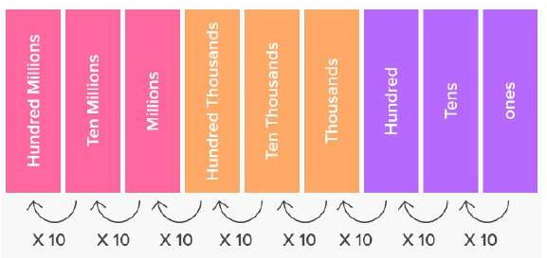

PLAY GAMES ON NUMBERS

https://[www.topmarks.co.uk/maths-games/5-7-years/counting](http://www.topmarks.co.uk/maths-games/5-7-years/counting)

# TOTAL VALUE

Total value is the **product of the digit and its place value**.

Example 1.2

Round off each of the following numbers to the nearest number indicated in brackets.

* 1. 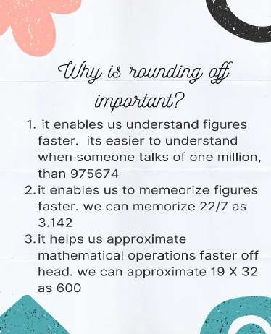435 678 754 (100 000)
  2. 673 098 123 (1000)
  3. 563 789 256 (10 000)
  4. 730 862 156 (100)

solution.

1. to the nearest 100 000, the number 453 6**7**8 754 becomes

453 700 000

1. to the nearest 1000, the number 673 098 **1**23 becomes

673 098 000

1. to the nearest 10 000, the number 563 78**9** 256 becomes

563 790 000

1. to the nearest 100, the number 730 862 1**5**6 becomes

730 862 200

NOTE: The digits in bold, are the digits we are considering before rounding off.

* 1. round off each of the following numbers to the nearest number indicated in brackets.
     1. 783 164 563 (10 000)
     2. 78 903 567 (100 000)
     3. 605 425 940 (1000 000)
     4. 9 628 144 (1000 000)

## Exercise 1.2

* + 1. 12 893 152 (1000)
  1. by rounding off to the nearest 100, estimate the value of:

( a ) 568×726

( b ) 2256−178 ( c ) 7854 +162

# 1.1.3 EVEN AND ODD NUMBERS.

An **even number** is a **number that can be divided into two equal groups**. Even numbers end in 2, 4, 6, 8 and 0 regardless of how many digits they have

An **odd number** is a **number that cannot be divided into two equal groups**. Odd numbers end in 1, 3, 5, 7, 9.

# 1.1.3 PRIME NUMBERS.

A **prime** number is a whole number greater than 1 whose only factors are 1 and itself. A **factor** is a whole number that can be divided evenly into another number. The first few prime numbers are 2, 3, 5, 7, 11, 13,

17 and 19.

Numbers that have more than two factors are called **composite**

numbers. The number 1 is neither prime nor composite.

## Why is 1 not prime?

1 can only be divided by one number, 1 itself, so with this definition 1 is not a prime number

## table 1: odd numbers, even numbers and prime numbers.

|  |  |  |  |  |  |  |  |  |  |
| --- | --- | --- | --- | --- | --- | --- | --- | --- | --- |
| 1 | 2 | 3 | 4 | 5 | 6 | 7 | 8 | 9 | 10 |
| 11 | 12 | 13 | 14 | 15 | 16 | 17 | 18 | 19 | 20 |
| 21 | 22 | 23 | 24 | 25 | 26 | 27 | 28 | 29 | 30 |
| 31 | 32 | 33 | 34 | 35 | 36 | 37 | 38 | 39 | 40 |
| 41 | 42 | 43 | 44 | 45 | 46 | 47 | 48 | 49 | 50 |
| 51 | 52 | 53 | 54 | 55 | 56 | 57 | 58 | 59 | 60 |
| 61 | 62 | 63 | 64 | 65 | 66 | 67 | 68 | 69 | 70 |
| 71 | 72 | 73 | 74 | 75 | 76 | 77 | 78 | 79 | 80 |
| 81 | 82 | 83 | 84 | 85 | 86 | 87 | 88 | 89 | 90 |
| 91 | 92 | 93 | 94 | 95 | 96 | 97 | 98 | 99 | 100 |

**There are other types of sequences which are random. Examples are:**

Find the next two terms in each of the following sequences:

1. 5, 7, 10, 14, …
2. 23, 18, 21, 16, 19, …
3. 15, 21, 25, 31, 35, …

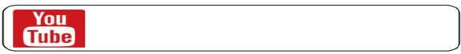

<https://youtu.be/mB0Tg_q5p38>

## Exercise 1.4

Write down the next three number in each of the following sequences.

1. 8 ,14, 20, 26, …
2. 2, 5, 8, 11, …
3. 11, 15, 19, 23,…
4. 7, 10, 13, 16,…
5. 5, 9, 13, 17, …
6. 2, 6, 18, 54, …
7. 256, 128, 64, 32, …
8. 7, 8, 10, 13, …
9. 10, 17, 22, 29, 34, …
10. 56, 52, 46, 38, 28, ...

# FACTORS

Factors are numbers we can multiply together to get another number. Example: 2 and 3 are factors of 6, because 2 × 3 = 6

# DIVISIBILITY TEST.

Divisibility tests help one to check whether a number is divisible by another number without the actual method of division.

If a number is completely divisible by another number then the quotient will be a whole number and the remainder will be zero.

## Divisibility Rule of 2

A number is divisible by 2 if its last digit is divisible by 2

**Example: Consider** the number 208

* Just take the last digit 8 and divide it by 2
* If the last digit 8 is divisible by 2 then the number 208 is also divisible by 2.

The factors of 24 are therefore, 1,2,3,4,6,8,12 and 24.

# PRIME FACTORIZATION.

Composite numbers can be written as a product of prime factors. It is easier to use factor trees for prime factorization as shown.

Example 1.8 Write 48 as a product of prime factors.

Solution.

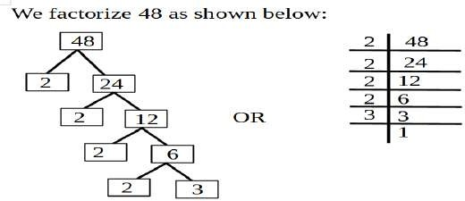

48=2×2×2×2×3 often written as

48=24×3

## Exercise 1.6

1. Use factor rainbows to list all the factors of each of the following numbers.
   1. 45
   2. 72
   3. 108
   4. 121
   5. 456
   6. 2000
   7. 1915
   8. 350
   9. 756
2. Use tree diagrams to express of of the numbers in question 1 as product of prime factors, leaving your answer in power form.

# 1.2.3 GREATEST COMMON DIVISOR.

The greatest common divisor (GCD) refers to the greatest positive integer that is a common divisor for a given set of positive integers. It is

To determine if its LCM or GCD which is required, we ask our self whether the required answer is larger or smaller than the numbers in the set given. If the number required is greater than the set given, then, LCM is required. If the number required is smaller than the set of given, then GCD is required.

We can also check some key words, if you notice the word LEAST, most of the times, LCM is required. If you notice the word GREATEST, in the most cases, GCD is required.

## Example:

A room measures 540 cm by 420 cm. Determine the length of the largest square tiles that can be used to cover the floor without requiring cutting.

<https://youtu.be/kHptV3zFP1k>



<https://youtu.be/kHptV3zFP1k>

## Example:

Find the shortest length of a thread that can be cut into pieces of 14 cm or 18 cm without leaving remainders.



<https://youtu.be/1W36n9xCZA8>

## Exercise 1.7

1. Find the GCD of the following sets of numbers
   1. 72,108,156
   2. 90,145,150
   3. 54,90,108
   4. 30,42,96
   5. 66,88,176
   6. 88,96,152
2. Find the LCM of each of the following
   1. 15,18,30
   2. 9,12,30
   3. 18,24,30
   4. 16,18,72
   5. 12,24,36
   6. 15,33,45

# SUBTRACTION.

Just like addition, there are 3 simple steps to subtract fractions

* + 1. Make sure the bottom numbers (the denominators) are the same
    2. Subtract the top numbers (the numerators). Put the answer over the same denominator.
    3. Simplify the fraction (if needed).

Example 1.18

5 2

7 −7

5−2 3

= 7 =7

Example 1.19

Solve 5 −1

12 3

Solution.

Putting the fractions under one denominator (12), we obtain,

5 −4 =1

12 12 12

Example 1.20

Evaluate 6 2 −15

3 6

Solution.

Writing as improper fraction, we have 20 −11

3 6

## Exercise 1.11

1. Fill in the next two terms in each of the following sequences.

1 2 1 1 1 1

(a)

3 *,* 1*,* 13 *,* 23 *,* .. *.*

(c) 1 *,* 3 *,*

9 *,* 27

*,*.. *.*

(b)

2 *,*  1

5 5

*,*  1 10

*,*  1 20

*,* .. *.*

(d)

1 *,*  1

10 5

*,*  3 10

*,*  2 5

*,* .. *.*

1. Create a number sequence of 5 terns starting with 3

2

and

adding 1

2

to get the next number.

# DECIMALS.

Decimals are one of the types of numbers, which has a whole number and the fractional part separated by a decimal point. The dot present between the whole number and fractions part is called the decimal point. For example, 34.7 is a decimal number.

# PLACE VALUE AND TOTAL VALUE IN DECIMALS.

The number 35.697422 can be placed on a place value chart as follows:

|  |  |  |  |  |  |  |  |
| --- | --- | --- | --- | --- | --- | --- | --- |
| Tens | Ones | Decimal point | Tenths | Hundredths | Thousandths | Ten thousandths | Hundred thousandths |
| 3 | 5 | . | 6 | **9** | 7 | 4 | 2 |

Find 625

√

1296

Solution.

We split the problem as

1296

√1296

√625 =√625

From factorization,

1296 = 2×2×2×2×3×3×3×3

We then solve for √625

From Factorization, 625=

5×5×5×5.

therefore √625 =5×5 =25 Then we find √1296

Therefore √1296 = 2×2×3×3

=36

√

So 625 =25

1296 36

# SQUARE ROOT OF DECIMALS.

To find the square root of decimals, we express the decimals as decimal fraction, then find the square root as in fractions.

Example1.34:

Find √20.25

Solution.

We express the number as decimal fractional

100

√100

√20.25=√2025 =√2025

We then proceed to find √2025 .

1. John has a square piece of land of area 5184 m2. Find the perimeter of the land.

|  |  |
| --- | --- |
| Example | YouTube link |
| 1.1 | <https://youtu.be/GhSz5Yp0DG0> |
| 1.2 | <https://youtu.be/wYXtJxrKomA> |
| 1.3 | <https://youtu.be/WXbwBsMi4OU> |
| 1.4 | <https://youtu.be/WXbwBsMi4OU> |
| 1.5 | <https://youtu.be/rh482q7MumA> |
| 1.6 | <https://youtu.be/QeXaZv60IjA> |
| 1.7 | <https://youtu.be/XZhCQOorff4> |
| 1.8 | <https://youtu.be/Nx4F6OWutmc> |
| 1.9 | <https://youtu.be/hUNJVnF8Utk> |
| 1.10 | <https://youtu.be/q1ad-INkoAA> |
| 1.12 | <https://youtu.be/URFySVc1KRc> |
| 1.13 | <https://youtu.be/LQiQtRAxMjg> |
| 1.14 | <https://youtu.be/nBgW9gx1peo> |
| 1.15 | <https://youtu.be/FwnvmBj39hU> |
| 1.16 | <https://youtu.be/ExCT2EEDyTo> |
| 1.17 | <https://youtu.be/5nye2Ah00I0> |
| 1.19 | <https://youtu.be/KzC0VApHADY> |
| 1.20 | <https://youtu.be/ZYUBL3wgQBg> |
| 1.21 | <https://youtu.be/teUkBvVFINg> |
| 1.22 | <https://youtu.be/S_pMGzX7SzE> |
| 1.23 | <https://youtu.be/ZiE4emWvOoE> |

This document shows some pages of the book.

The complete book is available for sh. 600 only. We are currently doing print on demand.

The book contains,

* + well summarized notes for grade 7 in line with the curriculum designs.
  + Solved examples.
  + Youtube links for the solved examples for reference in case the learner does not understand.
  + Exercises at the end of every sub strand.
  + Revision Exercises for all the work up to grade 7.
  + Answers to all exercises.

To order yours, contact,

**0728318891**

Michael Mutinda, Author and Publisher.

You can also subscribe to our youtube channel on the link, [http://www.youtube.com/@masterstrokekenya](http://www.youtube.com/%40masterstrokekenya)

or,

Simply search “Master stroke kenya” on youtube. Thank you for your support.

MICHAEL MUTINDA 0728318891

# ALGEBRA.

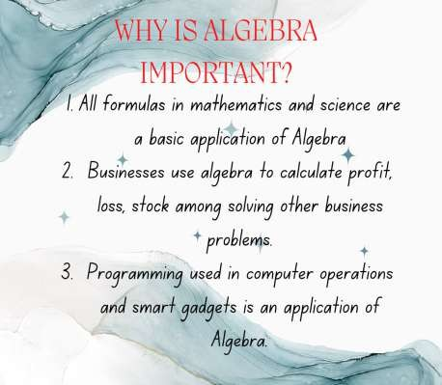Algebra is a part of mathematics in which letters and other general symbols are used to represent numbers and quantities in formulae and equations.

# ALGEBRAIC EXPRESSIONS

An algebraic expression is a combination of terms by the operations which are addition and subtraction. For example, let us have a look at the expression 5x + 7. Thus, we can say that 5x + 7 is an example of an algebraic expression.

An algebraic expression has the following parts.

1. 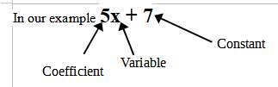Coefficient
2. Variable
3. Constant
4. Terms.

5x and 7 are known as terms.

Examples of such linear equations are:

1. 2x + 3=0 b) 4x=8

**NOTE: The difference between expressions and equations is that equations have an equal sign (=) while expressions do not.**

# FORMATION OF LINEAR EQUATIONS.

Example 2.5

A jar has n sweets. Two sweets are picked from the jar. The number of sweets that remain are 32. Form an equation in n for the number of sweets in the jar.

Solution. n – 2 = 32

Example 2.6

The length of a rectangle is 4 cm more than its width. If the width is x cm and the perimeter is 24 cm, form an equation from this information.

Solution.

The rectangle dimensions are as shown below.

(x+4) cm

(x) cm

The perimeter is 2(x+4+x)=24

2(2x+4)=24

# SOLUTION TO LINEAR EQUATIONS.

In solving an equation having only one variable, the following steps are followed

* 1. Using LCM, clear the fractions if any.
  2. Simplify both sides of the equation.
  3. Isolate the variable.
  4. Verify your answer.

Example 2.7

Solve 4x – 9 = 19 Solution.

We move -9 to the other side of equal sign 4x=19+9

4x=28

Divide both sides by 4 x=7

Example 2.8

Solve 1 *x*+5=8

2

Solution

Multiplying each term by 2, we have x + 10 =16

Moving 10 to the other side of the equation sign, we have x = 16 – 10

x = 6

Example 2.9

In one Week, Kimari spend x minutes on internet. Kyalo spend twice the amount of time spend by Kimari while Wafula spend 10 minutes more than Kyalo. If the total time they spend was 120 minutes, how many minutes were spend by Kimari on internet.

1. Fred is 21 years old. Ann is x years younger than Fred. The sum of their ages is 35. Calculate the age of Ann.

# LINEAR INEQUALITIES.

* + 1. **INEQUALITY SYMBOLS.**

Linear inequalities are defined as expressions in which two linear expressions are compared using the inequality symbols. The symbols that are used to represent the linear inequalities are listed below:

|  |  |  |
| --- | --- | --- |
| **Symbol Name** | **Symbol** | **Example** |
| [Less than](https://www.cuemath.com/numbers/less-than/) | (<) | x + 7 < 5 |
| [Greater than](https://www.cuemath.com/numbers/greater-than/) | (>) | 10x > 2 + 16x |
| [Less than or equal to](https://www.cuemath.com/numbers/less-than-or-equal-to/) | (≤) | y ≤ 4 |
| [Greater than or equal to](https://www.cuemath.com/numbers/greater-than-or-equal-to/) | (≥) | 3 – 3x ≥ 10 |

## NOTE: The inequality sign always points the smaller number.

Example 2.10

Using inequality symbols, show how each of the following numbers compare.

(a) 2 and 5 (b) 7 and 5

Solution

* 1. 2 is less than 5

The symbol used should be 2<5

* 1. 7 is greater than 5

The symbol used should be 7>5

# REPRESENTATION OF SIMPLE INEQUALITIES.

Inequalities can be represented in a number line.

To plot an inequality, such as x>3, on a number line, first draw a circle over the number (e.g., 3). Then if the sign includes equal to (≥ or ≤), fill in the circle. If the sign does not include equal to (> or <), leave the circle unfilled in. Finally, draw a line going from the circle in the direction of the numbers that make the inequality true.





Example 2.13

Represent each of the following inequalities in a number line.

* + 1. *x*≤8
    2. *x*> 5

Solution.

1. *x*≤8 means x is less than or equal to 8. It is represented as shown.





Notice that the circle is filled () to show that 8 is included in the inequality.

1. *x*> 5 means x is greater than 5. It is represented as shown





1. Draw a number line to represent each of the following inequalities.
   1. 1≤*x*≤8
   2. 2≤*x* ∈5
   3. 3∈ *x* ∈7
   4. 5∈ *x*≤13
2. Write down the whole numbers represented by the inequalities in question (8) above.

|  |  |
| --- | --- |
| Example | YouTube link |
| 2.1 | <https://youtu.be/14nhHn1fB5w> |
| 2.2 | <https://youtu.be/3GOJIDVeUu8> |
| 2.3 | <https://youtu.be/es2kyJXHPW0> |
| 2.4 | <https://youtu.be/M3QJgrVLS9Q> |
| 2.5 | <https://youtu.be/gONsuBpBphs> |
| 2.6 | <https://youtu.be/Ftvj0fyoyTg> |
| 2.7 | <https://youtu.be/r_fRlxSxHN4> |
| 2.8 | <https://youtu.be/SmSJ4VCbEtk> |
| 2.9 | <https://youtu.be/FllRu14PnbQ> |
| 2.10 | <https://youtu.be/9rV8jQHCxD0> |
| 2.11 | <https://youtu.be/EeqokfSjBMQ> |
| 2.12 | <https://youtu.be/JGwADiJrrXU> |
| 2.13 | <https://youtu.be/B06v6FdTdSQ> |
| 2.14 | <https://youtu.be/B06v6FdTdSQ> |
| 2.15 | <https://youtu.be/egF3zimrBHA> |

This document shows some pages of the book.

The complete book is available for sh. 600 only. We are currently doing print on demand.

The book contains,

* well summarized notes for grade 7 in line with the curriculum designs.
* Solved examples.
* Youtube links for the solved examples for reference in case the learner does not understand.
* Exercises at the end of every sub strand.
* Revision Exercises for all the work up to grade 7.
* Answers to all exercises.

To order yours, contact,

**0728318891**

Michael Mutinda, Author and Publisher.

You can also subscribe to our youtube channel on the link, [http://www.youtube.com/@masterstrokekenya](http://www.youtube.com/%40masterstrokekenya)

or,

Simply search “Master stroke kenya” on youtube. Thank you for your support.

MICHAEL MUTINDA 0728318891

# MEASUREMENTS.

# PYTHAGOREAN RELATIONSHIP

About 2000 years ago, an amazing discovery was made about **right angled triangles**. If squares of length equivalent to the sides of the triangle, then the sum of the area of the two small squares is exactly the same as the area of the large square.



**Area= c2**

**Area= a2**

**a**

**c**

**b**

**Area= b2**

# LENGTH.

Length is the distance between two points. Some measurements including length are:

1. Length.
2. Width.
3. Breadth.
4. Height.
5. Depth.
6. Diameter.
7. Radius.
8. Circumference.

# UNITS OF LENGTH.

The international standard (SI) unit of length is metre (m). The multiples and sub multiples of metre are as shown: 100 centimetres (cm) = 1 metre

10 decimetres (dm) = 1 metre

10 metres = 1 decametre (Dm)

100 metres = 1 hectometre (Hm)

Example 3.4.

Add each of the following giving your answer in metres.

1. 10 cm + 1 Dm
2. 2 Hm + 3 Dm Solution.
3. 150 cm + 1 Hm
4. 2 m + 5 Dm

Converting all the units to metres, we have

* 1. 10 *m*+(1×10) *m*=10.1 *m*

100

* 1. (2×100) *m*+(3×10) *m*=230 *m*
  2. 150 *m*+(1×100) *m*=101.5 *m*

100

* 1. 2 *m*+(5×10) *m*=52 *m*

# PERIMETER OF PLANE FIGURES.

Perimeter is the distance around a figure. The table below shows the formulae used to find the perimeter of different plane figures.

|  |  |  |
| --- | --- | --- |
| Figure | shape | Perimeter formulae |
| Triangle |  | ***P = a + b + c***,  Where *a, b* and *c* are sides of the triangle. |
| Square |  | ***P = 4a***  Where *a* is the length of a side. |
| Rectangle |  | ***P = 2l + 2w***  Where *l* is the length and *w* is the width. |
| Any other figure. |  | Add the length of all sides together. |

Example 3.5

A rectangle has a length of 8 cm and width of 4 cm. Calculate its perimeter.

Solution

Example 3.7

Calculate the circumference of a circle of radius 3.5 cm. Solution.

*C*=2*π r*

### *C*=2× 22 ×3.5 7

*C*=22 cm

Example 3.8

The figure below shows a running track. Kiptoo runs 5 rounds in the track. What distance does he run.

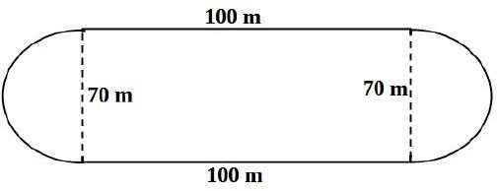

Solution.

The distance can be divided into two semi circles and two straight distances.

*P*=1

2

×22 ×70+100+100+ 1 ×22

7 2 7

×70

### *P*=110+100+100+110 *P*=420.

for 5 rounds Distance=5×420=2100 metres

1. A person walks round a square field and covers a distance of 3496m, find the side of the square field.
2. A rectangle has a width of 6 cm and a diagonal of 10 cm. Calculate its perimeter.
3. Find the perimeter of the figure below.

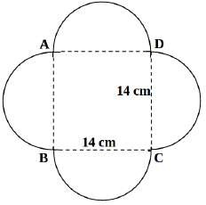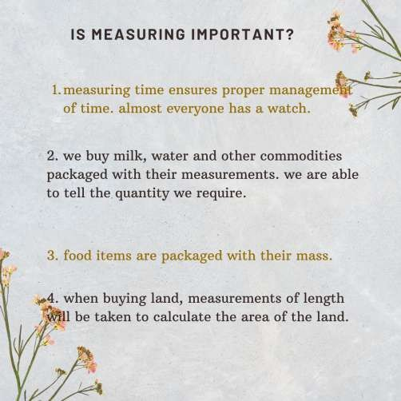

# AREA

* + 1. **UNITS OF AREA**

Area is defined as the measure of surface. The international standard unit (SI) of area is **square metre** (m2). Other units are hectares and acres.

### NOTE:

1 hectare=1 hectometre× 1hectometre 1 hectare=100 metres×100 metres

1 hectare=10 000 *m*2

### NOTE:

1 acre=4046 *m*2

# AREA OF PLANE FIGURES. RECTANGLES

Area of a rectangle is the product of the base length and its height.

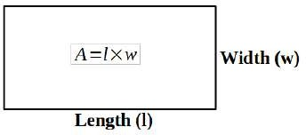

Example 3.10

A rectangle whose length is 8 metres has an area of 32 square metres. Calculate the width.

Example 3.15

A circle has a diameter of 70 m, calculate the area of the circle. Solution.

The diameter = 70 m, so the radius = 35 m.

*A*=*π r* 2

*A*= 22 ×35 m×35 m 7

*A*=3850 m2

Example 3.16

Find the radius of a circle which has an area of 154 cm2. Solution.

*A*=*π r*2 2

154

= 22 *r*

7

*r* =49

2 *r*=7 cm

# 3.3.3. AREA OF BORDERS AND COMBINED SHAPES.

Example 3.17

The figure below shows a flower bed surrounded by a path. Calculate the area of the path.

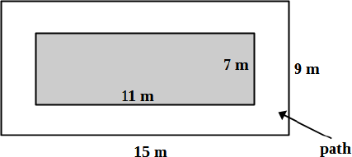

1. Out of a rectangular sheet of paper, a strip is cut out as shown in the figure below. Find the area of the remaining portion.

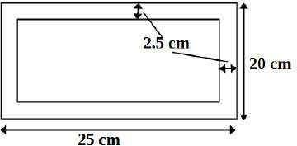

# VOLUME AND CAPACITY.

* + 1. **UNITS OF VOLUME**

Volume is the space occupied by matter, or enclosed by a surface. The SI unit of volume is cubic metre (m3).

Other units include cubic centimetres (cm3) NOTE:

1 *m*3=1 *m*×1 *m*×1 *m*

but 1 *m*=100 *cm .*

therefore 1 *m*3=100 *cm*×100 *cm*×100 *cm*

1 *m*3=1 000 000 *cm*3

Example 3.19

Convert 100 cm3 to cubic metres. Solution.

1 *m*3=1 000 000 *cm*3

*x*=100 *cm*3 cross multiplying we have,

1 *m*3×100 *cm*3

*x*=1 000 000 *cm*3

*x*=0.000 1*m*3

Example 3.20

Convert 0.2 m3 to cubic centimetres.

Solution.

1 *m*3=1 000 000 *cm*3

0.2 *m*3=*x* cross multiplying, we obtain

0.2 *m*3×1 000 000 *cm*3

*x*= 1 *m*3

*x*=200 000 *cm*3

# VOLUME OF OBJECTS.

The table below shows the formulae used in calculating volumes of cubes, cuboids and cylinders.

|  |  |  |
| --- | --- | --- |
| Object | Diagram | Formula used to calculate volume. |
| cube |  | *V* =*s*3  ***s*** is the length of side.  Note: all sides are equal in length. |

# RELATIONSHIP BETWEEN VOLUME AND CAPACITY.

Capacity is the amount of substance a container can hold. In most cases, capacity in fluids (liquids and gases) is measured in litres.

### NOTE:

1 litre =1000 millilitres

1 millilitre =1*cm*3

1 litre =1000 *cm*3

1000 litres =1 *m*3

Example 3.24

What volume in cubic centimetres is equivalent to 2 litres. Solution.

1 litre =1000 *cm*3

2 litres =*x* on cross multiplying, we obtain,

2 litres×1000 *cm*3

*x*= 1 litre

*x*=2000 *cm*3

# CAPACITY OF CONTAINERS

Example 3.25

A tank whose base is a rectangle of dimensions 2metres by 4 metres has a height of 0.5 metres. What is the capacity of the tank in litres?

Solution.

1. Convert each of the following to cubic centimetres.
   1. 100 litres
   2. 45 litres
2. Convert each of the following to litres.
3. 200 millilitres
4. 10 000 millilitres.

(a) 200 ml (b) 4000 ml

1. Calculate the volume of a cube whose side is 6 cm.
2. Calculate the volume of the cuboid shown below.

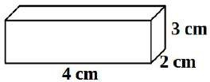

1. Calculate the volume of a cylinder whose radius is 70 cm and height is 1 metre. Give your answer in cubic metres.
2. Calculate the capacity in litres of a cylindrical tank whose diameter is 3 m and height is 0.7 m.
3. The volume of a rectangular based tank is 40m3. If the height is 2m, calculate the area of the base.

# TIME, DISTANCE AND SPEED.

* + 1. **TIME**

Time is the measure of duration in which an event happens. The SI unit of time is seconds(s).

Other units include minutes, hours, days, months, years, etc. NOTE:

1. Water at 298K is heated to 350K. What is the change in temperature in the water.
2. A piece of metal at 20oC gains 300oC on heating. What is its new temperature in Kelvins.

# MONEY. INTRODUCTION.

Money is a commodity accepted by general consent as a medium of economic exchange. It is the medium in which prices and values are expressed. Money circulates anonymously from person to person and country to country, thus facilitating trade, and it is the principal measure of wealth.

# PROFIT AND LOSS.

Businesses can make profits or losses. The understand the concepts of profit and loss, we will define some terms.

1. **Cost price (C.P).** This is the price at which the business man/woman buys an item.
2. **Selling price (S.P)**. This is the price at which a business man sells an item.

If the selling price is greater than the cost price, the business makes profit.

*Profit* =*Selling price* (*S . P*)−*Cost price*(*C . P*)

If the selling price is lower than the cost price, the business makes a loss.

*Discount*=*Marked price*−*buying price Discount*=*Ksh.* 1200−*Ksh* 1140=*Ksh .* 60 *Discount* (%)=  *Discount* ×100 %

*Marked price*

*Discount* (%)= 60 ×100 %

1200

*Discount* (%)=5 %

# 3.7.3 COMMISSION.

Commission is the amount of money given to a sales agent for them to sell more. Commission is usually a percentage of the money obtained from sale. Some of the people paid on commission are, company sales agents, real estate agents, professional sports men agents, etc.

Commission can be paid as straight commission or together with a salary.

Example 3.45

Mary sales goods on commission. She is paid a commission of 12% of all the sales made. In a particular month, Jane sold goods worth Sh.

135000. Calculate her commission. Solution.

Mary earns 12% of the total sales made.

So she made: 12 ×135 000= *Ksh* .16 200

100

Example 3.46

Ken is paid a basic salary of Sh. 7000 and a commission of 5% for all goods sold. In a certain month, he sold goods worth Sh. 90000.

Calculate the amount of money he made that month.

210

Total

The bill above shows two items (Soda and bread). The price for bottle of soda is Sh. 30 and for each bread is Sh. 60. The 3 sodas bought would cost Sh. 90 while the 2 breads bought would cost Sh. 120. The total cost for the items would be Sh. 210.

# PREPARING A BILL.

Example 3.48.

Peter went to a stationery shop and bought two pens @Sh. 15, one pencil @Sh. 10, three erasers @Sh.5 and one ruler @Sh.30. Prepare a bill for Peter.

Solution.

The bill for Peter is as shown.

|  |  |  |  |
| --- | --- | --- | --- |
| Item | Unit price(Sh) | Quantity | Cost(Sh) |
| Pen | 15 | 2 | 30 |
| Pencil | 10 | 1 | 10 |
| Eraser | 5 | 3 | 15 |
| Ruler | 30 | 1 | 30 |
| Total | | | 85 |

# 3.7.5 POSTAL CHARGES.

In Kenya, parcels can be send through the postal office. The parcels are charged according to their weight as shown in the table below.

|  |  |  |
| --- | --- | --- |
| 3501 – 5000 | 35 | 47 |
| 5001 – 10 000 | 50 | 55 |

1. Mike had Ksh. 19 000 in his mobile wallet. He send his sister Ksh. 5000 and his father Ksh. 6000. He then withdrew Ksh. 4500. How much money remained in his mobile wallet.
2. Purity wanted to withdraw Ksh. 6000 and send her friend Ksh. 9000. How much does she pay for the transactions.

|  |  |
| --- | --- |
| Example | YouTube link |
| 3.1 | <https://youtu.be/RkCqUPdAXkc> |
| 3.2 | <https://youtu.be/CKfC7f3S2-E> |
| 3.3 | <https://youtu.be/-eiWv0wVy1s> |
| 3.4 | <https://youtu.be/W96kOVWkh-4> |
| 3.5 | <https://youtu.be/-yOlWZIHnAw> |
| 3.6 | <https://youtu.be/6NrWDIWNjKo> |
| 3.7 | <https://youtu.be/zRTteP9wW9g> |
| 3.8 | <https://youtu.be/FYIpEXHptHQ> |
| 3.9 | <https://youtu.be/thfvDK-PtZM> |
| 3.10 | <https://youtu.be/R9hBkknN4F4> |
| 3.11 | <https://youtu.be/YVzyPxXx8jU> |
| 3.12 | <https://youtu.be/6poPw0aivvs> |
| 3.13 | <https://youtu.be/VwGwd-F_eqw> |
| 3.14 | <https://youtu.be/A8WYXzrwHz8> |

This document shows some pages of the book.

The complete book is available for sh. 600 only. We are currently doing print on demand.

The book contains,

* well summarized notes for grade 7 in line with the curriculum designs.
* Solved examples.
* Youtube links for the solved examples for reference in case the learner does not understand.
* Exercises at the end of every sub strand.
* Revision Exercises for all the work up to grade 7.
* Answers to all exercises.

To order yours, contact,

**0728318891**

Michael Mutinda, Author and Publisher.

You can also subscribe to our youtube channel on the link, [http://www.youtube.com/@masterstrokekenya](http://www.youtube.com/%40masterstrokekenya)

or,

Simply search “Master stroke kenya” on youtube. Thank you for your support.

MICHAEL MUTINDA 0728318891

# GEOMETRY.

# ANGLES.

* + 1. **ANGLES IN A STRAIGHT LINE**

Angles in a straight line add up to 180o.

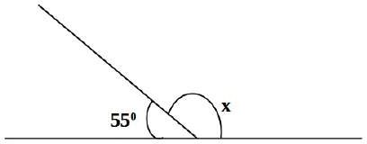Example 4.1 Calculate the value of angle x in the figure below.

Solution.

*x*+ 55=180 *x*=180−55 *x*=1250

Example 4.2

Calculate the value of angle marked y in the figure below.

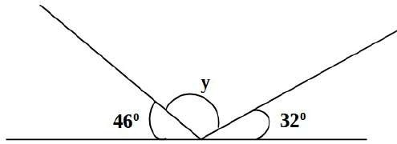

Solution.

460+ *y*+ 320=1800 *y*=1800−460−320 *y*=1020

# ANGLES AT A POINT.

Angles around a point describes the sum of angles that can be arranged together so that they form a full turn. Angles around a point add to 360°

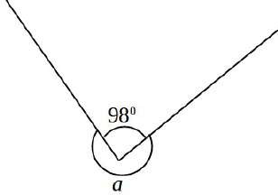Example 4.3 Calculate the value of angle *a*.

Solution.

Angles at a point add up to 3600

*a*+ 98=360 *a*=360−98 *a*=2620

Example 4.4 Calculate the value of angle c in the figure below.

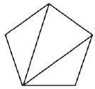

A polygon is named according the number of sides it has.

|  |  |
| --- | --- |
| Number of sides | Polygon name |
| 3 | Triangle |
| 4 | Quadrilateral |
| 5 | Pentagon |
| 6 | Hexagon |

**INTERIOR ANGLES OF POLYGONS.**

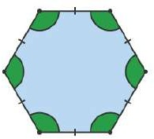Interior angles are angles formed inside the polygons.

To get the sum of interior angles in a particular polygon, we divide the polygon into triangles from the vertices of the polygon as shown.

The sum of interior angles =Number of triangles×1800

|  |  |  |  |
| --- | --- | --- | --- |
| Polygon | Shape | no. of triangles | Sum of interior angles |
| Quadrilateral |  | 2 | 2×1800=3600 |
| Pentagon |  | 3 | 3×1800=5400 |

1. Calculate the value of x in each of the following.

(a) (b)

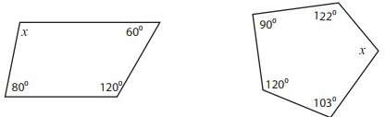

1. The exterior angles of a quadrilateral are x, 2x, 3x and (x+45) in degrees. Calculate the value of x.

# GEOMETRICAL CONSTRUCTIONS.

In this sub stand, we will be dealing with construction that use a ruler and a pair of compass only.

* + 1. **BISECTING ANGLES.**

Bisecting angles involves drawing a line that divides an angle into two equal angles.

The process of bisecting angles can be learned from the video below



<https://youtu.be/m1rHsOAlWDE>

# CONSTRUCTION OF ANGLES USING A RULER AND A PAIR OF COMPASS ONLY.

The basic angles are 900, and 600. From these two angles, other many angles can be constructed. Here we will have youtube links to construction of different angles.

|  |  |
| --- | --- |
| Angle | Youtube link |
| 900 | <https://youtu.be/4J-0MSgGeys> |
| 600 | <https://youtu.be/-CGqxkwg2cA> |
| 450 | <https://youtu.be/jqREpItOP3Y> |
| 22.50 | <https://youtu.be/xhPVlgI2KHI> |
| 300 | <https://youtu.be/TXAGR2u6wKM> |
| 150 | <https://youtu.be/9tSZlhRCtJA> |
| 750 | <https://youtu.be/-X9f3Jx0_H4> |
| 1500 | <https://youtu.be/JvbEMzjDE7g> |
| 1050 | <https://youtu.be/_LxAgR8LQ1w> |
| 1350 | <https://youtu.be/A_puUWaQbxA> |

# CONSTRUCTION OF TRIANGLES USING A RULER AND A PAIR OF COMPASS ONLY.

Example 4.11

Construct a triangle ABC in which BC = 6 cm, CA = 5 cm and AB = 4 cm. Measure angle ABC and angle ACB.

Solution.

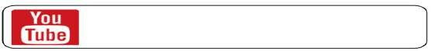

<https://youtu.be/8dS96KqFgXc>

Example 4.12

Using a ruler and a pair of compass only, construct triangle ABC in which ∠C = 90° and ∠ABC = 45°, CB = 5 cm. Measure AB.

Solution.

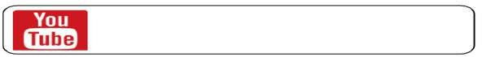

<https://youtu.be/ci8Jqyw7W5o>

Example 4.13.

Using a ruler and a pair of compass only, construct triangle ABC in which AB = 5 cm, ∠BAC = 30° and ∠ABC = 75°. Measure AC and CB.

Solution.

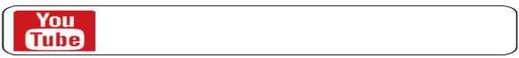

<https://youtu.be/9iuQ6TysmDE>

# CONSTRUCTION OF CIRCLES.

A Circle is constructed using an instrument known as a compass. Construction of a circle given its centre and radius is as shown.



<https://youtu.be/z7DwYJYFa9k>

A circle whose diameter line is given is constructed as shown below.



<https://youtu.be/RDGwWAzslK8>

# EXERCISE 4.2

In this exercise, all constructions should be done using a ruler and a pair of compass only.

1. Construct triangle ABC with AB = 10 cm, BC = 8 cm and AC=5.5cm. Measure ∠ABC and ∠ACB.
2. Construct triangle JKL with ∠JKL = 450, KL = 5cm and JL = 8cm. Measure length JK.
3. Construct triangle CAR with ∠ACR =300, ∠CRA=750 and CA = 7cm. Measure AR.
4. Construct triangle WXY with ∠XWY = 900, WX = 6cm and ∠WXY

= 600. Measure the length XY.

1. Construct a right triangle XYZ in which ∠XYZ = 90°, XY = 5 cm and YZ = 7 cm. Measure ∠ZXY.

|  |  |
| --- | --- |
| Example | Youtube link |
| 4.1 | <https://youtu.be/FzVw46mD1bw> |
| 4.2 | <https://youtu.be/46Xslz4chaI> |
| 4.3 | <https://youtu.be/QbQtsS-6p_Y> |
| 4.4 | <https://youtu.be/TKBVyZqVyZE> |
| 4.5 | <https://youtu.be/0r0bwym0EJc> |
| 4.6 | <https://youtu.be/IoS4S8wbTro> |
| 4.7 | <https://youtu.be/heKVnt6_SRo> |
| 4.8 | <https://youtu.be/KjsH4sTmXLg> |
| 4.9 | <https://youtu.be/j-LKg8dM27w> |
| 4.10 | <https://youtu.be/hae8INJcM-g> |

This document shows some pages of the book.

The complete book is available for sh. 600 only. We are currently doing print on demand.

The book contains,

* well summarized notes for grade 7 in line with the curriculum designs.
* Solved examples.
* Youtube links for the solved examples for reference in case the learner does not understand.
* Exercises at the end of every sub strand.
* Revision Exercises for all the work up to grade 7.
* Answers to all exercises.

To order yours, contact,

**0728318891**

Michael Mutinda, Author and Publisher.

You can also subscribe to our youtube channel on the link, [http://www.youtube.com/@masterstrokekenya](http://www.youtube.com/%40masterstrokekenya)

or,

Simply search “Master stroke kenya” on youtube. Thank you for your support.

MICHAEL MUTINDA 0728318891

# DATA HANDLING AND PROBABILITY.

# DATA HANDLING.

Data are the facts and figures that are collected, analyzed, and summarized for presentation and interpretation.

# DATA COLLECTION.

The three most common methods of data collection are:

1. Direct observation. The data collector observes and records observation. For example school attendance register.
2. Experiments. In this method, variables are controlled so as to investigate relationships between variables. Its commonly used in a scientific study.
3. Surveys. Data is obtained from people through interviews and questionnaires. A good example of survey is pre election opinion polls.

# ORGANIZATION OF DATA.

Data organization is the way to arrange the raw data in an understandable order. In mathematics, we organize data using frequency distribution table.

Frequency is the number of times an entry appears in a set of data.

Example 5.1

The masses of 40 students in a grade 7 to the nearest kg were recorded as:

# PIE CHARTS

A pie chart is a type of graph that represents the data in the circular graph. The circle is divided into sectors whose side depends on the size of data being represented.

Example 5.3

A farm has 120 animals out of which, 80 are chicken, 30 are goats and 10 are cattle. Represent this data in a pie chart.

Solution.

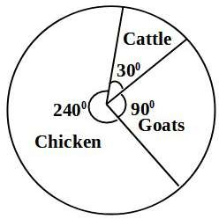The angles for the sectors are as shown Chicken:

80 ×3600=2400

120

Goats:

30 ×3600=900

120

Cattle

10 ×3600=300

120

Example 5.4

The figure below shows a pie chart showing the number of cars by manufacturer in a car yard. Determine the number of cars for each manufacturer if the yard has 24 cars.

|  |  |  |  |  |
| --- | --- | --- | --- | --- |
| 25 | 30 | 10 | 20 | 15 |

Draw a bar graph to represent the data. Solution.

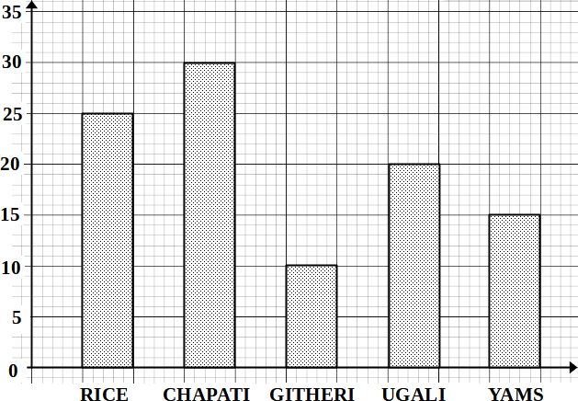

# LINE GRAPHS

Line Graph is a graph that shows information connected in some way (usually as it changes over time).

Example 5.6.

The temperature of Nanyuki in a certain day was recorded as shown.

|  |  |  |  |  |  |
| --- | --- | --- | --- | --- | --- |
| Time | 8.00 am | 9.00am | 10.00am | 11.00am | 12.00noon |

|  |  |  |  |  |  |
| --- | --- | --- | --- | --- | --- |
| Temperature (oC) | 23 | 24 | 26 | 25 | 23 |

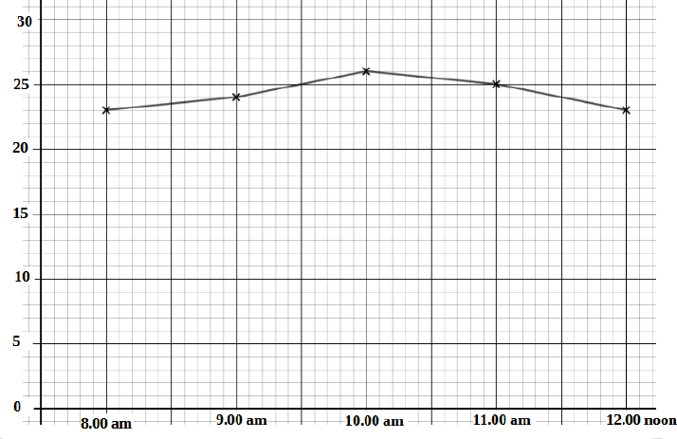Draw a line graph to represent the information. Solution.

# TRAVEL GRAPHS.

In this section, we will deal with graphs which show the distance covered against time taken.

Example 5.7

The graph below shows the distance covered by Lavenda against time.

* 1. How far is Jane from A at 8.00?
  2. Calculate Jane's speed in the first two hours of the journey.

|  |  |
| --- | --- |
| Example | Youtube links |
| 5.1 | <https://youtu.be/ul-J4Qcfjbs> |
| 5.2 | <https://youtu.be/_ARbsApZSoo> |
| 5.3 | <https://youtu.be/uV4VPpyPyfk> |
| 5.4 | <https://youtu.be/mGI_qj6a8QI> |
| 5.5 | <https://youtu.be/esWWoL3xknI> |
| 5.6 | <https://youtu.be/wLPzaUneQK4> |
| 5.7 | <https://youtu.be/v8J7mpztYhc> |
| 5.8 | <https://youtu.be/PyTFK0iAiS4> |

This document shows some pages of the book.

The complete book is available for sh. 600 only. We are currently doing print on demand.

The book contains,

* + - well summarized notes for grade 7 in line with the curriculum designs.
    - Solved examples.
    - Youtube links for the solved examples for reference in case the learner does not understand.
    - Exercises at the end of every sub strand.
    - Revision Exercises for all the work up to grade 7.
    - Answers to all exercises.

To order yours, contact,

**0728318891**

Michael Mutinda, Author and Publisher.

You can also subscribe to our youtube channel on the link, [http://www.youtube.com/@masterstrokekenya](http://www.youtube.com/%40masterstrokekenya)

or,

Simply search “Master stroke kenya” on youtube. Thank you for your support.

MICHAEL MUTINDA 0728318891

# SAMPLE EXAMINATION PAPERS. SAMPLE PAPER 1.

1. Write in words 2 473 273.07
2. What is 2734.998 rounded off to two decimal places?
3. How many days are there between 9th September to 25th December.
4. What is the total value of digit 8 in the product of 144 and 2 975?
5. What is the value of 7( 42+2)−4×6÷3
6. John bought the following items from a shop:
   1. 2½ kg of sugar @ sh. 160
   2. 50 g of tea for sh. 50
   3. 2 packets of milk @ sh. 60
   4. 2 bars of soap @ sh. 250.

How much did he pay for the commodities.

1. What is the sum of the square of 0.25 and the square of 1.4?
2. State the next two numbers in the pattern, 2, 4.5, 7, 9.5, …
3. Simplify: 6 *x*+ 1 (18 *x*−12 *y*)

3

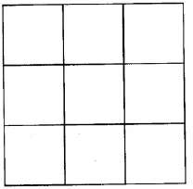

How many squares are there altogether?

50. A plot of land is the shape of a rhombus of side 200m. The length of one of the diagonals is 240 m. What is the area of the plot in hectares?

# SAMPLE PAPER 4

1. What is 2 345 278 written in words?
2. How many tens are there in the total value of digit 6 in the number 896 892?
3. What is the value of 8(5−9+6)

4

1. Round of 8.08936 to 2 decimal places
2. What is the place value of digit 2 in the number 652 890?
3. Find the square of 4 2

5

1. Arrange the following fractions in ascending order

2 3 6

*,*

3 4 *,* 7

and 7

12

1. In the figure below, line AC=CB and angle ACD=1400.

1(a). Millions

1. Ten thousands
2. Hundred millions

# ANSWERS NUMBERS

## Exercise 1.1

1. Hundred thousands
2. Hundred thousands

2(a) 8 000 000

1. 30 000
2. 100 000 000
3. 500 000
4. 20 000 000
5. 8 000 000

3(a) Nine hundred and seventy eight million, three hundred and sixty one thousand, three hundred and six.

1. Five hundred and sixty eight million, two hundred and thirty thousand, one hundred and sixty three.
2. One hundred and thirty seven million, eight hundred and fifty six thousand, six hundred and thirty five.
3. Six hundred and thirty two million, five hundred and two,seven hundred and sixty three
4. Eight hundred and twenty four million, six hundred and twelve thousand, nine hundred and seventy three.
5. Two hundred and seventy four million, eight hundred and ninety five thousand, four hundred and seventy.
   1. (a) 783 160 000
      1. 78 900 000

## Exercise 1.2

* + 1. 605 000 000
    2. 10 000 000
    3. 12 893 000
  1. (a) 420 000 (b) 2 100 (c) 8 100

48) 24.64 49) 6.6 50) 200

## Sample paper 1, question 18.

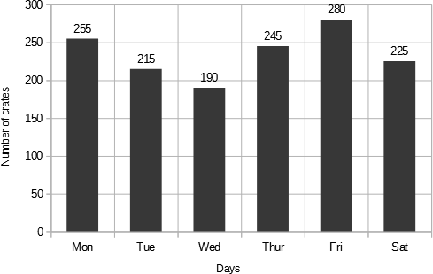

**Sample paper 2, question 17**

1. All sides are equal
2. Opposite sides are parallel
3. Opposite angles are equal

## Sample paper 2, question 37

1. Diagonals bisect at right angles
2. Diagonals bisect the angles
3. Sum of two adjacent angles is 1800.

|  |  |  |  |  |  |
| --- | --- | --- | --- | --- | --- |
| Activity | maize | Sugar cane | vegetable | Grazing | Homestead |
| Angle size in pie chart (0) | 72 | 120 | 60 | 84 | 24 |

## Sample paper 3, question 27

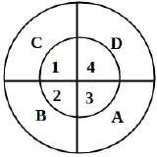

**DOYEN PRESS IS A PUBLISHING AND PRINTING COMPANY.**

WE OFFER,

* 1. BOOK PUBLISHING
  2. DOCUMENT PRINTING
  3. RECEIPT BOOK PRINTING
  4. DESIGNING (DOCUMENTS AND POSTERS)
  5. T SHIRT AND GARMENT PRINTING
  6. MAGIC MUGS
  7. ORDINARY MUGS
  8. TWO TONE MUGS
  9. WATER BOTTLES
  10. ALL CYBER SERVICES



**WE ARE LOCATED AT SULTAN HAMUD 0728 318 891**

