Kenya Junior School Education Assessment (KJSEA)

**KJSEA MATHEMATICS** **REVISION SERIES**

##### SECTION I (40 MARKS*)*

***Answer ALL the Questions in the spaces provided***

1. A school received sh. 22,041,005 from a donor to construct new classrooms. Write this amount in words. **(2mks)**
2. Juma plants both maize and beans in his farm. The area of the farm is 212,384,194m2. Round off the area of the farm to the nearest thousands **(2mks**)
3. Add one thousand and forty-four to the product of one thousand and six and one hundred and eighty. **(2mks)**
4. The mass of uncooked meat is 2.86 kg. Express the mass as a fraction. **(3mks)**
5. Use a number line to work out the value of (**-** 4) **+** (**-** 1) **+** (7) **(2mks)**
6. At Kanyamedha Comprehensive School, there are three bells one for Nursery School, one for Primary School and the other for Junior School, The three bells’ rings at an interval of 16 minutes, 24 minutes and 40 minutes. If they last rang together at 1:00 pm. Find the next

time they will ring together again. **(3mks**)

1. Express the following decimal numbers in standard form **(3mks)**

80 =

756.2 =

0.0056 =

1. Use mathematical table to work out **(4mks)**
   1. 19.32
   2. √1.856
2. Surface area of a square book is 1.25m2, use a calculator to find the length of each side in

2 significant figures. **(2mks)**

1. Below are number cards that were displayed by a grade eight learner during the maths lesson

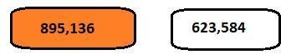

Test whether numbers on the cards are divisible by 11 **(2mks)**

1. A train took 3hrs to cover a distance of 162km.Find the speed of the train in m/**s (3mks)**
2. Express **210** as a product of it’s prime factors (**1mks)**
3. Find the value of k **(3mks)**

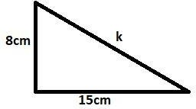

1. Ten men working at the same rate can paint a wall in 4 days. How long will it take 5 men working at the same rate to paint a similar wall. **(3mks)**
2. Work out 980 + 90 **÷** 15 −150 of 6 **(2mks)**
3. Mr. Ajowi spends of his monthly salary on food, on Transport and saves the rest. If he saves sh. 3,000 every month, work out his monthly salary. **(3mks)**

##### SECTION II (20MKS)

***Answer all question from this section***

1. 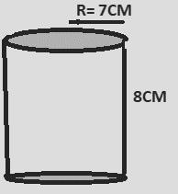The diagram below show a cylindrical container of radius 7cm and height 8cm.
2. Find the volume of the container in cm3 **(3mks)**
3. If the container has density of **50 g/cm3,** Work out the **mass** of the container in **kg**

##### (4mks)

1. What is the capacity of the container in liters **(3mks)**
2. **(a)** At Kanyamedha Junior School, of the population are Boys and the rest are Girls.
3. Express the number of Boys as a fraction of Girls. (**3mks)**
4. What is the ratio of Boys to Girls in the school? **(2mks)**
5. If the number of the learners in the Junior school was 360 last year and increased in the ratio of **7: 4** this year. Find
   1. The number number of the learners this year, **(2mks)**
   2. What was the percentage increase in school population **(3mks)**

SERIES 2

SECTION A: (20 Marks)

**Choose the correct answer**

1. A farmer harvested **5,678,912** maize cobs. What is the place value of **7** in this number?
   1. Seventy thousand
   2. Seven hundred thousand
   3. Seven million
   4. Seven hundred
2. A company recorded **4,230,567** shillings in revenue. Write this number in words.
   1. Four million, two hundred thirty thousand, five hundred sixty-seven
   2. Four million, twenty-three thousand, five hundred sixty-seven
   3. Forty-two million, three hundred fifty-six thousand, seven hundred
   4. Four billion, two hundred thirty million, five hundred sixty-seven thousand
3. A recipe requires **3/4** kg of sugar. Convert this fraction to a decimal.
   1. 0.75 B) 0.8

C) 0.7 D) 0.85

1. Jane spent **2/5** of her salary on rent and **1/4** on food. What fraction of her salary did she spend altogether?
   1. 3/9 B) 13/20 C) 9/20 D) 8/20
2. A car travels **360 km** in **6 hours**. What is its speed?
   1. 30 km/h B) 40 km/h

C) 50 km/h D) 60 km/h

1. A cyclist moves at **20 km/h** for **2.5 hours**. What distance does he cover?
   1. 40 km B) 50 km

C) 55 km D) 60 km

1. The area of a circular garden with a radius of **14 m** is:
   1. 154 m² B) 616 m²

C) 44 m² D) 98 m²

1. A builder cuts a **3.5 m** metal rod into pieces of **0.25 m** each. How many pieces does he get?
   1. 12 B) 14 C) 16 D) 18
2. A bag contains **5 red**, **3 green**, and **2 yellow** balls. What is the probability of picking a green ball?

A) 3

10

B) 2

10

C) 5

10

D) 8

10

1. The mean of the numbers **12, 18, 24, 30, and 36** is:
   1. 18 B) 22 C) 24 D) 30
2. What is **50,678** rounded to the nearest thousand?
   1. 50,000 B) 50,700

C) 51,000 D) 50,680

1. The least common multiple (LCM) of **12 and 18** is:
   1. 6 B) 36

C) 24 D) 48

1. Convert **0.375** into a fraction in its simplest form.

A) 3

5

C) 5

8

B) 3

8

D) 7

10

1. A car travels **540 km in 6 hours**. What is its average speed?
   1. 60 km/h B) 90 km/h

C) 45 km/h D) 80 km/h

1. A trader buys a bicycle for **Ksh 4,000** and sells it at **Ksh 5,200**. What is the percentage profit?
   1. 25% B) 30%

C) 20% D) 40%

1. Solve for **x**:

2x+5=172x + 5 = 172x+5=17

A) 5

B) 6

C) 7

D) 8

1. The perimeter of a rectangle is **42 cm**. If the length is **12 cm**, what is the width?
   1. 9 cm B) 8 cm

C) 7 cm D) 6 cm

1. What is the mode of the numbers **4, 7, 5, 7, 9, 7, 10**?
   1. 7
   2. 9
   3. 5
   4. 10
2. A bag contains **3 red, 5 green, and 7 yellow balls**. What is the probability of picking a **green ball**?

A) 5

12

C) 5

10

B) 5

15

D) 5

13

1. Find the area of a triangle with base **10 cm** and height **6 cm**.
   1. 30 cm²
   2. 40 cm²
   3. 50 cm²
   4. 60 c

SECTION B: (80 Marks)

Show your working

1. Numbers and Operations (10 marks)
   1. Write **9,602,345** in words. (2 marks)
   2. Find the LCM and GCD of **15** and **20**. (4 marks)
   3. A school bus carries **42** students per trip. How many trips are needed to transport **378** students? (2 marks)
   4. Round **568,349** to the nearest **hundred thousand**. (2 marks)
2. Algebra (10 marks)
   1. Solve for **x**: **4x - 7 = 2x + 5**. (3 marks)
   2. Factorize: **x² - 10x + 24**. (3 marks)
   3. Solve the inequality: **5x + 8 ≤ 23**. (2 marks)
   4. A fruit vendor sells **mangoes at Ksh 20 each**. Write an equation for the total cost **C** when buying **n** mangoes. (2 marks)
3. Matrices and Determinants (10 marks)



(3 marks)



|  |  |  |
| --- | --- | --- |
| (a) Find the determinant of **M =** | 3 | 2 |
|  | 4 | 5 |

1. Find the inverse of **M**. (4 marks)
2. Given **A =**
   1. 1 and **B =** 1 0



* 1. 4 2 3

Compute **AB**. (3 marks)

1. Geometry and Measurement (10 marks)
   1. The perimeter of a rectangular field is **84 m**. If its width is **18 m**, find its length. (3 marks)
   2. Convert **750 litres** into cubic meters. (3 marks)
   3. A triangle has sides **7 cm, 24 cm, and 25 cm**. Prove it is a right-angled triangle. (4 marks)
2. Probability and Data Handling (10 marks)
   1. Find the median of **5, 8, 12, 15, 20**. (2 marks)
   2. A school has **400 students**. A survey shows **35%** like football, **25%** like basketball, **20%** like swimming, and the rest prefer athletics. Find the angle representing athletics in a pie chart. (2 marks)
   3. A die is rolled. What is the probability of getting an even number? (2 marks)
   4. A basket contains **10 apples, 8 oranges, and 7 bananas**. What is the probability of picking a banana? (2 marks)
   5. A shopkeeper buys an item for **Ksh 3,000** and sells it for **Ksh 4,200**. Find the percentage profit. (2 marks)
3. Question (5 Marks):

Given a line segment **AB = 10 cm**, construct its **perpendicular bisector** and label the midpoint as **M**.

1. **Draw line segment AB = 10 cm** using a ruler.
2. **Set the compass width to more than half** of AB (approximately 6 cm).
3. **Place the compass needle at point A** and draw an arc above and below the line.
4. **Without changing the compass width, place the needle at point B** and draw another arc above and below the line to intersect the first arcs.
5. **Mark the intersection points of the arcs** above and below AB.
6. Draw a straight line connecting these intersection points. This is the perpendicular bisector of AB.
7. **Label the midpoint of AB as M**, where the bisector crosses AB.

**SERIES 3**

**SECTION A**: (20 Marks) *Choose the correct answer*

* 1. What is the place value of **7** in the number **5,789,342**?
     1. Seven hundred thousand
     2. Seventy thousand
     3. Seven million
     4. Seven hundred
  2. Convert **3,456,789** to words.
     1. Three million, four hundred sixty-seven thousand, eight hundred nine
     2. Three million, four hundred fifty-six thousand, seven hundred eighty-nine
     3. Three billion, four hundred fifty-six million, seven hundred eighty-nine thousand
     4. Thirty-four million, five hundred sixty-seven thousand, eight hundred ninety
  3. Find the LCM of **12 and 18**.
     1. 24 B) 36

C) 48 D) 72

* 1. Simplify: **(4/5 ÷ 2/3) × (3/4)**
     1. 3/5
     2. 2/3
     3. 6/5
     4. 5/6
  2. Solve for **x**: **3x - 5 = 7**
     1. 4 B) 2

C) 5 D) 3

* 1. The area of a circle with a radius of **7 cm** is:
     1. 154 cm²
     2. 49 cm²
     3. 21 cm²
     4. 44 cm²
  2. A car travels **240 km** in **4 hours**. What is its speed?
     1. 30 km/h B) 40 km/h

C) 50 km/h D) 60 km/h

* 1. Solve: **2x + 3 < 9**
     1. x < 2 B) x > 3

C) x < 3 D) x > 2

* 1. The determinant of the matrix **A = 3 2 is?**



**5**

**4**

1

* + 1. 7 B) -7 C) 2 D) -2
  1. The matrix **B = 1** **3**



2 4

is multiplied by **2**, what is the result?

A)



2

6

4

8

1

6

2

8

2

3

4

8

3

9

6

12

B)

C)

D)

* 1. Convert 𝟕 to a decimal.

𝟖

* + 1. 0.75 B) 0.875

C) 0.78 D) 0.8

* 1. Solve for **x** in **2x² = 50**.
     1. 5 B) ±5 C) 10 D) ±10
  2. The reciprocal of 𝟑 is:

𝟕

* + 1. 7

3

* + 1. 3

7

* + 1. − 3

7

* + 1. − 7

3

* 1. A triangle has sides **6 cm, 8 cm, and 10 cm**. Which type of triangle is it?
     1. Right-angled B) Equilateral

C) Isosceles D) Scalene

* 1. If **5x = 60**, find **x**.
     1. 15 B) 10

C) 12 D) 20

2

* 1. The mode of the numbers **4, 7, 9, 4, 10, 7, 4** is:
     1. 4 B) 7

C) 9 D) 10

* 1. A line parallel to the **x-axis** has an equation of the form:
     1. y = constant B) x = constant

C) y = mx + c D) xy = constant

* 1. Find the **square root** of **289**.
     1. 19 B) 17 C) 15 D) 21
  2. Convert **2.5 km** to meters.
     1. 25 m B) 250 m

C) 2,500 m D) 25,000 m

* 1. The interior angles of a quadrilateral add up to:
     1. 90°
     2. 180°
     3. 270°
     4. 360°

SECTION B: (80 Marks)

* 1. (a) Write **8,405,678** in words. (2 marks)

1. Find the **LCM** and **GCD** of **18 and 24**. (4 marks)
2. Convert **0.75** to a fraction and simplify. (2 marks)
3. Round **456,789** to the nearest **ten thousand**. (2 marks)
   1. (a) Solve for **x** in **5x - 3 = 2x + 9**. (3 marks)

3

1. Factorize: **x² - 7x + 12**. (3 marks)
2. Solve the inequality: **3x + 4 ≥ 10**. (2 marks)
3. Find the value of **y** if **2y + 5 = 15**. (2 marks)
   1. (a) Find the determinant of **M = 4** (3 marks)



**5**

**2**

**3**

(b) Find **M⁻¹**, the inverse of matrix **M**. (4 marks)

(3 marks)



|  |  |  |  |  |  |  |  |  |
| --- | --- | --- | --- | --- | --- | --- | --- | --- |
| (c) Given **A =** | **2** | **3** | and **B =** |  | **1** |  | **2** | , compute **AB**. |
|  | **1** | **4** |  | **0** |  | **3** |  |  |

* 1. (a) The perimeter of a rectangle is **36 cm**. If its width is **8 cm**, find its length. (3 marks)

1. A tank holds **500 litres**. Convert this to **m³**. (3 marks)
2. A triangle has sides **5 cm, 12 cm, and 13 cm**. Show it is a right-angled triangle. (4 marks)
   1. (a) Find the **mean** of the numbers **10, 15, 20, 25, 30**. (2 marks)
3. The probability of picking a red ball from a bag is **3/8**. What is the probability of not picking a red ball? (2 marks)
4. A pie chart shows students' favorite sports: **40% football, 25% basketball, 20% volleyball, and the rest hockey**. Find the angle for **hockey**. (2 marks)
5. A die is rolled. What is the probability of getting a prime number? (2 marks)
6. Find the median of **4, 7, 9, 12, 15**. (2 marks)

4

###### SERIES 4

SECTION A (20 marks)

* 1. Simplify: 3𝑥 + 5𝑥 − 7
     1. 8x−7
     2. 3x−7
     3. 5x+7
     4. 8x+7
  2. Solve for x: 5𝑥 − 3 = 17
     1. x=3
     2. x=4
     3. x=5
     4. x=6
  3. What is the LCM of 15 and 25?
     1. 30
     2. 45
     3. 75
     4. 100
  4. Simplify: 2(𝑥 + 3) + 4(𝑥 − 1)
     1. 6x+2
     2. 6x+2−4
     3. 6x+2
     4. 6x−2
  5. The ratio of boys to girls in a class is 4:5. If there are 80 boys, how many girls are there?
     1. 100
     2. 120
     3. 160
     4. 200
  6. Solve for x: 4 = 𝑥

5 15

* + 1. x=10
    2. x=12
    3. x=8
    4. x=20
  1. A car travels 180 km in 6 hours. What is the speed of the car in km/h?
     1. 30 km/h
     2. 36 km/h
     3. 40 km/h
     4. 45 km/h
  2. A shirt originally costs Ksh 1,500. After a 10% discount, what is the final price of the shirt?
     1. Ksh 1,350
     2. Ksh 1,400
     3. Ksh 1,500
     4. Ksh 1,600
  3. What is 25% of 320?
* A) 60
* B) 80
* C) 90
* D) 100
  1. The population of a town increases by 10% every year. If the current population is 50,000, what will the population be after 2 years?
     1. 55,000
     2. 60,000
     3. 61,000
     4. 62,100
  2. What is the area of a rectangle with length 10 cm and width 6 cm?
     1. 30 cm²
     2. 40 cm²
     3. 60 cm²
     4. 100 cm²
  3. The volume of a sphere is calculated using the formula V=4 πr3. If the

3

radius of a sphere is 3 cm, what is its volume? (Use π=3.14)

1. 84.78 cm³
2. 113.04 cm³
3. 27 cm³
4. 15.4 cm³
   1. What is the surface area of a cube with side length 4 cm?
      1. 48 cm²
      2. 64 cm²
      3. 96 cm²
      4. 128 cm²
   2. The marks obtained by a student in five subjects are: 70, 80, 90, 75, and

85. What is the median of the marks?

* + 1. 75
    2. 80
    3. 85
    4. 90
  1. If the mode of a data set is 12, which of the following could be the data set?
     1. 10, 12, 14, 16
     2. 5, 7, 12, 12, 12, 13
     3. 5, 5, 8, 8, 12, 13
     4. 6, 7, 8, 10, 12, 15
  2. If the equation of a line is y=2x+1, what is the y-intercept?

A) 0

B) 1

C) 2

D) 3

* 1. What is the slope of the line passing through the points (0, 2) and (3, 8)?

###### A) 3

5

###### B) 5

3

###### C) 2

D) 6

3

* 1. The points (2, 3) and (4, 7) lie on a straight line. What is the slope of the line?

###### A) 4

2

###### B) 7

3

###### C) 1

2

###### D) 2

* 1. What is the name of the figure below?

A. Trapezium B. Rhombus C. Square D. Rectangle 20.Calculate the area of the circle below that has a radius of 12.5cm

rounded off to the nearest whole number.



12.5 cm

A. 600cm2 B.409cm2 C. 125 cm2 D.491cm2

###### SECTION B: 80 MARKS

Number Operations and Algebra (20 Marks)

1. Simplify the following expressions:
   1. 5a−3b+2a−7b
   2. 3x(x+2)−4(x+2)
2. Solve for x in the equation: 2x+3=11
3. Find the LCM and HCF of 18 and 24.

Ratios and Proportions (15 Marks)

1. A school has 120 boys and 80 girls. Find the ratio of boys to girls in its simplest form.
2. Solve for x in the following proportion:

3 𝑥

 =

4 12

1. A car travels 120 km in 3 hours. How far will it travel in 5 hours at the

same speed?

Percentages (15 Marks)

1. A laptop originally costs Ksh 30,000. After a 15% discount, what is the price of the laptop?
2. A population of a town increases by 12% annually. If the current population is 50,000, what will be the population after 2 years?
3. Calculate the simple interest on a loan of Ksh 20,000 at 8% per annum for 3 years.

Measurement (20 Marks)

1. Find the area of a triangle with a base of 10 cm and a height of 6 cm.
2. Calculate the volume of a cylinder with a radius of 7 cm and height of

14 cm. Use π=22

7

1. Find the surface area of a cube with a side length of 5 cm.

Data handling (15 Marks)

1. The marks obtained by a student in five subjects are: 70, 85, 90, 65, and 75.
   1. Find the mean, median, and mode of the marks.
   2. Construct a bar graph to represent these marks.

Linear Graphs (15 Marks)

1. 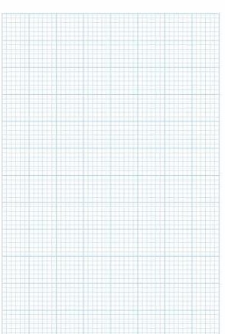Plot the following points on a graph: A(0, 2), B(2, 4), C(4, 6), D(6, 8).
   1. Draw the line that passes through these points.
   2. Find the gradient of the line.

## SERIES 5

**SECTION A:** (20 Marks): Answer all questions

### What is the place value of 6 in the number 3,462,189?

* 1. Hundreds
  2. Thousands
  3. Ten-thousands
  4. Hundred-thousands

### Write 8,013,025 in words.

* 1. Eight million, thirteen thousand, twenty- five
  2. Eight million, one hundred three thousand, twenty-five
  3. Eight million, thirteen hundred twenty- five
  4. Eight hundred thirteen thousand, twenty-five

### Convert 2,049 to Roman numerals.

* 1. MMXLIX B) MMCDIX

C) MMLIX D) MMIVIX

### Round 846,573,921 to the nearest hundred million.

* 1. 800,000,000 B) 900,000,000

C) 850,000,000 D) 840,000,000

### What is the least common multiple (LCM) of 9 and 12?

* 1. 18 B) 36

C) 72 D) 48

### Which of the following is NOT a prime number?

* 1. 13 B) 19

C) 21 D) 29

### Simplify: 12 ÷ (4 – 2) × 3

* 1. 18 B) 9

C) 6 D) 12

### Find the reciprocal of 5/8.

### 2, 4, 8, 16, , 64

* 1. 24 B) 32

C) 48 D) 56

### Solve for x: 3x + 7 = 2x + 12

* 1. 4 B) 5

C) 7 D) 9

### A triangular field has a base of 20 m and a height of 15 m. What is its area?

* 1. 150 m²
  2. 225 m²
  3. 200 m²
  4. 300 m²

### A shopkeeper bought a TV for Ksh 25,000 and sold it at Ksh 28,750. What was the percentage profit?

* 1. 12% B) 15%

C) 25% D) 30%

### Find the circumference of a circle with a radius of 7 cm (π = 3.14).

* 1. 21.98 cm B) 43.96 cm

C) 31.42 cm D) 50 cm

### Solve: 5/6 × 3/4 ÷ 2/5

* 1. 5/8
  2. 10/9
  3. 15/16
  4. 20/36

A) 8

5

B) 5

8

C) 3

5

D) 1

5

### Find the missing number in the sequence:

1. **Find the mean of 12, 18, 22, 14, and 16.**
   1. 16 B) 18

C) 20 D) 22

### What is the probability of picking a red marble from a bag containing 3 red, 5 blue, and 2 green marbles?

* 1. 1/5 B) 3/10

C) 3/9 D) 1/3

### Solve: (4³ ÷ 2²) + 5

* 1. 13 B) 14

C) 17 D) 21

### Find the gradient of a line passing through points (3,4) and (6,10).

A) 2

B) 3

C) 4

D) 5

### Find the surface area of a cube with a side of 5 cm.

* 1. 75 cm²
  2. 100 cm²
  3. 150 cm²
  4. 125 cm²

### If the exchange rate is 1 USD = Ksh 145, how much is 50 USD in Ksh?

* 1. 6,500
  2. 7,250
  3. 7,750
  4. 8,000

**SECTION B:** (80 Marks)

(Answer all questions. Show your working.)

1. **Write 9,608,214 in words.** (2 marks)
2. **Find the LCM and GCD of 24 and 36.** (4 marks)

### Round 752,684,519 to the nearest hundred million. (2 marks)

1. **Write 2025 in Roman numerals.** (2 marks)

### Convert 0.625 to a fraction in its simplest form. (2 marks)

1. **Simplify: (3/4 + 5/6) ÷ (2/3).** (4 marks)
2. **Round 3.8769 to 2 decimal places.** (2 marks)

### Find the square root of 225 using prime factorization. (2 marks)

1. **Solve for x: 4x - 5 = 3x + 7.** (3 marks)
2. **Factorize: x² - 9x + 20.** (3 marks)
3. **Solve for x in the inequality: 2x + 3 > 7.** (2 marks)
4. **Find the value of y if 2y + 5 = 15.** (2 marks)
5. **Find the area of a parallelogram with base 10 cm and height 8 cm.** (2 marks)
6. **A tank holds 250 litres. Convert this to cubic meters.** (2 marks)
7. **Construct a triangle with sides 6 cm, 8 cm, and 10 cm.** (3 marks)
8. **Find the volume of a cylinder with radius 4 cm and height 10 cm. (π = 3.14).** (3 marks
9. **Find the median of 4, 9, 11, 15, 21.** (2 marks)
10. **Draw a bar graph to represent the data: 3, 5, 8, 6, 7.** (4 marks)
11. **Find the probability of tossing a coin and getting heads.** (2 marks)
12. **A school has 200 students. 60 play football. Find the percentage of students who play football.** (2 marks)

SERIES 6

SECTION A: (20 Marks)

Choose the correct answer for each question.

1. A Kenyan farmer harvested 9,876,543 bags of maize. What is this number in words?
   1. Nine million, eight hundred seventy-six thousand, five hundred forty-three
   2. Nine billion, eight hundred seventy-six million, five hundred forty-three
   3. Nine million, eight hundred seventy-six thousand, five hundred thirty-four
   4. Nine million, eight hundred sixty-seven thousand, five hundred forty-three
2. A historic building in Nairobi was built in the year 2025. How is this written in Roman numerals?
   1. MMXXV B) MMXV

C) MMXXIV D) MMXXVI

1. A government report estimates the population of Nairobi as 654,321,789 people.

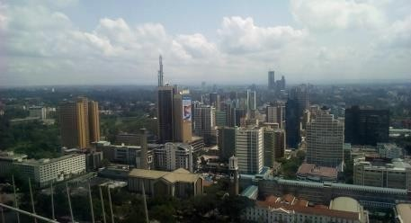

Round this to the nearest hundred million.

* 1. 600,000,000 B) 700,000,000

C) 650,000,000 D) 660,000,000

1. A school wants to divide 36 red and 48 blue chairs into equal groups. What is the greatest common divisor (GCD)?
   1. 12 B) 24 C) 18 D) 6
2. A bus leaves Nairobi every 4 hours, while another leaves every 10 hours. After how many hours will they leave at the same time again?
   1. 20 B) 40 C) 10 D) 30
3. A carpenter cuts wood into equal parts using the expression (50 ÷ 5) × 3 + 6. What is the result?
   1. 9 B) 30 C) 36 D) 15
4. A recipe requires 4.25 cups of flour. Convert this into a fraction.
   1. 17

4

* 1. 9

4

* 1. ¾ D) 16 4

1. A shopkeeper calculates the price of 3x + 5 = 17 for a customer. What is the value of x?
   1. 3 B) 4 C) 5 D) 6
2. A lottery randomly selects a prime number between 30 and 40. Which number is prime?
   1. 33 B) 37 C) 39 D) 49
3. A farmer fences a square garden with a total perimeter of 20 cm. What is the area?
   1. 25 cm² B) 16 cm² C) 9 cm² D) 20 cm²
4. A tourist from the USA exchanges 100 USD for Kenyan shillings. If the exchange rate is 1 USD = 150 Ksh, how much does the tourist get?
   1. 1,500 Ksh
   2. 15,000 Ksh
   3. 150,000 Ksh
   4. 1,050 Ksh
5. A shop increased the price of sugar from Ksh 200 to Ksh 240. What is the percentage increase?
   1. 20%
   2. 25%
   3. 15%
   4. 10%
6. A designer is making a parallelogram-shaped signboard. One angle is 65°. What is the value of its opposite angle?
   1. 65°
   2. 125°
   3. 90°
   4. 115°
7. A cyclist rides 40 km in 2 hours. What is their average speed in km/h?
   1. 20 km/h
   2. 30 km/h
   3. 40 km/h
   4. 50 km/h
8. A farmer builds a circular pond with a radius of 7 meters. What is the area of the pond? (Use π = 3.14)
   1. 154 m²
   2. 49 m²
   3. 21.98 m²
   4. 128.5 m²
9. A water tank measures 4 m long, 3 m wide, and 2 m high. What is its volume in cubic meters?
   1. 12 m³
   2. 24 m³
   3. 18 m³
   4. 20 m³
10. A customer buys a phone for Ksh 50,000 after a 10% discount. What was the original price before the discount?
    1. Ksh 45,000
    2. Ksh 55,000
    3. Ksh 50,000
    4. Ksh 60,000
11. A student records the number of pages read per day: 5, 7, 8, 6, 4. What is the mean number of pages read?
    1. 6 B) 5.5 C) 5 D) 7
12. A bag contains 5 red, 3 blue, and 2 green balls. If one ball is picked at random, what is the probability that it is not red?
    1. 3/10 B) 5/10 C) ½ D) 2/5
13. A bank offers a 5% annual simple interest rate. If a person deposits Ksh 10,000 for 2 years, how much interest is earned?
    1. Ksh 500 B) Ksh 1,000

C) Ksh 2,000 D) Ksh 1,500

SECTION B: (80 Marks)

Answer all questions and show all workings.

1. (2 marks)The Kenyan government announced a budget of 67,890,123 Ksh. Write this number in words.
2. (3 marks)A teacher distributes 256 pencils equally among students. Express 256 as a product of its prime factors.
3. (3 marks)A carpenter is making a wooden table with dimensions 12 cm by 5 cm.

Find the area and perimeter of the table.

1. (2 marks)A tailor sells a shirt where 5x - 2 = 18. Find the price x of one shirt.
2. (2 marks)A school plans to buy 225 desks. Find the square root of 225 using factorization.
3. (2 marks)A farmer has 3 hectares of land. Convert this to square meters.
4. (2 marks)A weather report states the temperature is 30°C. Convert this to Kelvin.
5. (2 marks)A carpenter is making a triangular window frame. If two angles are 75° and 45°, find the missing angle.
6. Profit Calculation (2 marks)

A trader buys a TV for Ksh. 20,000 and sells it for Ksh. 25,000. Find the percentage profit.

1. Pie Chart Representation (5 marks)

A class of 50 students was surveyed on favorite sports:

* + Football - 50 learners
  + Basketball - 40 learners
  + Volleyball - 30 learners
  + Athletics - 20 learners

Draw a pie chart for this data.

1. Time Conversion (3 marks)

A bus trip takes 3.5 hours. Convert this time to minutes and seconds.

1. Surface Area of a Cube (3 marks)

A shipping box is shaped like a cube with 4 cm sides. Find the total surface area.

1. Speed, Distance, and Time (3 marks)

A car travels at 90 km/h. How long does it take to cover 270 km?

1. Volume of a Cylinder (4 marks)

A cylindrical water tank has a radius of 7 cm and a height of 10 cm. Find its volume using π = 3.14.

1. Decimal to Fraction (2 marks)

Convert 0.375 to a fraction in its simplest form.

1. Pythagoras’ relationships (3 marks)

A ladder is placed against a 9 cm high wall, and its base is 12 cm from the wall. Find the ladder’s length.

1. Discount Calculation (3 marks)

A shopkeeper gives a 15% discount on a Ksh. 3000 item. Find the new price.

1. Inequalities (2 marks) Solve for x: 2x + 3 ≤ 9.
2. Capacity Conversion (2 marks)

A water tank holds 25 liters. Convert this to cubic centimeters.

1. Median Calculation (3 marks)

Find the median of: 3, 7, 2, 9, 5, 8, 10.

#### SERIES 7

**SECTION A: Multiple Choice (20 Marks)** *Choose the correct answer*

1. What is 9,876,543 in words?
   1. Nine million, eight hundred seventy-six thousand, five hundred forty-three
   2. Nine billion, eight hundred seventy-six million, five hundred forty-three
   3. Nine million, eight hundred seventy-six thousand, five hundred thirty-four
   4. Nine million, eight hundred sixty-seven thousand, five hundred forty-three
2. Convert **2025** to Roman numerals:
   1. MMXXV
   2. MMXV
   3. MMXXIV
   4. MMXXVI
3. Round off **654,321,789** to the nearest hundred million:
   1. 600,000,000
   2. 700,000,000
   3. 650,000,000
   4. 660,000,000
4. Find the **GCD** of **36 and 48**:
   1. 12 B) 24 C) 18 D) 6
5. **LCM** of 4 and 10 is:
   1. 20 B) 40

C) 10 D) 30

1. Solve: **(50 ÷ 5) × 3 + 6**
   1. 9 B) 30

C) 36 D) 15

1. Convert **4.25** into a fraction:

17 9

* 1.  B) 

4 4

16

C) ¾ D) 

4

1. Solve for **x**: **3x + 5 = 17**
   1. 3 B) 4

C) 5 D) 6

1. Which of the following is a **prime number**?
   1. 33 B) 37

C) 39 D) 49

1. If a square has a **perimeter of 20 cm**, find its area.
   1. 25 cm² B) 16 cm²

C) 9 cm² D) 20 cm²

1. What is the **value of √121**?
   1. 10
   2. 11
   3. 12
   4. 13
2. Convert **200 cm** to meters.
   1. 2 m B) 20 m



C) 0.2 m D) 2000 m

1. If a car travels **180 km in 3 hours**, find its speed.
   1. 50 km/h
   2. 60 km/h
   3. 70 km/h
   4. 80 km/h
2. A trader sells a shoe for **Ksh. 1500** and makes a **25% profit**. Find the cost price.
   1. Ksh. 1200
   2. Ksh. 1000
   3. Ksh. 1250
   4. Ksh. 1350
3. Find the missing angle in a parallelogram if one angle is **80°**.
   1. 80° B) 90°

C) 100° D) 110°

1. Find the **mean** of 5, 10, 15, 20, and 25.
   1. 10 B) 15

C) 20 D) 25

1. A **pie chart** represents a class of 50 students. If 20 students like Integrated Science, what is the angle for this sector?
   1. 72°
   2. 90°
   3. 144°
   4. 180°
2. Solve: **4x - 3 = 17**
   1. 5 B) 6

C) 7 D) 8

1. What is the **reciprocal** of 3/5?

5

A) 

3

3

B) 

2

5

C) 

2

1

D) 

3

1

1. Find the **area of a trapezium** with bases 10 cm and 6 cm, and height 5 cm.
   1. 35 cm² B) 40 cm²

C) 50 cm² D) 60 cm²

#### SECTION B: Structured Questions (80 Marks)

1. **Write 67,890,123 in words.** *(2 marks)*
2. Express 256 as a product of its prime factors. *(3 marks)*
3. **A rectangle has a length of 12 cm and a width of 5 cm. Find its area and perimeter.** *(3 marks)*

5cm

12cm

1. **Solve the equation: 5x - 2 = 18.** *(2 marks)*
2. Find the square root of 225 by factorization. *(2 marks)*
3. **A farmer has 3 hectares of land. Convert this to square meters.** *(2 marks)*
4. **Convert 30°C to Kelvin.** *(2 marks)*
5. **Find the missing angle in a triangle if two angles are 75° and 45°.** *(2 marks)*
6. **If a trader buys a TV for Ksh. 20,000 and sells it for Ksh. 25,000, find the percentage profit.** *(2 marks)*
7. **During an outdoor activity, grade 8 learners conducted an activity to find out learners' favorite sports:**

they recorded findings as follows: *(5 marks)*

2

1. Football: 50 learners
2. Basketball: 40 learners
3. Volleyball: 30 learners
4. Athletics: 20 learners

*Draw a pie chart to represent this data. (5 marks)*

1. Convert 3.5 hours into minutes and seconds. *(3 marks)*
2. **Find the total surface area of a cube with side length 4 cm.** *(3 marks)*

4cm

1. A car travels at 90 km/h. How long will it take to cover 270 km? *(3 marks)*

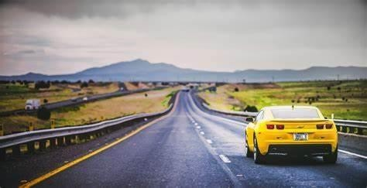

1. **Find the volume of a cylinder with a radius of 7 cm and height of 10 cm. (Use π = 3.14)** *(4 marks)*

10cm



7cm

1. Convert the decimal 0.375 to a fraction in its simplest form. *(2 marks)*

3

1. **Find the Pythagorean Theorem missing side: If a right-angled triangle has base of 9 cm and a height of 12 cm, find the hypotenuse.** *(3 marks)*

12cm

9cm

1. A shopkeeper gives a 15% discount on a Ksh. 3000 item.

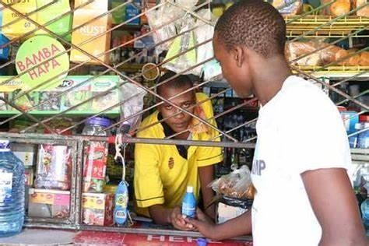

**Find the new price.** *(3 marks)*

1. **Solve: 2x + 3 ≤ 9.** *(2 marks)*
2. **Convert 25 liters into cubic centimeters.** *(2 marks)*
3. **Find the median of the numbers: 3, 7, 2, 9, 5, 8, 10.** *(3 marks)*

4

##### SERIES 8

1. Which of the following is a **perfect square**?

###### 81 B) 50 C) 99 D) 105

1. A survey showed **40% of students** like Mathematics. Express this as a fraction.
   1. 2

5

* 1. ¼ C) 4 10

###### D) 3

8

1. A school bus covers **240 km in 4 hours**. What is its average speed?
   1. 60 km/h B) 50 km/h

C) 80 km/h D) 100 km/h

1. The mode of **3, 5, 7, 5, 3, 5, 6, 5** is:

###### 5 B) 3 C) 7 D) 6

1. A trader made a **loss of 20%**. What was the selling price of an item bought at **Ksh. 2,500**?
   1. Ksh. 2,000 B) Ksh. 2,800

C) Ksh. 3,000 D) Ksh. 1,800

1. James scored **72 marks** out of **80** in a test. What percentage did he score?

###### 80% B) 85% C) 90% D) 95%

1. A bus travels **300 km in 5 hours**. What is its average speed?
   1. 50 km/h B) 60 km/h

C) 70 km/h D) 40 km/h

1. A quadrilateral has three angles measuring **85°, 95°, and 80°**. What is the fourth angle?

###### 100° B) 90° C) 105° B) 85°

1. Solve **6 × (4 + 2) - 8 ÷ 2**
   1. 28
   2. 30
   3. 32
   4. 34
2. Round **246,789** to the nearest thousand.

###### 246,700 B) 246,800

C) 247,000 D) 246,000

1. The perimeter of a square is **48 cm**. What is its area?
   1. 144 cm² B) 120 cm² C) 100 cm² D) 225 cm²
2. A cuboid has a length of **10 cm**, a width of **5 cm**, and a height of **8 cm**. What is its volume?
   1. 400 cm³ B) 450 cm³

C) 500 cm³ D) 600 cm³

1. Estimate the sum of **1,999 + 3,002** by rounding to the nearest hundred.

###### 4,900 B) 5,000

C) 5,100 D) 5,200

1. If the temperature in Nairobi is **30°C**, what is it in **Kelvin**? (K = °C + 273)

###### 273 K B) 293 K

C) 303 K D) 333 K

1. Evaluate **(8 + 4 ÷ 2) × 5**

###### 60 B) 50 C) 40 D) 30

1. If the mean of **5, 7, 9, x, 11** is **8**, find **x**.

###### 8 B) 9 C) 10 D) 7

1. Solve **2x + 3 = 11**

###### 4 B) 5 C) 6 D) 7

1. What is **0.007 + 0.06 + 0.4**?

###### 0.467 B) 0.507

C) 0.47 D) 0.503

1. Find the **LCM** of **8 and 12**.

###### 12 B) 16 C) 24 D) 32

1. A clock shows **3:45 PM**. What is this time in **24-hour format**?
   1. 15:45
   2. 14:45
   3. 16:45
   4. 13:45

SECTION B: ANSWER ALL QUESTIONS

1. What Is the difference of the total value of digit 8 and the total value of digit 6 in the number (2mks)

2108963

1. Munga converted 1529g into kilograms. What will be the place value of digit 9? **(2mks)**
2. During a fundraising, a total of Ksh.1,263,096 was collected. Round off the amount to the nearest million.

(2mks)

1. The area of a square is equal to the area of a rectangle. The rectangle measures 36cm by 16cm. what is the length of the square? **(2mks)**
2. What is the product of prime numbers between 20 and 30? **(2mks)**
3. Find the next number in the pattern below. (2mks) 400, 484, 576, 676,
4. A number that is divisible by 6 is also divisible by (1mk)
5. Simplify the following expression. (2mks) 2(3x - 2y) + 4(x + y)
6. Findc

2a+b if a=3, b=6 and c= a+1 (2mks)

1. Solve the equations. **(1mk)**

a.) 1 x -3 = 2

3

b.) 5(𝑥 − 3) = 4(𝑥 − 1) **(2mks)**

1. What is the value of:

3 1

5 + 3

4 1 2

𝑜𝑓 ( − ) ÷ 

7 5 3

1. The area of the right-angled triangle drawn below is 30cm2. What is its perimeter if the base is 12cm

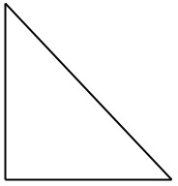(2mks)

1. Peter bought 5TV sets at a price of Ksh.16,250 each. During transportation, one TV set cracked. He sold the remaining at a total of Ksh.90,000. Calculate his percentage profit. **(2mks)**
2. A flag post has a length of 3,568 metres. What is the length of 14 such posts.**(2mks)**
3. Express 1296 as a product of its prime factors. **(2mks)**
4. A piece of ribbon measuring 4.57 metres long was cuts into smaller pieces of length 0.35 metres. how many pieces were cut? **(2mks)**
5. Arrange the fractions below in descending order. **(2mks)**

2/9, ¼, 7/8, 11/16

1. Covert 13/10 as a decimal.**(2mks)**
2. An SGR train departed from Nairobi to Mombasa at 15oohrs. It reached Mombasa at 9.00 p.m. How many hours did it take? **(2mks)**
3. The triangle below is a right angled. Calculate the value of x. **(2mks)**

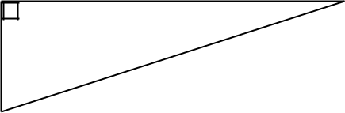

3x + 300

SERIES 9

**SECTION A: (**20 MARKS) ANSWER ALL QUESTIONS

1. Section I (Multiple choice questions) A teacher wrote the work below on a card and showed to her class. Calculate the answer in the following task:
   1. 384
   2. 1100
   3. 380
   4. 95
2. Common factors are factors that can divide both numbers. What are the common factors of 24 and 36?
   1. 24, 36 and 1
   2. 1, 2, 3, 4, 6 and 12
   3. 2, 3, 4 and 6
   4. 1, 2, 3, 4, 6 and 12 and 18
3. Given a fraction to add, find the solution of the following addition; 5 1/4 + 5 2/5 =
   1. 10 3/20
   2. 10 5/20
   3. 10 13/20
   4. 10 15/20
4. What do you get when you subtract the sum of 382.43 and 45.49 from 513.99?
   1. 45.49
   2. 850.6
   3. 176.72
   4. 85.74
5. A square board has an area of 144 square units. How long is each side of the board?
   1. 11 units
   2. 12 units
   3. 13 units
   4. 14 units
6. The ratio between the number of Anita's cousins and the number of John's cousins is 5:8. If Anita has 15 cousins, how many cousins does John has?
   1. 5
   2. 8
   3. 24
   4. 40
7. If 24 learners took an exam and 4 of them failed. What percentage of them have passed the exam?
   1. 0.8
   2. 0.84
   3. 0.85
   4. None
8. What is the volume of a rectangular box whose length, breadth and height is 2p, 4p and 8r respectively is?
   1. 14pqr

B. 2p + 4q + 8r

1. 64pqr
2. 64
3. Which one of the following best desribes the solutions to the inequality show below? 3l – 6 ≥ 8
   1. l ≥
   2. l ≥ 2
   3. l ≥ 1
   4. 3l ≥ 14
4. 2x + 9 = 20
   1. x = 14
   2. x = 8
   3. x = 6
   4. x = 10
5. 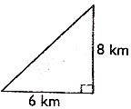A ship sails 6 km East and then 8 km north. Find the ship's distance from it's starting point.
   1. 14 km
   2. 10 km
   3. 29 km
   4. 2 km
6. What is the length of the pair of scissors below?

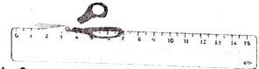

* 1. 9 cm
  2. 7 m
  3. 8 cm
  4. 7 cm

1. The following figure is a parallelogram. Find it's area in m²?

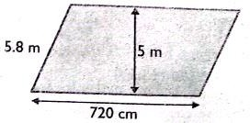

* 1. 36 m²
  2. 41.76 m²
  3. 29 m²
  4. 3 600 m²

1. 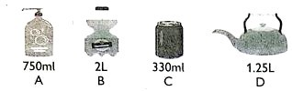Compare the volume of liquid in the containers below and write them in an increasing order:
   1. D,B,C,A
   2. C,A,B,D
   3. C,A,D,B
   4. A,B,C,D
2. A helicopter flies 18 km in 20 minutes. Calculate the average speed in km/h.
   1. 0.9 km/hr

B. 1.1 km/hr

1. 90 km/hr
2. 54 km/hr
3. Find the radius of the circle if area of sector is 924 cm² and angle at the center is 60°
   1. 42
   2. 21
   3. 22
   4. 46
4. A bottle of cola costs sh 35.50 and a bag of crisps costs sh 70.50. Lamia buys 3 bottles of cola and 5 bags of crisps. She pays with a sh 500 note. Calculate the balance Lamia got.
   1. Sh 459
   2. Sh 31.50
   3. Sh 41.50
   4. Sh 41
5. Triangle ABC below is an isosceles triangle. Angle ABC is 32°. And AB = AC. Find angle BAC

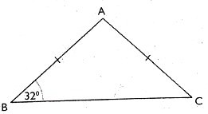

* 1. 116°
  2. 32°
  3. 158°
  4. 164°

1. Construct traingle ABC, with AB is 6 cm angle BAC is 60° and angle ABC is 45°. Measure the

distance AC.

* 1. 4.2 cm
  2. 4.4 cm
  3. 4.0 cm
  4. 4.5 cm

1. Jayden play in a golf tournament. Find his average score for the four rounds if his scores were 72, 66, 70 and 68.
   1. 276
   2. 92
   3. 1
   4. 69

SECTION B

1. Given the following activities in integers, find their solutions showing the correct:
2. (– 9) + (– 4) – (– 3) = (1 mark)
3. (– 6) x (– 3) = (1 mark)
4. The restaurant sells 142.46 litres of milk on Sunday and 17.23 litres more than this amount on Monday. The following day, 18.81 litres less milk than on Monday were sold. How many litres of milk did they sell on Tuesday? (2mks)
5. One face of a cube has an area of 225 m². What is the volume of the cube? (2mks)
6. Given an index below to express in logarithm form, show the way. 5³ = 125 (2mks)
7. 5 photocopiers can produce 90, 000 copies in 6 hours a day. How many photocopiers will be required to produce 168, 000 copies working 8 hours a day? (2mks)
8. A group of students are making posters to advertise for a bake sale. 12 large signs and 60 small signs are needed. It takes 10 minutes to paint a small sign and 30 minutes to paint a large sign. How many students will be needed to paint all of the signs in 2 hours or less? (2mks)
9. Use square and square roots table to solve the following: 4.56² – √30.4
10. Andrew has ³/₄ of a candy bar left. He gives ¹/₂ of the remaining bit of the candy bar to his sister. What fraction of the whole candy bar does Andrew have left now? (2 mks)
11. Simplify each of the following algebraic expressions:
12. (4x²y³ – 2x) – (2x + 2x²y³) (2mks)
13. (–2 – 2u³) – (– 5u³ + 5) (2mks)
14. (–3+3x) – (–7x+2) (2mks)
15. a) Solve the linear inequalities below and represent the answer on a number line. – 7≤ 2x + 3 ≤ 15. (3mks)

b) The sum of two brother's ages is less than 28 years. Represent the statement above in a linear inequality (2mks)

1. a) The cost to rent a video game is $2 plus $0.50 per day. The cost to rent a video game at TeeVee rentals is $1 plus $0.75 per day After hour many days will the cost of renting a video game at Action video will be the same as the cost of renting a video game at TeeVee rentals? (3mks)

b) The sum of father's age and twice the age of his son is 70. If we double the age of the father, and add it to the age of his son the sum is 95. Find their present ages? (2mks)

1. Alex and Sam start from the same point. Alex walks 400 meters west. Sam walks x meters south, until they are 600 m apart from each other. How far does Sam walk? (2 mks)

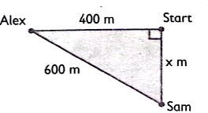

1. 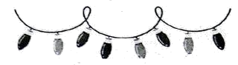Mr. Green was hanging Christmas lights. On strand of light was 2 m long. A second strand of light was 120 cm long. If Mr. Green strung the lights from end to end, how many centimeters did both strand span? (3 mks)
2. The radius of a circle is 3.5 cm. Work out the area of the circle. Give your answer correct to 3 significant figures. (3mks)
3. Jesse throws a ball that moves at an average speed of 35 meters per second and travels for a total of 4.5 seconds. Work out the distance travelled by the ball. (2mks)
4. The circle is 21 cm and the angle subtending the arc is 60°. The arc is the angle substending. Find the area of the sector. (3mks)

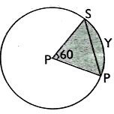

1. Jonathan went to America. He exchanged *£* 750 into American dollars. The exchange rate was *£*1 = $ 1.23
2. Exchange £ 750 into American dollars. Give your answer to the nearest 10 dollars.
3. Jonathan brings $ 147 back home. Exchange $ 147 into UK pounds. Give your answer correct to the nearest pence.
4. a. Given the triangle PQE, calculate the size of angle Q. (2 mks)

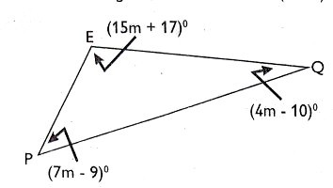

b. Work out the value of angles marked with letters. (6 marks)

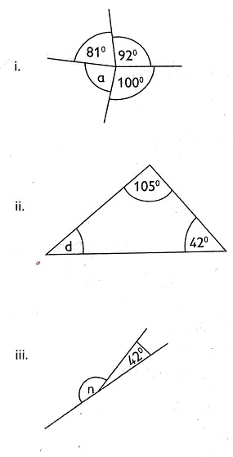

1. a. Construct a triangle ABC in which a = 4 c, b = 5 cm, c = 6 cm (3 mks)

b. Construct a square ABCD with diagonal AC = e = 12 cm

c. Measure the angles in triangle ABC in (a) and (b) (2 mks)

1. a. Given a grouped data in the table below. Study the table and answer the questions.

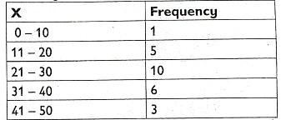

1. Find the mean (3 mks)
2. Determine the mode (2 mks)
3. What is the median? (2 mks)

b. A jar contains 3 red, 4 blue and 5 green marbles. What is the probability of randomly drawing a;

1. Red marble? (2 mks)
2. Blue marble (2 mks)
3. Green marble (2 mks)

## SERIES 10

**SECTION A (40 MARKS)**

1. What is the place value of digit 7 in the number 7,364,215?
   1. Thousands
   2. Millions
   3. Hundred thousands
   4. Ten thousands
2. A farmer harvested 5,472,619 maize cobs. Express this number in words.
   1. Five million, four thousand, seven hundred and twenty-six hundred nineteen
   2. Five million, four hundred seventy-two thousand, six hundred nineteen
   3. Five billion, four hundred seventy-two thousand, six hundred nineteen
   4. Five hundred million, four hundred seventy-two thousand, six hundred nineteen
3. A school bus traveled 894,563 kilometers. Round off this number to the nearest hundred thousand.
   1. 800,000
   2. 890,000
   3. 900,000
   4. 1,000,000
4. Which of the following is an odd number?
   1. 246
   2. 1342
   3. 573
   4. 800
5. James and Peter visit the market every 6 and 8 days, respectively. After how many days will they meet again at the market?
   1. 12
   2. 24
   3. 48
   4. 6
6. The reciprocal of 3/5 is:
   1. 5/3
   2. 3/5
   3. 3
   4. 1/5
7. Solve using BODMAS: ½ of 16 ÷ 4 × 5 (9 - 4) + 4 - 5
   1. 49
   2. 57
   3. 12
   4. 18
8. A square table has sides measuring 12 cm. Find the area.
   1. 120
   2. 144
   3. 36
   4. 24
9. Which of the following is a prime number?
   1. 9
   2. 11
   3. 21
   4. 15
10. A fruit vendor had 249 oranges. Which of the following numbers is divisible by 3?
    1. 124
    2. 249
    3. 452
    4. 650
11. A baker uses 2 eggs per cake. If he bakes 5 cakes, how many eggs does he use in total?
    1. 20
    2. 10
    3. 5
    4. 15
12. A class has 24 girls and 36 boys. Find the greatest common divisor (GCD) of these numbers.
    1. 6
    2. 12
    3. 24
    4. 36
13. Convert 1200 cm to meters.
    1. 1.2 m
    2. 12 m
    3. 120 m
    4. 0.12 m
14. A ladder is placed against a wall. If the base is 9m away from the wall and the ladder is 12m long, find the height it reaches.
    1. 15 m
    2. 16 m
    3. 18 m
    4. 20 m
15. The square root of 81 is:
    1. 7
    2. 8
    3. 9
    4. 10

## SECTION B (60 MARKS)

1. Convert 3.5 kilometers to meters. (2 marks)
2. A farmer had 450 mangoes. He sold 2 of them. How many mangoes did he sell? (3

5

marks)

1. Multiply: (3) × (10). (2 marks)

5 6

1. A student spent 2 of his money on books and 3 on a bag. What fraction of his money

5 10

is left? (3 marks)

1. A number is divisible by both 2 and 5. What is the smallest possible number that satisfies this condition? (2 marks)
2. Expand and simplify: 2(3x + 4) - (x - 2). (3 marks)
3. Solve the inequality: 3x + 5 < 14. (2 marks)
4. Find the square root of 196. (2 marks)
5. A school compound has a rectangular garden with a perimeter of 48 cm. If the width is 10 cm, find its length. (3 marks)
6. A right-angled triangle has one leg of 8 cm and a hypotenuse of 10 cm. Find the other leg. (3 marks)
7. A tailor has 36 meters of cloth. If she cuts equal pieces of 4 meters each, how many pieces does she get? (3 marks)
8. A family consumes 120 liters of water daily. How much water is used in 7 days? (3 marks)
9. A car travels at 80 km/h. How far does it travel in 3.5 hours? (3 marks)
10. The price of a shirt is Ksh. 850. A customer buys 3 shirts and gets a discount of 10%. How much does he pay in total? (3 marks)
11. A tank holds 5000 liters of water. If a household uses 250 liters per day, how many days will the water last? (3 marks)

SERIES 11

Section A: (20 marks)

(Each question carries 2 marks.)

1. Simplify: 3x+5x−2
   1. 8x−28x
   2. 8x+28x
   3. 2x−22x
   4. 6x−26x
2. Evaluate 12÷3+4×2
   1. 14
   2. 8
   3. 11
   4. 16
3. Solve for xxx: 4x−3=9
   1. x=3x
   2. x=4x
   3. x=2x
   4. x=6x
4. Convert 0.75 to a fraction in its simplest form.
   1. ¾
   2. 75/100
   3. ¼
   4. 3/5
5. Find the area of a triangle with base 10 cm and height 6 cm.
   1. 30 cm²
   2. 60 cm²
   3. 16 cm²
   4. 36 cm²

Section B: (40 marks)

(Each question carries 4 marks.)

1. Factorize completely: x2−9
2. A shopkeeper sold a shirt for Ksh 1,500, making a profit of 25%. Find the cost price of the shirt.
3. Simplify: ¾ + 2

3

1. Solve for x in the equation: 3(x+2)=12
2. Calculate the perimeter of a rectangle whose length is 12 cm and width is 8 cm.

Section C: (40 marks)

(Each question carries 10 marks.)

1. A student scored the following marks in five subjects: 68, 75, 82, 90, and 65. Calculate:
2. The mean score.
3. The range of the scores.
4. The diagram below shows a trapezium with parallel sides measuring 8 cm and 12 cm, and a height of 6 cm. Calculate its area.
5. A car travels 240 km in 3 hours. Calculate:
6. The average speed of the car.
7. How long it would take to travel 400 km at the same speed
8. The sum of the interior angles of a polygon is 1,440∘
9. How many sides does the polygon have?
10. What is the measure of one interior angle if the polygon is regular?

SERIES 13

SECTION I (40 marks)

Instruction: Answer all questions in this section.

1. (a) Work out the following using the number line. (1 mark) –4– (– 2)+6



-10-9-8 -7-6 -5-4-3 -2-1 0 1 2 3 4 5 6 7 8 9 10

(b) An elevator is on the fourteenth floor. It goes down 11 floors and then up 5 floors. Use a number line to determine the floor on which the elevator will end up. (1 mark)

1. Evaluate: (3 marks)

1 + 1

2 3

1

+

1 of ( 2 _ 1 ) 2

7 5 6

1. A foreign government donated Ksh. 38 million for the construction of a highway bridge while the Kenyan Government contributed Ksh 15 million towards the same project. Of the total amount, Ksh. 10 800 000 was used to pay the contractors, Ksh. 17 000 200 for the purchase of materials and Ksh. 7 200 000 for the acquisition of machinery. How much money remained unused?

(Express your answer in words). (3 marks)

**. .**

1. Express **0.215** as a fraction.

(3 marks)

1. Use tables to evaluate:
   1. 0.50362 (3 marks)
   2. 573.1 (3 marks)



1. A firm pays Sh 9 800 every week in wages. If the number of hours worked is decreased from 40 to 38 and the hourly rate of pay is increased by Sh 5 from Sh 35, find the new weekly total wages of an

employee. (3 marks)

1. Rudisha ran 800 m in a race in 1 minute 20 seconds. What was Rudisha’s speed in m/s? (3 marks)
2. In the figure below, lines ***J*** and ***K*** are parallel. Line ***T*** intersect the lines ***J*** and ***K*** at P and Q, respectively. Determine the sum 2a + b. (3 marks)

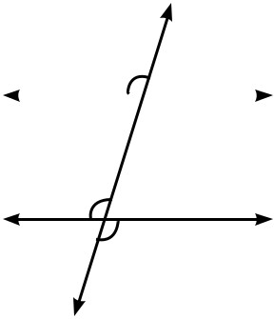

T

J a P

K 1320 Q

b

1. 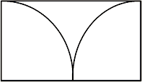The perimeter of the rectangle enclosing the two equal quarter circles below is 84 cm. Determine the radius of the two equal quarter circles, which touch at X. (3 marks)

r cm r cm

X

1. Mary and Tom shared some oranges in the ratio 4:5 respectively. Tom received 3 more oranges than Mary. How many oranges did Mary get? (3 marks)
2. The cost of 3 rulers and 2 erasers is Ksh 144. If 4 rulers and an eraser cost Ksh 152, work out the cost of two erasers and a ruler. (4 marks)
3. An electric pole is supported to stand vertically by a tight wire as shown below. Determine the height of the pole above the ground. (4 marks)

1

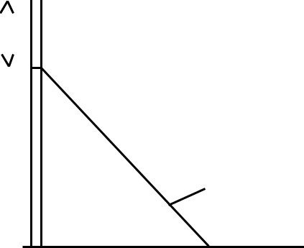

m

10 m

Wire

6 m

**SECTION II (30 marks)**

Instruction: Answer any THREE questions in this section.

13.(a) Wangeci formed a number **m** by writing all the prime numbers between 0 and 10 in ascending order. Kiptoo formed another number **n** by writing all the perfect squares between 0 and 10 in a descending order.

1. Determine m – n (2 marks)
2. Express (m – n) as a product of its prime numbers. (1 mark)
3. Evlaute: (4 marks)

# 1 2 3 1

2 + of 3 ‒ 4

5 3 4 6

1. Mwaruwa is paid sh 20 000 as wages after working for 25 days. How much money would he be paid if he does not work for 4 days? (3 marks)

14.(a) The price of a radio increased by 20% from Ksh 3,000. Calculate:

* 1. the new buying price. (2 marks)
  2. the percentage profit if the buying price was Ksh 2,500. (3 marks)

1. The family of Jamal stays in a rented house. At the end of every month, they pay Ksh. 15,000 as rent. They also use 50 units of electricity tokens in a month which costs Ksh. 30 per token. They consume 5 units of water per month, which they pay Ksh. 120 per unit. They also pay Ksh 300 per month for garbage collection services.
   1. Calculate the amount of money they spend on electricity and water. (3 marks)
   2. How much does Jamal’s family spend to clear all the bills in a month? (2 marks)
2. The following are some of the ages, in years, of learners in a given school.

11, 11, 12, 13, 14, 15, 15, 15, 17, 16, 16, 17, 18, 18, 13, 15, 15, 18, 13, 12, 17, 17, 11.

1. Represent this data in a frequency distribution table. (5 marks)
2. Represent the information in (a) above in a bar graph. (5 marks)

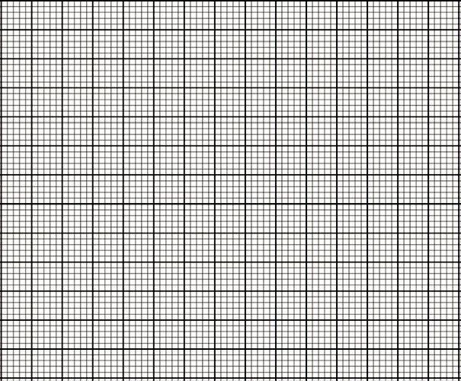

1. 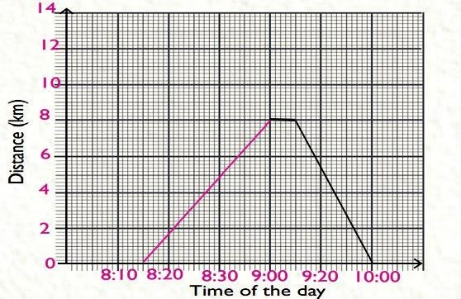Yvonne cycled from her home to a friend’s house. She stayed for some time and then travelled back home. The travel graph below summarises Yvonne's jouney.
2. At what time did Yvonne leave her home? (1 mark)
3. How far is the friend’s home from Yvonne’s? (1 mark)
4. How long did it take her to reach her friend’s home? (2 marks)
5. How long did she take at the friend’s home? (2 marks)
6. Calculate the total distance she covered. (2 marks)
7. Calculate the total time taken for the whole journey. (2 marks)

SERIES 14

SECTION I (40 marks)

Instruction: Answer all questions in this section.

1. Miwani Enterprises borrowed Ksh 50 000 000 to fund a mega project. They paid back Ksh 15 000 000 in the first month, Ksh 10 500 000 in the second month and Ksh 8 500 000 in the third month. They paid

the balance in equal amounts for two months. How much did they pay in each month? (3 marks)

1. Determine the smallest number, which when put in the box in the number below, will make it divisible by 11. (3 marks)

86  72

1. Four wooden poles are of lengths 280 cm, 336 cm and 420 cm. The owner wishes to cut them into shorter pieces of equal length. Determine the greatest possible length of each piece if no wood is left over. (3 marks)
2. All prime numbers less than ten are arranged in descending order to form a number.
   1. Write down the number formed. (1 mark)
   2. State the total value of the second digit in the number in (a) above. (1 mark)
   3. Test if the number in (a) is divisible by 4. (1 mark)
3. A water tank is 3 full. After adding 52 litres, it is 4 full. What is its total capacity? (3 marks)

7 5

1. A rectangular flower garden measures 38.47 m by 15.75 m. Calculate the total distance round the flower garden. (3 marks)
2. The length of a square room is 1 1 m. Determine the area of the room. (3 marks)

4

*(Leave your answer in fraction form)*.

1. Evaluate: (3 marks)



0.0016

1. There are ***p*** learners in a Grade 7 class. During a tree planting day, each learner planted 3 trees. The total number of trees planted was less than or equal to 400. Write an inequality to represent this information.

(2 marks)

1. The figure below is composed of two shapes. Determine its area. (3 marks)

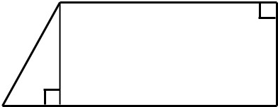14 cm

7 cm

18 cm

1. Joy’s dad bought a rectangular jerrycan measuring 50 cm by 60 cm by 80 cm. Joy filled the jerrican with water. How many litres of water are in the jerrican? (3 marks)
2. A *mama mboga* bought 125 tomatoes at Ksh 5 each. If she sold each tomato at Ksh 10, how much profit did she make? (3 marks)
3. Determine the size of the largest angle in the diagram below. (3 marks)

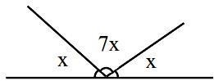

**SECTION II (30 marks)**

This section consists of 4 questions.

Instruction: Answer any THREE questions in the spaces provided.

1. (a) A retailer packed 178 kg of fat into 128 packets of 1 kg each and the rest into 1 kg packets. Determine: 4 2
2. How many 1 kg packets of cooking fat he obtained. (2 marks)

2

1. The total number of packets obtained. (2 marks)

# 1 1 2

(b) What is the fifth term in the following sequence? (3 marks) 3, 2, 3,…

1. A strip of metal was painted in three different colours. Two fifths of the strip was painted white, 1 of

the strip was painted green and the remaining part was painted black. 8

* 1. What fraction of the strip was painted black? (1 mark)
  2. Write in order, the fractions of the strip painted from the smallest to the largest. (2 marks)

1. (a) A classroom was being constructed in a school. A worker at the construction site transported 4 tonnes of sand using a wheelbarrow. The wheelbarrow was used to carry 80 kg of sand on each trip.
2. What was the mass of sand in the construction site in kilograms? (2 marks)
3. The worker made 29 trips on the first day. How many kilograms of sand did the worker

transport on that day? (2 marks)

1. How many trips were made by the worker to transport all the sand? (2 marks)

(b) The following is a price list in a shop:

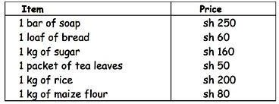

Adelle bought the following items from the shop:

*2 loaves of bread 1 kg of sugar*

*3 kg of rice*

*2 packets of tea leaves*

Adelle gave the shopkeeper a sh 1000 note for the items. How much money did she receive as

balance? (4 marks)

1. 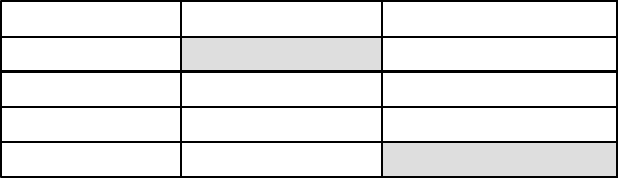Below is a travel timetable for a vehicle operating between towns A and D, 70 kilometres apart:

|  |  |  |
| --- | --- | --- |
| Town | Arrival | Departure |
| A |  | 8.20 a.m |
| B | 10.40 p.m | 11.00 a.m |
| C | 2.30 p.m | 2.50 p.m |
| D | 4.00 p.m |  |

1. At what time does the vehicle leave town A? (1 mark)
2. At what time does it arrive in town D? (1 mark)
3. How long does it take to travel from town B to C? (2 marks)
4. What time does the vehicle take to travel from C to D? (3 marks)
5. How long does it take to travel from town A to D? (3 marks)
6. (a) Using a pair of compass and ruler only, construct triangle ABC such that angle ABC = 90 0, BC = 4 cm and AB = 3 cm. What is the measure of AC? (5 marks)

b) Using a pair of compass and ruler only, construct triangle PQR such that angle PQ = QR = RP = 6 cm. What is the measure of angle PQR? (5 marks)

SERIES 15

Answer all the following questions.

1. Add one thousand and forty-four to the product of one thousand and six and one hundred (3mks)
2. Benazir’s home is 0.25 km from the church. Express the distance to 1 significant figure. (1mk)
3. Express the following in standard form.

(a) 0.0039 (2mks) (b) 89 (2mks)



1. Grade 8 learners sold their agricultural produce for Ksh. 1200.They used 1\3 of the money to buy crop

1

seeds, 4 to buy organic manure and saved the rest.

* 1. What fraction represents savings? (1mks)
  2. How much money did they save? (2mks)

1. Evaluate; -8 ÷ 2 + 12 x 9 - 4 x 6 + 56 ÷ 7 x 2 (2mks)
2. Work out the following operation on a number line.

(-7) + (-2) + (+6) (1mk)

2

1. Clare mixed 5

1 kg of maize and 3

kg of beans to prepare Githeri. She served the githeri equally

11

among her family members. If each family member got 30kg of githeri. How many family members were served? (3mks)

1. 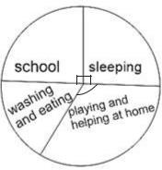Ngetich spent his day as shown in the pie chart below. Use it to answer the questions below.

( ) What fraction of the day did he spend on washing and eating? (1mk)

* 1. How many hours are there in one day? (1mk)
  2. How many hours did he spend at school? (1mk)

1. At 8:00 am on Tuesday, the temperature was 283 kelvin. At midday, the temperature was 297 kelvin. By how many degrees did the temperature rise? (2mks)
2. Mumo bought onions at sh. 50 per kg. He then sold them at sh.60 per kg. What was the percentage
   1. What is the width of the field? (1mk)
   2. What is the area of the field in hectares? (2mks)
3. A school has a field in the shape of a trapezium. The area of the field is 6300m2. The lengths of parallel sides are 48m and 120m. What is the perpendicular distance between the two parallel sides?

(3mks)

1

1. Pauline is a business person. She bought 5kg of sugar and packed them into 4 kg packets for sale.

1

* 1. Work out the reciprocal of 4 (1mk)

1

* 1. How many 4 kg packets did she get for sale? (2mks)

1. Muthoni is 1.512m tall while Waithera is 1.625m tall. What is the total value of digit 1 in the sum of their heights? (2mks)
2. A road construction company was laying 0.825km of tarmac daily. How many km of tarmac did they lay in 45 days? (2mks)

1

1. Paul was discussing the use of squares of fractions with his daughter. Eva Paul wanted to divide 4 kg

1

of salt into 4 equal packets. Eva convinced him to work out the square of 4 to get the mass of the packets.

1

* 1. Find the square of 4 . (1mk)

1

* 1. Write how to work out 4 ÷ 4 using reciprocal. (2 mks)

1. Muchiri is two years older than Amokoh, Muchiri’s age is represented by x years. Form an expression to show:
   1. Amokoh’s age. (1mk)
   2. The sum of their ages. (2mks)
2. A number is multiplied by 6 and when 8 is added to the result, the answer is 56. What is the number?

(3mks)

1. Represent the following on a number line 3 > x < 7 ( 1mk)
2. Convert 0.05 hectares into cm2. ( 1mks)
3. Abdy’s piece of land takes the shape of a rhombus. The measurement of its base length and perpendicular height is 250m and 180m respectively. Find the area of the land in

(a) m2 (b)Ares (c) Hectares

1. Grade 7 learners had strings of measurements; 6cm, 12cm and 18cm. What is the sum of the GCD and LCM of 6, 12 and 18? (3mks)
2. A school has 80 classrooms. Express the number of classrooms as a product of its prime factors using a factor tree. (2mks)
3. Find the area of the figure below. (2mks)

20m

32m

1. Name the type of angle shown below. (1mk)

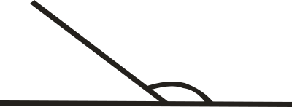

1. Helen scored 25% in a test. What is 25% written as a fraction in its simplest form? (1mk)
2. What is the volume of the cuboid below? (2mks)

4m

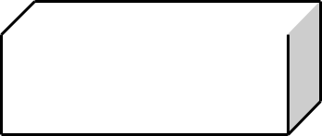

5m

10m

1. The interior angles of a triangle are as shown below.

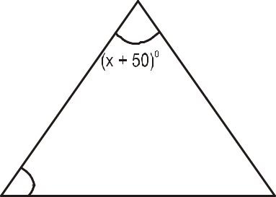

(x + 25)0

(2x - 10)0

Find the value of x. (2mks)

1. 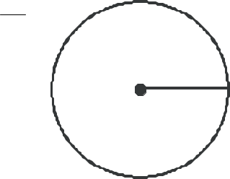Find the area of the circle shown below. (2mks) (Take π = 227 )

14cm

1. Convert 72000m2 into hectares. (2mks

SERIES 16

**Answer all the following questions**

1. The population of a country was 36289374 five years ago. (2mks)
   1. Determine the place value of digit 6 in the population.
   2. What is the total value of digit 8 in the number 36289374?
2. 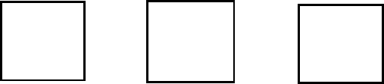Mary, Hellen and Maxwell took turns to arrange the fraction cards below in an increasing order and a decreasing order respectively.

|  |  |  |  |  |  |  |
| --- | --- | --- | --- | --- | --- | --- |
| 7 |  | 9 |  | 11 |  | 23 |
| 8 |  | 16 |  | 12 |  | 24 |

* 1. Write how they should arrange them in an increasing order.(2mks)
  2. Write how they should arrange them in a decreasing order.(2mks)

1. Kiprono bought type A and type B fertiliser while planting maize. The mass of type A fertiliser was 69 tonnes 678 kg and that of type B fertiliser was 78 tonnes 5 kg. What was the total mass of the fertiliser? (1mk)
2. Gladwell and Janet played a game of picking cards with numbers that are divisible by 11. They had the cards below for the game. (2mks)



3743

33545

64573

22891

Which cards should they pick? (Give a reason)

............................................................................................................................................................

1. 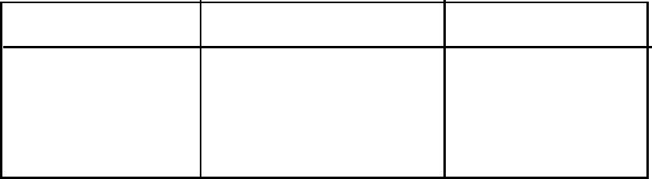The travel time of a delivery van is shown below.

|  |  |  |
| --- | --- | --- |
| Town | Arrival | Departure |
| Kigofi |  | 0850 h |
| Lodwar  Matopeni | 1220 h  1700 h | 1250 h |

How long does the whole journey take? (2mk)

1. A teacher bought k apples for her students. The fruit seller gave her 6 more apples and now she had more than 100 apples. Form an inequality to represent the information. (2mks)
2. Find the smallest number which on adding 12 to it, it becomes divisible by 5, 20 and 36. (2mks)



1. Mwasiah received 5 3 ha of piece of land as inheritance from his father. He divided it into 3 equal parts; one part for planting trees, another one for planting maize and the other part to build some rental houses. Work out the fraction allocation for each part. (2mks)

4



1. A square tile measures 2 5 m. What is the area of the tile? (1mk)
2. What is the sum of all prime numbers between 20 and 45? (1mk)
3. A certain town has a population of 56 056. If the number of people increases by 1000 every year, work out the population in the next 4 years. (2 marks)
4. Nzioka bought a necklace at Ksh 2000 and later sold it at ksh 2500. What was her profit? (1mk)
5. Work out; (2mks)

23 - (6 x 5) + 40 ÷ 2

1



1. The length of a piece of cloth is 2 2 m. What is the length expressed as a decimal? (1mk)
2. Thome had a circular wire with a radius of 350cm. Work out the circumference of the wire.

(Give your answer in metres) (2mks)

3 1



1. Wangeci sold 2 5 kg of melons in the morning and 6 2 kg in the afternoon. How many kilograms did she sell altogether? (1mk)
2. 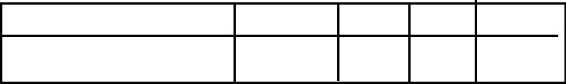The table below represents the number of domestic animals in Kemunto’s farm.

|  |  |  |  |
| --- | --- | --- | --- |
| Type of animal | Cows dogs | hens | Sheep |
| Number of animals | 5 2 | 8 | 12 |



1. Find the reciprocal of 3 2 . (1mk)
2. Five Grade 7 learners had 5 ropes of lengths 91cm, 35cm, 29cm, 66cm and 73cm. Circle the odd lengths of the ropes. (1mk)
3. The diagram below represents one side of a roof. Find the size of the angle marked a. (1mk)

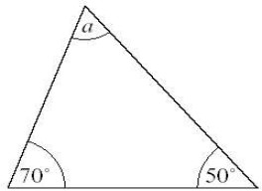

1. Work out the area of the shape below. (3mks)

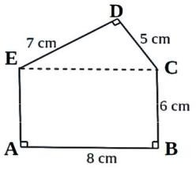

1. The top of a square table has a side of 28cm.The top of the table is divided along a diagonal. One part is painted yellow and the other one grey. Find the area of the part painted grey. (1mk)
2. Shantel had a piece of cloth measuring 160cm 5mm. He later divided it into 3 equal parts. What was the measurement for each part? (2mks)
3. A soap industry produces 34521 bags of soap in a month. How many such bags of soap can they produce in 6 months ?(1mk)
4. Share 3004 mangoes among 9 friends. (2mks)
5. Draw line XY whose length is 10cm. Construct a perpendicular line to cut line XY at point T. (2mks)
6. Find the divisors of 36 and 48 using factor rainbows. (4mks)
7. The number of fruits that were unripe in the market were 2%. Write the percentage of the unripe fruits as a decimal. (1mk)
8. Wambora had 568.9 grams of wheat and 67.98 grams of sunflower flour. He mixed them and

prepared a paste for animal use. What was the total mass of the mixture? (1mk)

## SERIES 17 SECTION A

### What is the place value of digit 7 in the number 7,364,215?

* 1. Thousands
  2. Millions
  3. Hundred thousands
  4. Ten thousands

### Express 5,472,619 in words.

* 1. Five million, four thousand, seven hundred and twenty-six hundred nineteen
  2. Five million, four hundred seventy-two thousand, six hundred nineteen
  3. Five billion, four hundred seventy-two thousand, six hundred nineteen
  4. Five hundred million, four hundred seventy-two thousand, six hundred nineteen

### Round off 894,563 to the nearest hundred thousand.

* 1. 800,000
  2. 890,000
  3. 900,000
  4. 1,000,000

### Which of the following is an odd number?

* 1. 246
  2. 1342
  3. 573
  4. 800

### What is the least common multiple (LCM) of 6 and 8?

* 1. 12 B) 24 C) 48 D) 6

### The reciprocal 𝟑 of is:

𝟓

A) 5

3

B) 3

5

C) 3

D) 1

5

### Solve using BODMAS rule.

½ of 16÷4×5(9-4)+4-5

* 1. 49
  2. 57
  3. 12
  4. 18

### Find the square of 12.

* 1. 120
  2. 144
  3. 36
  4. 24

### Simplify .



* 1. 7
  2. 2x
  3. 3x + 7
  4. 7x

### Which of the following is a prime number?

* 1. 9 B) 11 C) 21 D) 15

### Which of the following numbers is divisible by 3?

* 1. 124 B) 249 C) 452 D) 650

### What is the sum of the first 5 even numbers?

* 1. 20 B) 30 C) 40 D) 50

### Find the greatest common divisor (GCD) of 24 and 36.

* 1. 6 B) 12 C) 24 D) 36

### A composite number is:

* 1. A number with only two factors
  2. A number with more than two factors
  3. A number that is a prime number
  4. A number divisible by 1 only

### The square root of 81 is:

* 1. 7 B) 8 C) 9 D) 10

### Simplify.



5

### right-angled triangle has sides of 9 cm and 12 cm. Find the hypotenuse.

* + 1. 15 cm
    2. 16 cm
    3. 18 cm
    4. 20 cm

### Solve for x in .

A) 5

1. 10 B) 6

C) 7

1. 7

10

1. ½
2. 4

5

### Convert 1200 cm to meters.

* 1. 1.2 m B) 12 m C) 120 m D) 0.12 m

D) 8

### Find the missing number in the sequence: 2, 4, 8, 16, , 64.

1. 24
2. 30
3. 32
4. 40

## SECTION B

1. Convert 3.5 kilometers to meters. (2 marks)
2. A shopkeeper had 450 apples. He sold 2 of them. How many apples did he sell? (3 marks

5

1. Multiply (2 marks)



1. Solve . (3 marks)
2. A number is divisible by both 2 and 5. What is the smallest possible number that satisfies this condition? (2 marks)
3. Expand and simplify . (3 marks)



1. Solve the inequality . (2 marks)



1. Find the square root of 196. (2 marks)
2. The perimeter of a rectangle is 48 cm. If its width is 10 cm, find its length. (3 marks)
3. A right-angled triangle has one leg of 8 cm and a hypotenuse of 10 cm. Find the other leg. (3 marks)

SERIES 18

1. The number of learners who joined grade 1 in the year 2023 was two million two hundred and two thousand two hundred and two. What is this number in symbols?(2mks)
2. What is the difference between the largest and the smallest numbers that can be formed using these digits 4, 7, 3, 0 and 8?(2mks)
3. A farmer subdivided his farm into equal square plots. The area of each plot was 1024m². What is the length of each plot of land?(2mks)
4. In a school, 0.45 of the learners are boys while the rest are girls. What is the percentage of the girls in the school?
5. Work out the value of: 140+90 - 30 x 24 + 6
6. What is the reciprocal of 18?
7. What is the smallest number that can be divided by 6, 16 and 28 without a remainder?(2marks)
8. A motorist covered a distance of 54.1586km. Round off the distance he covered to three decimal places.(2marks)
9. What is the sum of the prime numbers between 20 and 30?(2mks)
10. The county government of Nairobi distributed 43 bags of rice to each of the 546 schools in the county.How many bags were distributed altogether?(2mks)
11. The length of a spoon is 22cm 5mm. What is the total length of 10 such spoons in mm?(2mks)
12. Find the total area of the field drawn below in square metres (2mks)

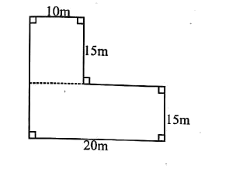

1. Find the area of the shaded part in the figure below( 2marks )

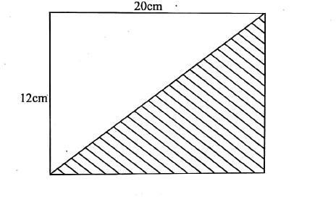

1. A butcher had 15 kilograms of meat, he sold  kilograms. How many kilograms of meat was he left with? (2marks)
2. Find the size of the angle marked **x** (2marks

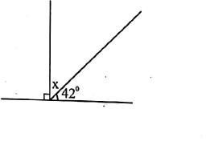

1. In the equation below,solve the value of y(2mks)



1. Ahmed sold a radio for sh. 2450. He made a loss of sh. 550. How much had he bought the radio?
2. A shop keeper had 2 tonnes of sugar. He packed the sugar into 5kg packets. How many packets did he obtain?(2mks)
3. Find the circumference of the circular field drawn below.(2marks)
4. What is 12:10am written in 24 hour clock system?(1mk)
5. Grace bought the following items from the shop:
   1. loaves of bread at sh. 65
   2. packets of milk for sh. 165 1 match box @ sh.5.

If she paid for the items using a 500 shilling note. How much balance did she get?

1. A rectangular container measures 13cm long, 10 cm wide and 14 cm high. Calculate the amount of water it can hold in cubic centimetres.(2marks)
2. A family used 45 litres of water in one week. What is the capacity of water used by the family in 3 weeks in millilitres?(2marks)
3. The diagram below shows a 3-D shape. What is the sum of its faces, vertices and edges?(3mks)

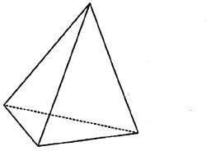

1. The graph below shows the number of learners who were present in a school in one week. (2 marks)

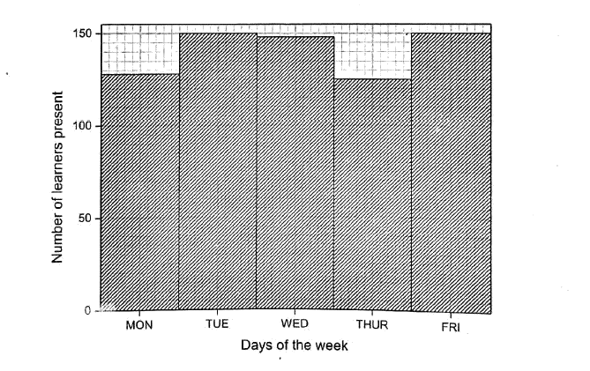

what was the total number of learners present the whole week?

SERIES 19

1. A certain county had 2 000 790 voters in the year 2017. In the year 2022, the number of voters increased by 210. What was the total number of voters in the year 2022 written in words? (2mks)

..............................................................................................................................................................

..............................................................................................................................................................

1. The number of elephants in a park was 1 768 531. What is the difference between the total values of digits 6 and 3 in the number? (2mks) ..............................................................................
2. A farmer harvested 99 708 443 bags of maize. What is the number of bags harvested to the nearest ten million? (2mks)....................................................................
3. A piece of land is in the shape of a rectangle. The perimeter of the rectangle is 64m. What is the area of the rectangle if its width is 12m? (2mks)...............................................

3

1. Juma had 75kg of sugar. He packed the sugar into 4 kg packets. If he sold each packet at sh. 150, how much money did he get from the sell of the sugar? (2mks)................................................
2. During tree planting day, a community planted 1000 trees. During a dry season, x trees dried up. The community then planted 99 more trees. Write an expression to represent the number of trees in that community. (2mks)

................................................................................................................................................

1. A fruit vendor bought y bananas. She sold 200 bananas and was left with 50 bananas. How many bananas had she bought? (2mks).................................................................

.

1. The diagram below represents a flower garden in the shape of a triangle.

C

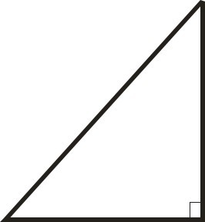

15m

B

50m

A

What is the length of the distance marked AC? (2mks).........................................

1. A vehicle took 30 seconds to reach its destination which was 1000m away.What was its speed in

Km/h? (3mks)..........................................................................................................................

1. Kiptoo ran around the track shown below 3 times. (Take π = 22 ) 

7

200m

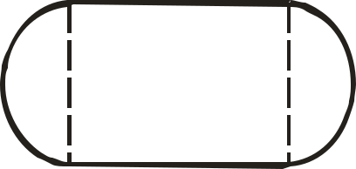

63m

What distance did he cover in km? (3.mks)...........................................

1. Jane bought the following items from a shop:
   * Two - 2kg packets of flour for Sh. 400
   * 2kg of sugar @ Sh. 200.
   * 3packets of milk @ Sh. 60.

If she paid for the items using a one thousand shilling note, what balance did she get? (3mks)

.....................................................................

13 (a) Using a ruler and a pair of compasses only, construct triangle ABC such that line BC = 7cm, line AB

= 5cm and angle ABC = 70°. (3mks)

(b) Measure the length of line AC. (2mks) ..........................................................................

1. Juma bought a TV set at sh. 18000 after being allowed a 10% discount. What was the marked price of the TV set? (1mks)................................................................................
2. Grade seven learners recorded animals in a park as follows; 15 elephants, 25 gazelles, 30 giraffes, 10 lions and 20 zebras. If they re-presented the information on a pie chart , what angle will represent the number of zebras in the park? (3mks) ....................................................................
3. The diagram below represents a triangle.

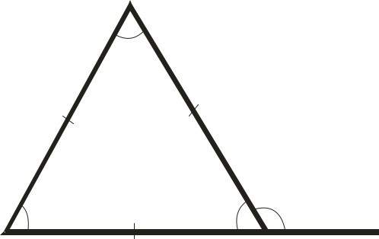

b

a

b

b

Find the value of the angle marked a. (3mks).............................................................

1. The number of blue balls in a basket is such that they are greater than 9 but less than or equal to 12.
   1. Write a compound inequality to represent this information. (2mks)

..............................................................................................................

* 1. Represent the inequality in a number line. (1mks)

...........................................................................................................

1. A tank that measures 40m long and 30m wide contains 48 000 litres of water. What is the height of the tank in metres? (3mks).............................................................................

.

1. The diagram below represent a cylindrical piece of wood of a diameter 14m and a length of 10m made by Grade 8 pupils during artwork. The pupils split the wood into half as shown below.

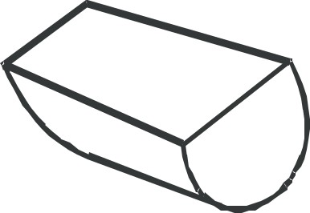

1

0

m

m 4

1

(Take π = 227 )

What was total surface area of the wood made? (3mk).....................................................................

1. A community was given 18 sheep, 12 cows and 36 goats by an Agricultural Cooperative. Find the least number of the community members that could share the animals equally. (3mks)

........................................................................

SERIES 20

Answer all the following questions.

1. **In a Mathematics contest held in one secondary school, the total number of boys was 994 the number of girls was**

**723 while the teachers were 274. By rounding off all the numbers given to the nearest hundreds estimate the total**

number of people who attended the contest. (2 marks)

1. **Njuguna has 4 mangoes. He cuts them into quarters. He eats one piece and leaves the rest of the pieces to his**

**family. If 5 members were to eat them, how many pieces did each one of them receive? (1 mark)**

3 2



1. **Nila’s class voted for where to go on the school outing. 4 of the class voted for the game park, 9 of the class**

**voted for the zoo. The rest of the class voted for a river trip. What fraction of the class voted for the river**

**trip? (1mark)**

1. Two teams, A and B, competed in a 5 match test series. Team A won 60% of the matches. Find how many matches were lost by team A.

**(1mark)**

1. **During a road construction project, the KERRA company constructed a 2km 50m road. They only tarmacked**

600m of the road. Calculate the distance of the road in km that was not tarmacked. (2 marks)

**5**

1. **A jerrican of water can hold up to 8 litres of water. If the jerrican is filled with water up to 8 of it, calculate the**

amount of water remaining to fill the jerrican. (2marks)

1. **Maria’s eraser is in the shape of a cuboid. Her friends try applying the concept of volume on this. The volume of the cuboid is 1536cm³. Two of its sides are 16cm and 12 cm respectively. Work out the length of the side that is not given, showing all your working. (3 marks)**
2. The table below shoes the price list of items in Mbeya’s shop.

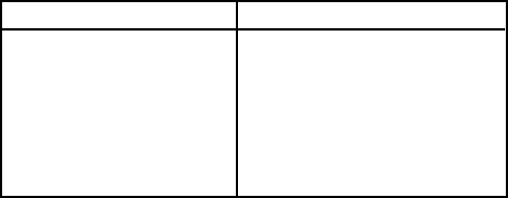

**Item Sugar 1kg Toothbrush Tissue**

**A packet of pencil Soap**

**Toothpaste**

**Price (sh.) 210**

**70**

**50**

**80**

**150**

**70**

**Kimani went to the shop and bought 2kgs of sugar, soap, two toothbrushes and a packet of pencils. How much**

**money did he spend? (1 mark)**

|  |  |  |  |
| --- | --- | --- | --- |
| **Day of the week Mon Tue** | **Wed** | **Thur Fri** | **Sat** |
| **Number of students 30 35** | **50** | **60 ?** | **40** |

1. 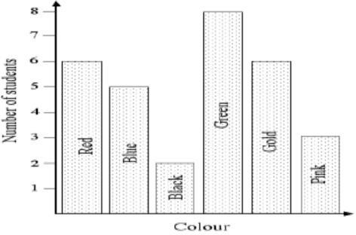**Some learners in a class were asked about their favorite colours and the results were as below.**

How many prefer green to black? (1 mark)

1. **Omari is working out sums to find the greatest number that can divide 16 and 48 without a remainder. What is the**

number? (1mark)

1. **At point 0, a frog jumped 7 steps in the right direction. position did the frog land?**

**It was then kicked 5 steps in the left direction. At what**

**(2 marks)**

1. **Hussein scored the following marks in his final exams in five different learning areas; 70, 82, 88, 64 and 76. What is the difference in the highest and lowest score? (1 mark)**
2. **A Math’s teacher comes up with the expression 8x - 10. Find its value when the value of x=5. (1mark)**
3. **Johanna has c mangoes. Kamau has twice as many mangoes as Johanna. Kim has 2 less mangoes as compared to Kamau. Calculate the total mangoes they all have. (2 marks)**
4. **Alex is a farmer. He planted 2025 seedlings in squared rows.**
   1. **Work out the number of rows for his seedlings. (1 marks)**
   2. **How many seedlings were planted in each row? (2 marks)**
5. **The figure below was presented to Grade 7 learners. They realised that one of the numbers was missing. They**

calculated it to find out the angle. What is the size of the angle? (1 mark)

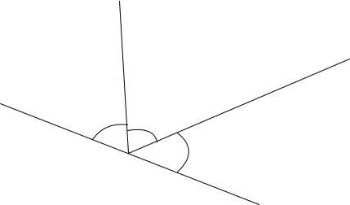

**600 4X**

O **400**

**P**

**S**

1. **The table below show the weather patterns of Keroka area.**

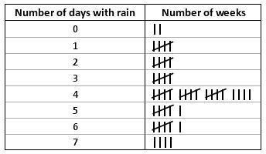

How many weeks had 4 days with rain? (1mark)

1. **If x = 3, calculate the volume of the rectangular box shown in cm³. (2 marks)**

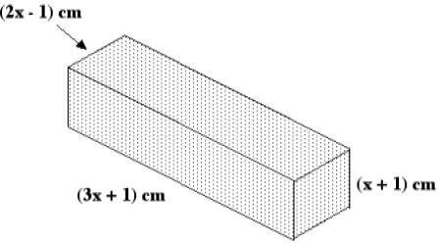

1. **Four sisters bought a present for their grandfather that cost sh 2000. If they had been given sh 3555, how much**

**was the balance? (1mark)**

1. **Two pieces of a pipe are 12cm and 16cm long. The pipes are to be cut into pieces of equal length. Find the**
2. **Kaly has p pens. Sally has 5 more pens than Kaly. If they have less than 20 pens in total, write an inequality to**

**represent the information. (1 marks)**

1. **Omari is working out sums to find the greatest number that can divide 16 and 48 without a remainder. What is the**

number? (1mark)

1. **Judy was requested to work out the sum of all prime numbers between 10 and 20. What answer did she get?**

**(1 mark)**

1. **Sam can finish a running course in 6.5 minutes. His goal is to reduce his time to 5 minutes. Which inequality**

solution set includes all of the time, t, Sam could achieve that meet his goal? (2marks)

1. **During a cancer screening session, 3 counties sent a number of patients. County A sent 750 patients, county B sent 600 and county C also sent. If the total number of patients who attended the screening were 200, how many**

patients did county C send? (1 mark)

1. **A garden is of the shape below. Work out the area of the garden. (2 marks)**

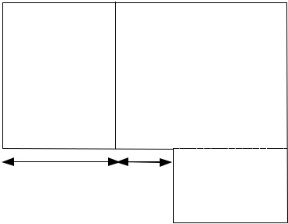**5m**

**4m Peanut Corn 6m 2m 1m Tomatoes**

1. **The difference between two numbers is 2475. If the smaller number is 1872, what is the other**

**number? (1 mark)**

1. **Eva and Havy arranged 144 chairs in a squared religion hall. The chairs were spaced equally along the rows and**

**columns. Work out the number of chairs in one row. (1 mark)**

**30. What is the size of the angle formed by the minute hand and the hour hand when the clock is showing 4.00**