## RATIONALIZED PRE-TECHNICAL STUDIES GRADE 7 NOTES

**Strand 1: FOUNDATION OF PRE-TECHNICAL STUDIES.**

### 1.1-Introduction to Pre-technical studies

**Pre-technical studies** is a series of learning areas written to provide practical experiences that support the acquisition of skills in technical areas derived from computer science and business studies.

#### Components of Pre-technical studies.

Pre-technical studies is a technical learning area comprising of:

Pre-technical studies – a learning area that involves acquiring practical skills and experience in technical area.

Computer science the study of computers and how computer technology can be used to solve problems. Business study-involves study of activities that involves production, distribution and consumption of goods and services aimed at making profits.

#### The role of Pre-technical studies in day today life.

* It gives learners the skills they need to think critically and solve problems as well as preparing them for a technical & digital future.
* Facilitates development of appropriate skills and knowledge gained from the learning areas such as computer science and business studies.
* Offers a wide range of careers in Pre-technical area such as in safety and material handling, in computer science such as programmers, software engineering and in business studies such as accountant, traders, manager, bankers and shopkeeper.
* Pre-technical studies promotes independence and self-learning through various skills enhancing chances of creating employment opportunities and self-employment in individual.
* It equips learners with skills to use when observing personal safety and safety in working environment.

**1.2 - Safety in the work environment.**

#### What is safety?

**Safety** is a situation where one avoids causing harm, discomfort or sickness to self and to others when carrying out the daily activities.

#### Examples of safety measures include:

 Wearing face mask to prevent spreading of airborne diseases or breathing in dirty air.

 Buckling a safety belt while in a vehicle to avoid falling off the seat in case of emergency brakes.

 Wearing hand gloves when working to avoid injury and dirt to the hands when working.

 Wearing gum boots to protect the feet from injury when working in areas with mud or sharp objects.

 Wearing an overall to guard against soiling clothes.

#### Potential safety threats in a work environment.

* Potential safety threats in work environment can either be physical or online.

#### Physical threats at workplaces.

* Physical safety threats include:

 Sharp edged tools and objects that can easily cut or poke someone.

 Disarranged rooms where one can easily tumble and fall.

 Naked electric wires that can easily cause electric shock.

 Poorly lit rooms where one can easily know oneself against objects.

 Poorly stored items on the shelves where they can easily fall off and hit someone.

 Working without protective gear where one can easily be hurt or injured.

 Rooms with wet slippery floors where one can easily slip and fall.

#### Online threats at a workplace.

* Every online user should ensure they stay safe online by protecting themselves and others from online threats.

#### Examples of online threats at work place include:

 Malware/virus attack.

 Hacking.

 Data theft.

 Cyberbullying.

 Friend requests from unknown people.

 Phishing attacks.

 Ransomware-attempts to encrypt data and calling for ransom to release it or unlock code

#### Online safety rules and regulations in the work environment.

* **Online safety** is keeping safe from possible threats that a computer user may experience while engaging in activities through the internet.
* It includes:
* Protecting and managing personal information.
* Avoiding harmful or illegal content.

 To avoid online fraud, always buy online items from secure and trusted sites. Also, watch out for scams that come in form of messages and emails.

 Do not accept friend requests from strangers. Some strangers are hackers who might access your personal information and even take over your accounts.

 Phishing is an online fraud system used to steal private data such as login usernames and passwords.

 Use strong passwords that cannot be crashed easily in case your password is compromised.

Consider changing it right away.

 Always back up your data and keep your computer security updated.

#### Physical threats to digital devices.

 Physical threats to a computer include:

✗ Fluids such as water, milk and juice that can damage different parts of the devices.

✗ Theft.

✗ Damage caused by natural disasters, fire and impact of falls.

✗ Corrosion caused by excessive humidity and dampness.

✗ Exposed cables in the computer room.

✗ Hardware failure

* Ways of mitigating/reducing physical threats to digital devices.

To prevent physical threats, the following should be done.

 Do not carry water into the computer room or near the computer.

 Do not use old and loose power extension cables in a computer room. They produce sparks that can cause fire in the computer room.

 Replace loose power extension cables because they may lead to unstable power supply.

 Use voltage controllers to curb unstable power supply in the computer room.

 Equip computer rooms with fire extinguishers that do not use water, the computer room can be fit with automatic fire detectors that will detect fire or smoke and alert the personnel in charge for quick action.

 Tuck computer cables in trunks or carefully lay them down under the desks in order to prevent falls in the computer room.

 Place computers on strong furniture to prevent them from falling.

 Restrict access to computer rooms.

 Secure the computer room with strong windows and doors to control theft of computers. To increase the security level, you can install CCTV cameras and also employ security personnel.

 Use computer cable locks to control theft in the computer room.

 Use dehumidifiers to control excess humidity and dampness.

 Ensure there is enough ventilation or free circulation of air in the computer room.

 Fit window curtains and air conditioners in the computer room to control and filter dust particles from entering the room.

 Cover computers with dust covers when they are not in use.

#### Ideas and practices on how to personal and sensitive data from the public when online:

To keep personal and sensitive data from the public when online, the following can be done:

 Protect and manage personal information.

 Do not accept friend requests from strangers.

 Avoiding harmful or illegal content.

 Buy online items from secure and trusted sites.

 Installation of antivirus software.

 Backing up data.

 Use of strong passwords.

 Log out from your online accounts after using public internet to browse.

 Do not communicate with strangers online.

#### Safety Rules and Regulations at Work.

* Safety rules and regulations exist in all workplaces. They are principles that govern the actions and procedures to keep the works property and the environment safe.
* Some of the general safety rules and regulations include:

 To ensure that you know how to safely perform the task.

 To ensure you know the hazards of the task and how to protect yourself.

 To wear the required personal protective equipment necessary for the task.

 To always work clear of suspended loads.

 To always keep your mind and eyes on the task at hand.

 To obey all warning signs and barricades.

 To inspect all tools and equipment to ensure they are not defective before using them.

 Do not perform a task under unsafe conditions and report any unsafe tools, equipment or hazardous conditions.

 All chemicals’ containers should be well labelled and covered.

 Maintain good housekeeping at workplace all the time.

**1.3 – Computer Concepts.**

### What is a computer?

▪ **A computer is an electronic device that process or converts data into information.**

* A computer receives, stores, organizes and processes data into information.
* The word computer came from Latin word ‘**computare’** which means to **calculate**.
* A computer uses programs that are sets of instructions which a computer follows to perform tasks.

#### What is Data?

 **Data** refers to raw facts such as numbers, symbols, images and letters that are not processed and have no meaning to the user.

 Data is plural while in singular it is datum.

 Data is not meaningful to the user until it is processed.

#### Examples of Data include:

* + Texts.
  + Images.
  + Sound.
  + Videos.

####  What is information?

 **Information** refers to processed data that is meaningful to the user.

 Information is meaningful to the user.

#### List the examples of computers used today.

* The following are examples of computers:
* Notebook.
* Desktop.
* Laptop.
* Tablets.
* PDA (Personal Digital Assistant)
* Electronic calculators.
* ATM Machines.
* Washing machines.
* Microwaves.
* Server.
* IPad.
* MacBook.
* Smartphone.
* Smart watch.
* Workstations.

#### Characteristics of Computers.

* **Speed**- computers perform tasks faster compared to human beings.
* **Accuracy**- computers performs tasks without any errors if the correct data is entered.
* **Versatility** –versatility is the ability of a computer to perform different tasks. A computer can be applied in education, agriculture, military and medical fields.
* **Reliability**- Computers are reliable because they give consistent output results for similar tasks.
* **Diligence** –a computer can perform millions of tasks without getting tired. It does not get fatigue or loss concentration like human beings.
* **Storage** - computers have storage facilities or memory for storing data and information either temporarily or permanently which can be retrieved to be used later.
* **Automation**-a computer is an automatic machine. It starts a task from beginning to end without requiring human assistance.
* **No logical decision**-a computer cannot work on its own without being instructed by a user hence it is not intelligent enough on its own.

#### Classification of Computers Computers are classified according to some criteria.

* We can classify computer by looking at the following:
* **Functionality.**
* **Purpose.**
* **Size.**
* **Criteria used to classify computers.**

|  |  |  |
| --- | --- | --- |
| **By functionality or data**  **handling** | **By size** | **By purpose** |
| Analogue computers | Micro computers | General purpose computers |
| Digital computers | Mini computers | Special purpose computers. |
| Hybrid computers | Mainframe computers |  |
|  | Super computers |  |

**Classifying Computers According to functionality/data handling**

* Computers are classified as **analogue**, **digital** or **hybrid** based on functionality/data handling.
* Data handling is the form in which data is represented in a computer.

**Analogue computers.**

▪

* + They were the first computers to be developed and used in measuring quantities such as temperatures, pressure, car speed and voltage.
  + They accepted data directly without converting it.
  + Examples of analogue computers include: speedometer and mercury thermometer.

**Digital computers.**

▪

* + They included modern computers like laptops, tablets, desktops and smartphones.
  + They are designed to perform calculations and logic operations at high speed.

▪

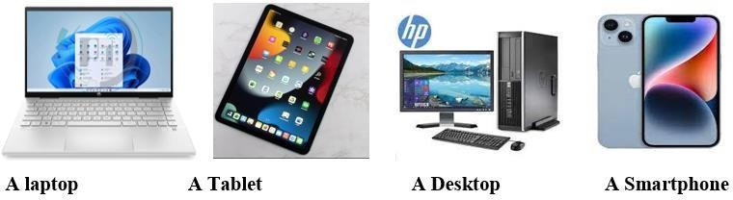

They accept the raw data as input and process it with programs stored in its memory to produce the desired output.

**Hybrid computers.**

▪

* + They combined best features of the analogue computers such as speed and those of the digital computers such as internal memory.
  + They are used in specialized applications where both analogue signals and convert them into digital form before processing.
  + Examples of hybrid computers are fuel pump and the analogue blood pressure

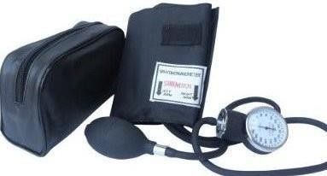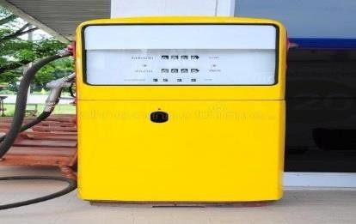

#### Classifying Computers According to Purpose

1. **General purpose computers**
   * They are most common computers that can perform most common tasks such as word processing, calculations, draw, play music and send electronic mails.
   * General purpose computers are mostly used in schools, hotels, hospitals and at homes.

#### Special purpose computers.

* + They are computers designed to carry out specific tasks only.
  + They are mainly used in manufacturing industries, traffic control systems, weather forecasting, robotic systems, satellites and ATM machines.

#### Classifying Computers According to Purpose

1. **Supercomputer.**

 It is the biggest.

 It is the most expensive.

 It is the fastest and most powerful computer for big data processing.

 It is able to process many instructions in a second.

 It is mainly used in application requiring complex mathematical calculations such as in- flight simulation in aerospace, in weather forecasting and in satellite launching.

#### Mainframe computers.

 They are the largest and most expensive after super computers.

 They have a higher processing power which can handle thousands of connected peripheral devices or users at the same time.

 They store large amount of data, instructions and information.

 Most government institutions use mainframe computers to store data, calculate interest rates and customer balances.

#### Mini computers.

 They are smaller, less powerful and less expensive than main frame and super computers.

 They are more expensive and powerful than personal computers.

 They provide a centralized location for data, information and programs.

 They are also used to perform calculations and process business transactions.

#### Microcomputers.

 They are the least powerful, smallest and cheapest computers.

 They are also called personal computers. They are called microcomputers because their processing device is called a microprocessor.

 They are designed to be used by one person at a time.

 They are used in offices, schools, businesses, media houses or to keep records, prepare lesson plans and to browse.

# STRAND 2- COMMUNICATION

**2.1Fundamentals of communication.**

#### Meaning of Communication.

* + **Communication** is the process of sharing information through a channel from the sender to the receiver.

#### Importance of communication in the work environment.

 Good communication ensures making decision is easier.

 Communication helps to build positive relationships, teamwork and trust at workplaces.

 Good communication helps to achieve greater goals.

 Communication enables managers’ shares goals with shareholders both inside and outside the organisation. It gives managers permission to stimulate behaviour changes in employees and suppliers and to inspire loyalty from the employees and customers.

 It allows managers to convince employees and unions to abandon counterproductive practices, managers persuade leaders to provide financing and it permits managers to calm angry customers and impress new ones.

 Preventing misunderstanding and conflicts.

 Improving customer services.

 Meeting goals and earning success.

 Promoting creativity and innovation.

 Advancing individual career prospects.

#### ICT Tools in Communication.

* **Emails**-used to exchange information over the internet to other individuals.
* **Mobile phones**- allows calling and messaging in communication.
* **Computers** -computer provide various communication channels such as emailing, video calling etc.
* **Videos and web conferencing**- Video conferencing has a focus on face-to-face communication. Web conferencing has a focus on interaction and collaboration such as document sharing.
* **Social networking** - use of dedicated websites and applications to interact with other users.
* Online collaboration - using the internet and online tools to collaborate.
* **Softwares like word processor** are used to design letters and memos that are used to pass information in business.
* **Social media** is used to give immediate response to customer needs.

#### Benefits and challenges of the internet.

* **Benefits of the Internet.**
* Internet enables communication worldwide through emails, chat services and video calls.
* Enable E-learning through video teachings and research has enabled learners and researchers to get information.
* The internet is a source of entertainment where people listen to music, watch videos, sports and even play online games through the internet.
* Business flourish by using internet for online shopping and marketing of their products.
* Uploading, downloading and sharing data has been made easier with the internet.
* The banking sector has embraced online banking. Sending and receiving money is now faster and more convenient because of the internet.
* Some job seekers use the internet to find and apply for jobs online.
* **Challenges of the internet.**
* Causes antisocial behaviour due to too much use or addiction.
* Causes laziness.
* Hacking and computer viruses are online threats associated with the internet.
* Some internet activities such as online gambling and posting of illicit photos and videos are indicators of moral decay.
* Personal data can be compromised through the internet and used to commit crimes such as fraud and cyber bullying.
* Sometimes the internet contains misleading and false information.
* **Ways of overcoming Internet challenges.**
  + Using updated software and antivirus programs to prevent data attacks by viruses.
  + Having strong and different passwords that cannot be cracked also protect data from being compromised.
  + Practising self-control through limiting the time spent on the internet and shutting down devices to avoid internet distractions.
  + Always watching out for scam messages and emails in order to prevent online fraud.
  + Parents, teachers and guardians monitoring all online activities done by their children and advising them on how to use the internet wisely.
  + Not sharing personal information.

**2.2 - Introduction to drawing.**

#### Importance of Drawing as a means of Communication.

* Drawing are types of diagrams used for communication to show the shape and structure of a given idea or product.
* Technical fields use drawings to draw designs of different items before they are made.

#### Types of drawing used in technical fields.

* Drawing involves making marks on a surface to create images of forms and shapes.
* **Artistic drawing** – these are drawings that allows the communication of emotions, ideas or feelings.

#### Examples of artistic drawing include:

* + Illustrations -drawings for people to visualize and understand the picture by picture rather than through text.
  + Portraits-drawn pictures in which the face is dominant.
  + Caricature – drawing or painting in which features have been distorted and exaggerated in order to mock or satirize the subject e.g., cartoon
  + Graffiti-drawings made in public spaces such as public walls or buildings using spray paints.

|  |  |
| --- | --- |
| **Illustration.** | **Portrait.** |
|  |  |

|  |  |
| --- | --- |
| **Caricature.** | **Graffiti.** |

* **Technical drawings** – these are drawings made to scale to communicate specific idea on how a physical object function or is constructed.
* They are made to give a precise and detailed view of an object. They give information about how an object function or how it is constructed.
* Examples of technical drawings:
  + Architectural drawings.
  + Structural drawing.
  + Mechanical systems drawings.
  + Electrical drawings,

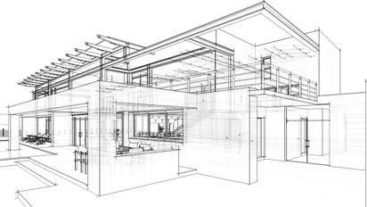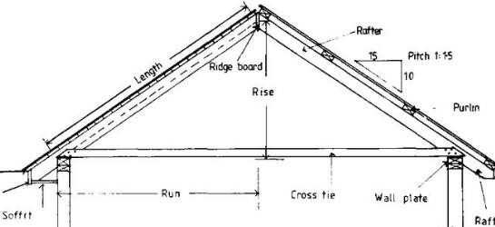

* **Differences between Artistic and Technical Drawings.**

|  |  |  |  |  |
| --- | --- | --- | --- | --- |
|  | **Feature** | **Technical drawings** | **Artistic drawing** |  |
| 1 | Purpose | A technical drawing is used to provide accurate measurement of an object to scale. | An artistic drawing is used to express one’s ideas, to decorate or to give pleasing appearance to a  surface. |
| 2 | Presentation | The technical drawings are  presented on a convenient. | The artistic drawings are done on  any material and in all sizes. |
| 3 | Dimensioning and precision. | Technical drawing MUST be precise and accurate in  dimension. | The artistic drawing need not and do not obey the rules of dimensions,  shape or proportion. | |
| 4 | Emotions, feelings and sentiments | The technical drawings do not take care of feelings or sentiments of a person.  They are factual, functional,  productive and result-oriented. | The artistic drawings involve expression of feelings and sentiments. | |
| 5 | Interpretation | The technical drawings must be interpreted in the same way all over the globe regardless of the geographical boundaries,  religions or nations | The interpretation of the drawing is strictly left to the individual or the onlooker. | |

#### Types of Lines used in drawing and their application.

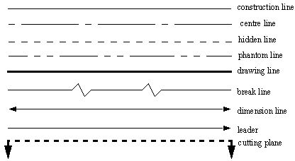

**Drawing lines and shapes using drawing instruments**

|  |  |  |  |  |
| --- | --- | --- | --- | --- |
| **Name of the line** | | | **How the line is used in technical drawing** | |
| Construction line | | | A faint line used for sketching and drawing the initial details of a  drawing | |
| Centre line | | | used to show hole centres and centre positions of rounded features | |
| Hidden line | | | how edges, surfaces and corners which cannot be seen. | |
| Phantom line | | | long-short-short-long lines most often used to show the travel or  movement of an object or a part in alternate positions | |
| Break line | | | used to show where an object is broken to save drawing space or reveal  interior features. | |
| Drawing line | | | define the edges of a form | |
| Dimension line | | | a thin, solid line that shows the extent and direction of a dimension | |
| Leader line | | | A line that connects a data label and its associated data point | |
| Cutting line | | |  | |
|  | **Type of line** |  | |  |
|  | Horizontal |  | |

Vertical

Diagonal

Parallel

Perdendicular

Thick and thin

Curved

|  |  |
| --- | --- |
| Zigzag |  |
| Wavy |  |
| Spiral |  |
| Dotted | ......................................................................................... |

#### Basic symbols and abbreviations used in drawing.

|  |  |  |
| --- | --- | --- |
|  | **Symbol** | **Meaning** |
| 1 |  | Diameter |
| 2 |  | Perpendicularity. |
| 3 |  | Centerline. |
| 4 |  | Radius |
| 5 |  | Square |

|  |  |  |
| --- | --- | --- |
| 6 |  |  |

**Basic abbreviations used in drawing.**

1. **DRG** -means drawing.
2. **A/F** – means across flat.
3. **A/C** – means across corners.
4. **I/D** – means inner diameter.
5. **O/D** – means outer diameter.

#### STRAND 3-MATERIALS FOR PRODUCTION.

**3.1 Economic Resources.**

**Meaning and types of Economic Resources.**

* **Resources** are all the materials available in our environment which are accessible, economically feasible and culturally sustainable and help us to satisfy our needs and wants.
* **Economic resources** are the resources used for carrying out economic activities.
* The main classes of economic resources are:
  + Land.
  + Labour.
  + Capital.
  + Entrepreneurship.

#### Characteristics of Economic Resources used for production of goods and services.

 **Uneven distribution**-economic resources are not found in all places.

 **Scarcity**- these resources are not enough to satisfy all human wants.

 Economic resources have **alternative uses.**

 **Usefulness**-Economic resources have utility and they are useful.

 **Mobility**-They can be transported from one place to another.

 **Combinability**-Economic resources can be combined to produce different goods and services.

 **Monetary Value**-Economic resources are measured in terms of money. Therefore, they have monetary value.

 They can **change ownership**.

#### Classification and Types of economic resources in Kenya.

* There are example types of economic resources in Kenya. They include mountains, minerals, machineries, land, information, sunshine, rainwater, lakes, rivers, oceans, etc.
* There are three types of economic resources namely;

 Human-made resources

 Natural resources.

 Human resources.

#### Human-made economic resources.

 They are resources that are created by human beings through various productive activities. They include:

* + Tarmac roads.
  + Machineries.
  + Dam
  + Watch etc

#### Natural economic resources.

* They are resources that exists in nature.
* They are found in natural environment.

- They include:

✗ Mountains.

✗ Rivers.

✗ Lakes.

✗ Wind.

✗ Sun.

✗ Natural forests etc.

#### Human economic resources.

* They are also referred to as labour or people who provide human services.
* For example;
  + Teachers.
  + Drivers.
  + Painters.
  + Nurses.

#### Differences between metallic and non-metallic materials as economic resources.

|  |  |  |  |  |
| --- | --- | --- | --- | --- |
|  | * **Distinction between metallic and Non-metallic materials.** | | | |
|  |  | **Metallic materials** | **Non-metallic materials** |  |
|  | Some rust | They do not rust. |  |
|  | They have definite shape. | Liquids and air do not have a definite shape but solids have a definite shape. |  |
|  | They produce a sharp loud sound on knocking. (sonorous). | They produce a dull sound on knocking. |  |
|  | They are more reflective. | They are less reflective, except glasses. |  |
|  | They are generally smooth. | They are generally rougher when not polished. |  |
|  | They heat up faster when put under the sun. | They heat up slowly. |  |
|  | They are hotter than non-metals when under the sun. | They are cooler than metals when put under a shade. |  |
|  | They cool faster when put under a shade. | They cool slowly when put under a shade. |  |
|  | They are colder than non-metals under cold weather. | They are warmer than metals under cold weather. |  |
|  | They are not easy to break. | They are easier to break than metals. |  |

**Sustainable ways of using economic resources.**

* Reusing and saving resources.
* Avoid wastage and use of non-environmental pollutants.
* Safeguarding natural resources air, water, land etc., for the benefit of present and future generations through careful planning or management as appropriate.
* Adopting efficient technology.
* Investing in renewable energy sources.
* Reducing usage or consumption of economic resources through reusing and recycling.
* The capacity of the earth to produce important renewable resources must be maintained and whenever practicable, restored or improved.
* The non-renewable resources of the earth must be employed in such a way as to guard against the danger of their future exhaustion and to ensure that benefits from such employment are shared by all mankind.

**3.2 – Metallic Materials.**

* A metal is a solid material which is typically hard, shiny, malleable, fusible and ductile.
* Metallic materials are materials that have properties of metal.
* They have good electrical and thermal conductivity.
* Metals are mostly identified by the items made from them. The types of materials include:

#### Metals include:

 Copper.

 Iron.

 Aluminium.

 Steel.

 Silver among others.

1. **Shiny metals** such as copper, silver and gold for decorative arts, jewellery and coins.

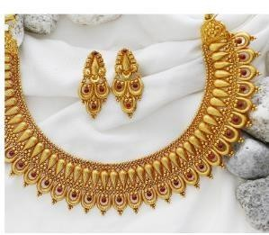 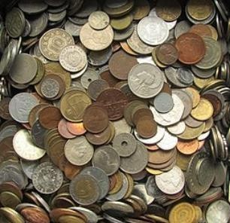

1. **Iron and steel** for structures like buildings, furniture and vehicle parts.

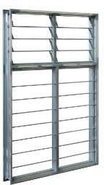 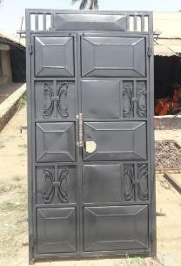 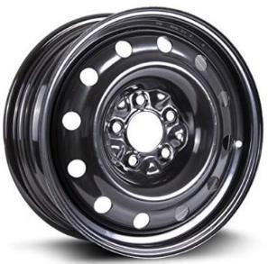

1. **Copper** for electric wires.

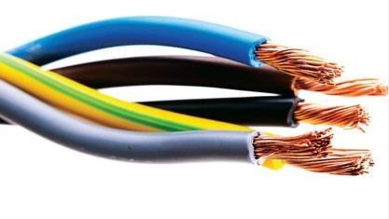

1. **Aluminium** for cams, bottle tops and caps, household appliances and utensils, airplanes.

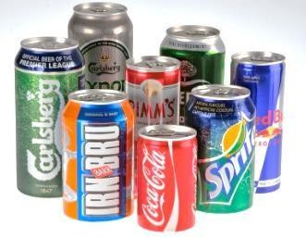 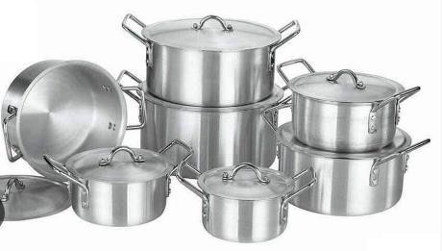

1. **Bronze** for church and school bells.

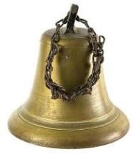

**Physical properties of Ferrous and non-ferrous metals.**

* + **Ferrous metals** are metals that consists mostly of iron and small amount of other elements.
  + Some of the physical properties of ferrous metals include:
    - **Magnetism**-ferrous metals are highly attracted to a magnet.
    - **Heat conductivity**- ferrous metals are better conductors of heat than non-ferrous materials.
    - **Appearance**-ferrous metals have a silvery colour.
    - **Electricity conductivity** – ferrous metals are poor conductors of electricity than non- ferrous metals.
  + **Non-ferrous metals** are metals that do not have any iron in them at all.
  + Some of the physical properties of non-ferrous materials include:
    - **Magnetism**-non-ferrous metals are not magnetic.
    - **Heat conductivity**- non-ferrous metals are poor conductors of heat than ferrous metals.
    - **Appearance**- non-ferrous metals like gold have a more colourful appearance than ferrous metals.
    - **Electricity conductivity**- non-ferrous metals like copper are better conductors of electricity than ferrous metals.

**3.3 – Non-metallic materials.**

Non-metallic materials found in the environment.

#### Non-metals include:

 Wood.

 Stones.

 Textile.

 Soil.

 Glass.

 Leather.

 Plastic.

 Rubber.

 Water.

 Air among others

**Categorization of Non-metallic materials as either synthetic or natural.**

* Non-metallic materials can be categorized as **synthetic** or **natural**.
* Synthetic materials include plastics, manufactured glass, manufactured fibres, polythene, ink, paints and drugs among others.
* Natural non-metallic materials include plant and animal products such as wood, wool, bones and skin among others. They also include inorganic material such as stones, minerals, sand, clay and ballast among others.

**Physical properties of non-metallic materials.**

|  |  |
| --- | --- |
| Physical state | Non-metals can exist in all the three physical stats; solid, liquid and gaseous. |
| Hardness | Non-metals are generally soft. Some of the solid non-metals are quite soft. They  can easily be cut with a knife. |
| Brittleness | Non-metallic materials are brittle because they break down into pieces on  hammering. |
| Decomposition | Natural non-metallic decompose (rot) after sometime. Synthetic non- metallic  materials do not decompose easily. |
| Combustibility | Non-metallic materials generally burn in fire, except earth and mineral products. |
| Heat conduction | Non-metallic materials do not conduct heat. This means that non-metals do not  allow heat to pass through them. |
| shininess | Natural non-metallic materials are dull. Synthetic non-metals appear a little  shiny. |

# STRAND 4- TOOLS & PRODUCTION.

**4.1 - Measuring & Marking Tools.**

* **A measuring tool** is a device used to measure a physical quantity such as length, time, weight, angle, volume and temperature.
* **A marking tool** is a device used to indicate a point on a surface to obtain accurate size and shape.
* Common measuring and marking tools are:
* **Measuring tools.**

✗ **Steel rule**-also called steel ruler.

A flat metallic tool with a calibrated surface. Made from stainless steel.

Can either be flexible or rigid with different thickness.

#### Uses:

* Measure length of an object or distance between 2 points.
* To draw straight lines.
* To guide cuts.
* 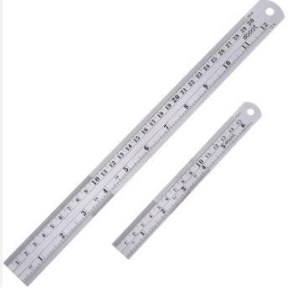**Fields in which ruler is used:** geometry, welding and fabrication, technical drawing, architecture and construction.

✗ **Tape measure**-also called measuring tape.

A flexible tool marked millimetres, centimetres and inches. There are different types of measuring tapes.

Tape measure is made up of materials such as fiberglass, cloth, plastic, metal ribbon or strip.

#### Uses:

* used to measure length of an item and distances between points.
* Measures a round curved object because it is flexible in nature.

#### Fields it is used:

* Masonry, plumbing, electrical installation, surveying, crafts and woodworking.

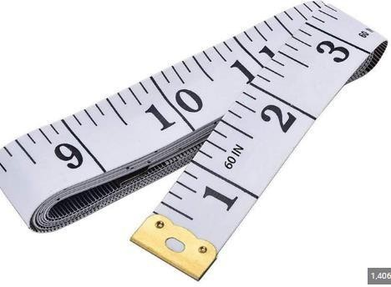 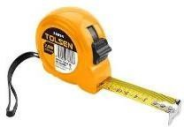

✗ **Square** – it is a measuring device that consists of two straight edges set at right angles to each other.

There are different types of squares.

#### Uses:

* used to measure and ensure that two perpendicular surfaces are at a right angle.
* Used in different fields to ensure that joints and corners of objects are truly square.

#### Fields in which square is used:

* Woodwork, masonry, mechanical engineering and plumbing among others.

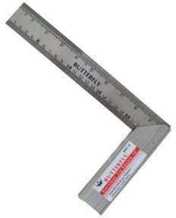 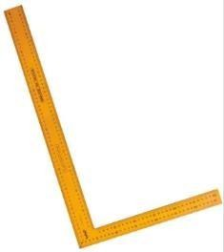

Try square Mason’s square

✗ **Calipers** - it is a measuring tool that consists of two adjustable jaws.

There are different types of calipers.

#### Uses:

* Use to measure thickness and ouside dinensions of an object like tennis ball or bottle.
* Used to measure the internal dimensions of hollow objects like a rectangular tube or cylindrical pipe.

**Fields in which callipers are used:**science, woodwork, metalwork and other mechanical trades. Inside callipers Outside callipers Vernier calipers.

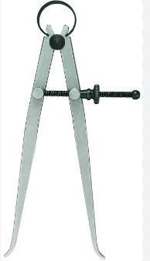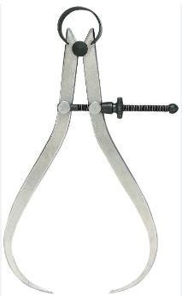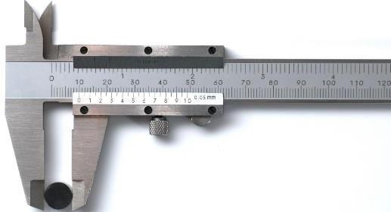

✗ **Micrometer screw gauge** - also called a micrometer.

It is a measuring instrument with a G-frame with an adjustable spindle.

#### Uses:

* Used to measure the diameter of wires and thickness of small sheets such as glass or plastic.

**Fields in which callipers are used:**metal working and other mechanical fields.

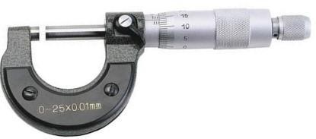

✗ **Spirit level**-it is a tool consisting of a sealed glass tube partially filled with a liquid, containing an air bubble.

Used to determine if a surface is vertical or horizontal.

#### Uses:

* Used to indicate how horizontal or vertical a surface or an item is.

**Fields in which callipers are used:**masonry, carpentry, surveyor, plumber, metalworker and other interior designers.

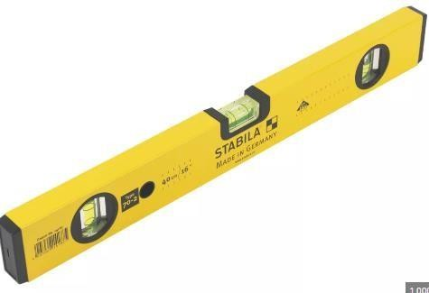

✗ **Thermometer**- it is an instrument that is used to measure the temperature.

It can be digital or analogue.

#### Uses:

* Used to measure the tempereture of solids like food, liquids like water or gas like air.

**Fields in which callipers are used:** widely used in industry and technology, in medicine and in research.

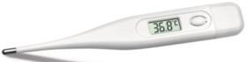

✗ **Plumb bob** – also called plummet.

It is a weight with a pointed tip on the bottom, which can be suspended from a string to give a vertical line.

#### Uses:

* Used in construction industry to ensure that a vertical installation such as a wall is perfectly vertical.

#### Examples of real-life situations of uses of plumb bob include:

-ensuring a wall is vertical when constructing.

-ensuring fencing posts are vertical during fencing. Fixing a foor fram.

Installation of ceiling lights or pot lights and hanging of pictures. Installing wallpapers.

**Fields in which callipers are used:**construction, masonry.

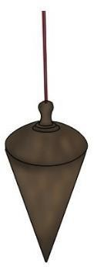

✗ **Measuring cylinder**-a calibrated glass or plastic cylinder.

#### Uses:

* Used to measure volume of liquids and to determine volume of a solid by measuring displacement of a liquid.

**Fields in which callipers are used:** laboratories, veterinaery and human services to measure drugs, chemicals and medicines.

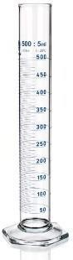

✗ **Stop watch**- a stop watch is a time measuring device with buttons, which you press at the beginning and at the end of a timed event.

#### Uses:

* Used to measure the time interval of an event.

**Fields in which callipers are used:** areas where accurate timing of events is required. Such as sports activities and laboratory experiments.

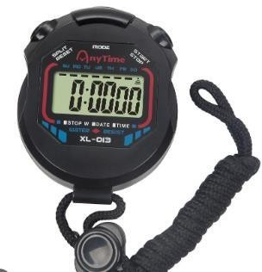

✗ **Voltmeter**-it is also known as a voltage meter.

It is an electric measuring instrument with a letter V marked on the face.

#### Uses:

* Used to measure voltage across the two terminals in an electrical circuit.
* Used by electrical technician s to chack input and output voltage of electrical equipment such as moter, batterries, medical equipment, electrical panel boards,

plastic machinery and electrical devices.

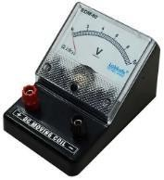

✗ **Ammeter**-it is also known as ampere meter.

It an electric measuring instrument with letter A marked on the face.

#### Uses:

* Used to measure the amount of electric current in a closed circuit.

**Fields in which callipers are used:**used by electrical technicians.

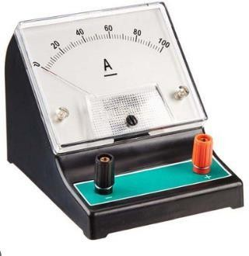

✗ **Ohmmeter**-it is an electric measuring instrument with a symbol  marked on the face.

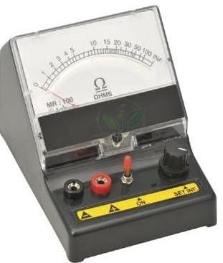

✗ **Multimeter**- it is a digital electric measuring instrument that can measure multiple electrical properties.

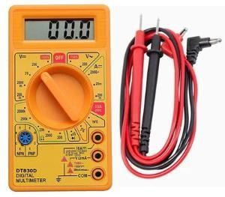

✗ **Weighing balance**- it is also called a weighing scale.

It is an instrument that is used to determine the weight or mass of an object. They are of different types.

#### Uses:

* Used to determine the weight of test materials and sampling amounts that require high degree of accuracy.

**Fields in which callipers are used:**laboratories in pharmaceuticals, educational, food and beverage, chemical and industrial.

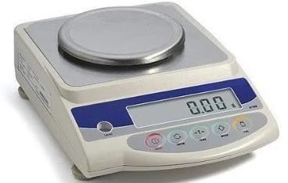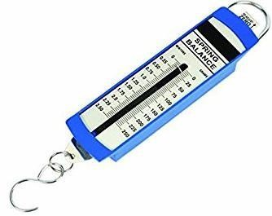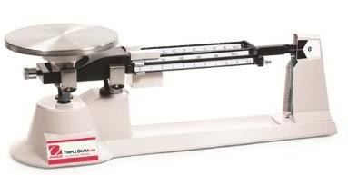

Electronic weighing balance Spring balance Beam balance

* **Marking tools.**

✗ **Pencil** – a thin piece of woof with a rod of black or coloured lead through the middle.

* Uses: Mark lines and centres for cutting or joining.

**Fields in which callipers are used:**carpentry, tailoring, geometry etc.

a pencil

✗ **Scriber** – it is a metallic hand tool with hard sharpened ends.

#### Uses:

* Mark line on metal or wood.
* Can be used together with a straight edge or square.

**Fields in which callipers are used:** woodwork, tiling, clay works and metalwork.

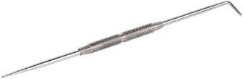scriber

✗ **Marking gauge** – it is also called scratch. it is a tool with a small pin.

#### Uses:

* Used to mark aline parallel to the edge of the piece of work.

**Fields in which callipers are used:**used in woodwork joinery and sheet metal operations to mark out lines for cutting or other operations.

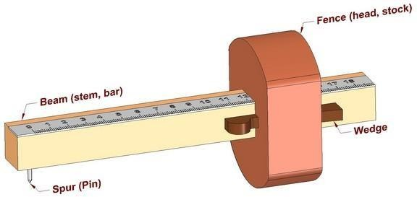 a marking gauge.

✗ **Tailor’s chalk** – it is a thin flat piece of hard chalk used by tailors and dressmakers.

#### Uses:

* Used to mark guides on a fabric to indicate where it needs to be cut, folded or stitched.

**Field where it is used**: tailoring

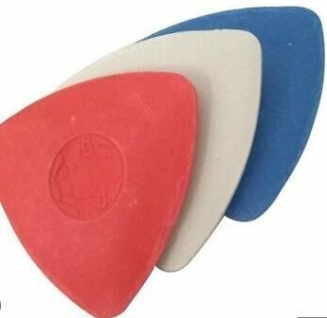

✗ **Sliding bevel** – it is also called a bevel square.

It is a tool with adjustable blade angles.

#### Uses:

□ Used to set an angle to be marked ob itens like timber, metal, tile or brick.

**Fields in which callipers are used:** woodwork, tiling, clay works and metalworks.

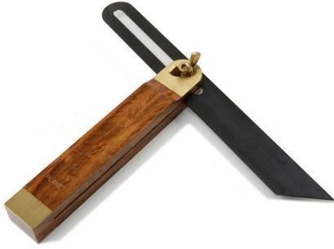

✗ **Punch** – a punch is a shard sharp ended tool. There are two types of punches. Centre punch and dot punch.

#### Uses:

* Can be used to make indent in materials such as metal, leather, rubber, wood or plastics.
* It is used to showa point where a hole is to be drilled.

**Fields in which callipers are used:** metalwork, woodwork and leatherwork.

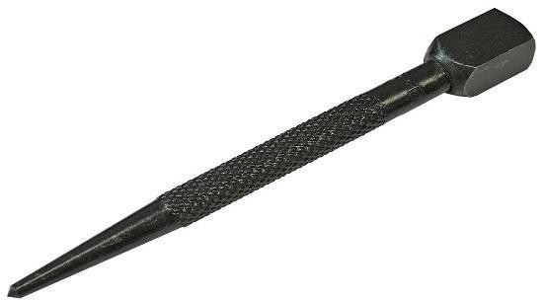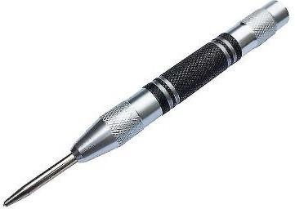

Centre punch Dot punch

✗ **Marking knife** – it is also called a striking knife.

✗ It is a tool that is either single beveled or double beveled.

#### Uses:

* Used to make markings on workpieces.
* Used to cut a visible line that can then be used to guide a hand saw, chisel or plane when making woodworking joints and others operations,

**Fields in which callipers are used:** woordworking.

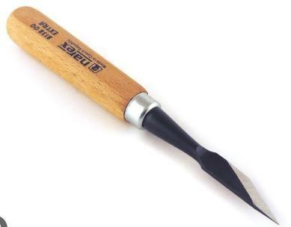

Single bevel Double bevel.

✗ **Spacing wheel** – it is a leather marking tool with evenly spaced spikes pn a wheel.

#### Uses:

* Used in the leather industry to mark a line a long which stitching can be done,
* It is also used to mark points where holes can be punched.

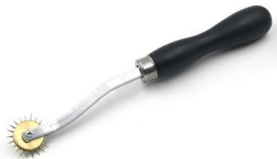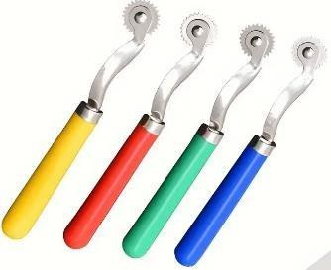**Fields in which callipers are used:** leather work

spacing wheel

**Dual purpose measuring and marking tools.**

✗ **Odd-leg caliper** -it is an instrument that consists of two curved, hinged legs.

#### Uses:

* To measure and transfer thickness and distance to a workplace.
* Draw a line at a set distance from the edge of an object.

#### Field where it is used:

* Woodwork, tiling, clay work and metal work.

✗ **Divider** -a divider is a measuring instrument of two straight adjustable legs hinged together and ending in sharp points.

#### Uses:

* + Used to mark off equal distances on a surface.
  + Divide lines into equal parts.
  + Mark arcs and circles on a surface.

#### Fields/area used:

* + Surveying.
  + Technical drawing.
  + Engineering.
  + construction

✗ **Trammel** – an instrument for drawing large arcs or circles on a surface.

It consists of a beam with two sliding parts.

#### uses:

* + - Used to transfer measurements.
    - 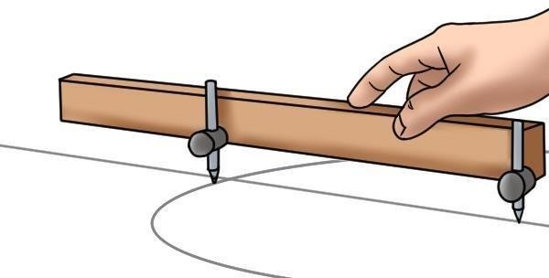To mark arcs.
    - Lay out circles that are too big for normal compass or dividers.

#### fields/area where It is used:

* + - Construction.

#### Care for measuring and Marking tools.

* Caring for measuring and marking tools is the process of keeping them in good working condition even when they are not being used.
* Some of the ways of caring for measuring and marking tools include the following:
* Clean the measuring and marking tools after every use.
* Lubricate instruments properly to avoid corrosion and wearing out of the moving parts.
* Ensure proper storage of the measuring and marking tools after use. The store should be cool and dry, well organised without staking tools directly on each other.
* Ensure proper handling of measuring and marking tools to avoid rough and sudden shocks that could damage the tools or lead to mis-calibration.
* Ensure measuring tools are only services by qualified and certified professionals.
* Use the measuring and marking tools for their right purposes only.

#### What is the importance of measuring and marking tools in the work environment?

* + They allow for the accurate determination of lengths, widths, diameters and other dimensions.
  + By accurately and measuring and checking dimensions, workers can ensure that the items they make meet the required standard and specifications. This leads to improved quality and safety of the items produced.
  + Measuring and marking tools enable workers to produce similar items with uniform size and capacity across the world. For example, vehicle parts, building components etc.
  + Use of measuring and marking tools ensures safety in many practices e.g., in building construction where accurate measurements and marking of the components helps to ensure stability and loading capacity.
  + Measuring and marking tools are useful in the designing and planning of different items. Architects, engineers and interior designers use these tools to measure spaces, create accurate drawings and mark locations for different items and ensuring they fit well.

#### STRAND 4- TOOLS & PRODUCTION

**4.2 Production of Goods & Services.**

**Meaning of Production in the Community.**

* **Production** is the creation of goods or provision of services to satisfy human needs and wants.
* It involves extraction, manufacturing, processing, construction, trade and service provision.

#### Importance of Production.

* + Goods and services are made available for members of the community through production.
  + Production provides employment for people in the community.
  + Workers who engage in production gain skills.
  + The standard of living od people in the community improves.

#### GOODS AND SERVICES.

**Meaning of Goods and Services.**

* **Goods** are physical items or commodities that can be touched and felt and used to satisfy human wants.
* **Services** are intangible activities which cannot be touched and felt and do not deliver a tangible commodity.
* **A market** is a place where buyers and sellers meet or interact to buy goods and services such as food market, supermarket, the stock market and bond market.
* Human beings require goods and services to satisfy increasing human wants.
* Great services lead to better customer loyalty, higher revenues and lower costs.

#### Types and importance of goods and services found in the local market.

* Goods can be grouped into different types as follows.

#### Free goods and economic goods.

* **Free goods** are goods that are naturally provided like sunshine, rain, oceans.
* **Economic goods** are commodities which have money value that can be used to satisfy human needs and wants.

#### Producer goods and consumer goods.

* **Producer goods** are used in producing other goods. They include machines, equipment and tools.
* **Consumer goods** are final products that are bought and used by consumers. They include microwaves, fridges, t-shirts and candles.

#### Perishable goods and durable goods.

* **Perishable goods** are goods that go bad easily unless stored using very special facilities. These goods include meat, milk and vegetable
* **Durable goods** are goods that are used for a long period of time for example radio, furniture or building among others.

#### Public goods and private goods.

* **Public goods** are goods that are enjoyable by all citizens like roads, airports, rivers, public hospitals, public parks, railway or churches.
* **Private goods** are goods that are owned by individuals such as personal cars, private schools, private land among others.

#### Distinguishing Characteristics between goods and services.

|  |  |
| --- | --- |
| **GOODS** | **SERVICES** |
| Goods are tangible | Services are intangible. |
| Goods can be separated from the seller. | Services cannot be separated from the service  provider. |
| Goods can be stored for future use. | Services cannot be stored for future use. |
| Goods have a significant time gap between | Services are purchased and consumed together. |

|  |  |
| --- | --- |
| production and consumption. |  |
| Goods can be seen. | In order to provide services, you need physical  tools. |
| Goods can be spoiled over time. | Services are rendered directly by one person to  another and they expire. |
| Goods can be standardized. | Quality of services can be standardized. |
| Goods can be transported from one place to  another. | Services cannot be transported from one place to  another. |
|  |  |

**Factors of Production, Importance, Characteristics and Rewards for the factors of Production in the Community.**

* + Resources are used in production of goods and services.
  + These resources are called factors of production.
  + They payment for each factor of production is known as reward.
  + There are four factors of production namely:
    - **Land.**
    - **Capital.**
    - **Labour.**
    - **Entrepreneurship.**
  + **Land**
* It is defined as agricultural land, commercial real estate and natural resources such as oil, gas etc.

#### Labour.

* It is made up of the individuals who are responsible for the development of goods and services.

#### Capital goods.

* Such as tools, equipment and machinery are part of the capital category.

#### Entrepreneurship.

* It includes visionaries and innovators who are behind the production process.

|  |  |  |  |
| --- | --- | --- | --- |
| **Characteristics of Factors of Production.** | | | |
|  | **LAND.**   * Land is limited. Therefore, it cannot be increased. * Land is a natural resource. * Productivity of land can be increased. * Land production quality varies. * Land cannot be moved from one place to another. | **LABOUR**   * Labourers can move from one place to another. * They have skills. * Labour cannot be stored. * Labour is a basic production factor. |  |

|  |  |
| --- | --- |
| **CAPITAL.**   * It is a human-made resources. * They reduce with time when used. * They can be improved with technology. * They can be moved from one place to another. | **ENTREPRENEURSHIP.**   * They hire employees. * They start and control the business. * They pay for all other factors of production. * They take all risks that cone with the   business. |

#### Ethical and unethical practices in production of goods and services. Ethical practices:

* Transparency.
* Safety.
* Social and environmental responsibility.
* Fairness etc.
* Product quality.

#### Unethical practices:

* **Low quality of product-**Poor quality products will lead to losing many customers.
* **Low quantity of products -**Giving consumers less products than what they paid for can lead to consumer concern.
* **Overpricing** -Putting higher prices to the commodities can lead to consumers concerns.
* **Hoarding** -In some occasions, outlet hide products to create a shortage so that prices can rise up. Therefore, affecting the price of goods and services.

#### Safety of products.

* Consumers are concerned about the safety of the products that they buy.
* Outlets should ensure that goods and services that they produce are good for consumer use.
* **Harmful ingredients-**Ingredients used in production of goods and services should not be harmful to the consumers.

#### STRAND 5- ENTREPRENEURSHIP.

**5.1-Introduction to Entrepreneurship.**

**Meaning of entrepreneur, social entrepreneur and entrepreneurship.**

* **Entrepreneur** -this is a person who identifies business opportunity and provides necessary resources to start and run the business.
* **A social entrepreneur** -this is an entrepreneur who pursues a project that has the potential to solve problems affecting people in a community.
* **Entrepreneurship –** this is the process of identifying a business opportunity and providing the necessary resources to start and run the business with the aim of making a profit.

#### Importance of entrepreneurship to an individual.

* Provides a career opportunity for the entrepreneur.
* Provides profit from the business activities leading to improved living standards.
* Creates a source of income for the entrepreneur.

#### Importance of entrepreneurship to the community.

* It addresses the need of people by providing goods and services.
* Entrepreneurship results to creation of jobs and source of lively hoods for community members.
* Entrepreneurship leads to advancement in technology and better infrastructure through innovation.
* It leads to use or utilization of locally available resources hence creating revenue for the government.
* It contributes to taxes.
* It provides consumers with a variety of products leading to production of different products and improvement in quality of various products.

#### Qualities of an entrepreneur in business.

✰ Risk taker-Have patience and dedication to work on an idea until it succeeds.

✰ Creative and innovative-they come up with ideas that are unique and can help solve problems.

✰ Have ability to make and follow a budget faithful.

✰ Curiosity-they keep looking for new business opportunities

✰

✰ Are willing to adapt to changes to help sustain the business in the face of hardship and changing needs.

✰ Decisive-they make firm decisions in different situations and stand by them

✰ Focused-ensure their businesses remain successful in the long-term.

#### Sources and ways of generating idea of Business ideas for a business venture.

✗ **A business idea** is the thought that is in the mind of an entrepreneur concerning a potential business opportunity.

#### Sources of business ides include the following: -

 **Advertisements in media such as** in newspapers, magazines, radios and television.

 **The internet** is a rich source of business ideas. One can get ideas from various internet sources such as blogs, websites and social media platforms.

 **Hobbies**- one can make money from what he or she does during their free time.

 **Complaints**- this is feedback given by unsatisfied customers.

####  Attending exhibitions and trade fairs.

 **Travelling** – it exposes a person to different ways of doing things.

 **Family and friends** – they could suggest different business ideas, some of which are from their own experiences.

 **Entrepreneurs** observe the environment and identify the gaps that need to be addressed.

 **Entrepreneurs** pick ideas from personal experiences.

#### Ways of generating business ideas.

One can generate ideas for a business venture by:

* Consulting family and friends.
* Creating focus groups.
* Analysing quality of goods and services offered by other businesses.
* Talking with dissatisfied customers to know what they prefer.
* Building on professional training and skills.

#### Evaluating a business opportunity to determine viability.

* Evaluating business opportunities refers to considering them against certain factors to determine if they are viable.
* A viable business opportunity is one that can be turned into a profitable business by an entrepreneur.
* An entrepreneur should evaluate strengths, weaknesses, threats and opportunities of the business opportunity.

#### Factors that an entrepreneur should consider to determine business viability include the following:

✗ Right skills to run a particular business venture.

✗ Knowledge about a product and the market.

✗ Profitability of the product.

✗ Competition from other businesses.

✗ Resources available to the entrepreneur.

✗ Availability of relevant technology to support the business.

#### Factors that enhance business success in the community.

The following are factors that entrepreneurs should consider to enhance success in business:

* + Understanding the customer needs.
  + Fair pricing of products.
  + Maintaining good relations with the customers.
  + Keeping proper business records.
  + Observing government laws and regulations.
  + Choosing the right products.
  + Having a clear business plan.

**5.2Money.**

✗ **Money** is anything which is generally accepted as a medium of exchange.

#### What are the uses of Money?

* Money **serves as a medium of exchange** and people use money to pay for goods and services.
* Money **serves as a store of value.** You do not need to spend it immediately because it will still hold its value the next day or year.
* Money **serves as a unit of account**, which means that it is used to measure and record financial transactions or buying and selling of goods and services.
* Money **serves as a means of transfer of immobile properties**. One can sell or buy immovable properties such as land by use of money.

#### Features/ characteristics of Money

**For anything to serve as money, it must have the following characteristics:**

* **Acceptability**: The item must be acceptable to everyone.
* **Durability**: The material used to make money must be able to last long without getting torn, defaced or losing its shape or texture.
* **Divisibility**: Money should be easily divisible into smaller units (denominations) but still maintains it value.
* **Cognizability**: The material used to make money should be easily recognized.

This helps reduce chances of forgery. It also helps people to differentiate between various denominations.

* **Homogeneity**: Money should be made using a similar material so as to appear identical. This eliminates any risk of confusion and forgeries.
* **Portability**: - Money should be easy to carry regardless of its value.
* **Stability in value**: The value of money should remain fairly stable over a given time period.
* **Liquidity**: - it should be easily convertible to other forms of wealth (assets).
* **Scarcity**: - It should be limited in supply. If it is abundantly available its value will reduce.
* **Not easy to forge**- money should not be easy to imitate.

**Key Security features in the Kenyan Currency.**

* The new generation of Kenyan currency is divided into nine (9) denominations as follows.
  + **1** shilling
  + **5** shillings
  + **10** shillings
  + **20** shillings
  + **50** shillings
  + **100** shillings
  + **200** shillings
  + **500** shillings
  + **1000** shillings
* There are several special characteristics (security features) that make each Kenyan note unique.
* Security features on each not is identified by feeling, looking and tilting.

The table below helps to identify these characteristics or security features on every Kenyan currency note.

|  |  |  |  |
| --- | --- | --- | --- |
| **Denomination**  ***50 notes***  ***100 notes***  ***200 notes***  ***500 notes*** |  | | |
| **The security features when you** | | |
| **Feel** | **Look** | **Tilt** |
| 1. Feel the word KENYA. 2. Feel the   value (**50**).   1. Feel 1 bar | * The watermark of a perfect lion’s head, the text CBK and the value of the note (**50**). * The security thread appears as a continuous line. | * The security thread changes colour from red to green. * The 200, 500 and   1000 notes have additional rainbow colours on the thread.   * The golden band on the note shows the value of   the bank note **50** |
| 1. Feel the word KENYA. 2. Feel the   value (**100**). | * The watermark of a perfect lion’s head, the text CBK and the value of the note | * The security thread changes colour from red to green. * The 200, 500 and   1000 notes have |

|  |  |  |
| --- | --- | --- |
| 3. Feel 2 bars. | (**100**).   * The security thread appears as a continuous line. | additional rainbow colours on the thread.   * The golden band on the note shows the value of the bank note **100** |
| 1. Feel the word KENYA. 2. Feel the   value (**200**).   1. Feel 3 bars. | * The watermark of a perfect lion’s head, the text CBK and the value of the note (**200**). * The security thread appears as a continuous line. | * The security thread changes colour from red to green. * Has additional rainbow colours on the thread. * The golden band on the back of the note shows the value of the bank   note **200** |
| 1. Feel the  word KENYA. | * The watermark of   a perfect lion’s head, | * The security thread   changes colour from red to green. |

|  |  |  |  |
| --- | --- | --- | --- |
| **1000 notes** | 1. Feel the   value (**500**).   1. Feel 4 bars. | the text CBK and the value of the note (**500**).   * The security thread appears as a continuous line. | * Has additional rainbow colours on the thread. * The golden band on the back of the note shows the value of the bank   note **500** |
| 1. Feel the word KENYA. 2. Feel the value (**1000**). 3. Feel 4 bars. | * The watermark of a perfect lion’s head, the text CBK and the value of the note (**1000**). * The security thread appears as a continuous line. | * The security thread changes colour from red to green. * Has additional rainbow colours on the thread. * The golden band on the back of the note shows the value of the bank note   **1000** |
|  | | | |

**Themes and Symbols on the Kenyan currency.**

|  |  |  |
| --- | --- | --- |
| **Denomination** | **Note image** | **The animal presented**  pg. 46 |

|  |  |  |
| --- | --- | --- |
| **50-shilling note** |  | BUFFALO |
| **100-shilling note** |  | LEOPARD |

pg. 47

|  |  |  |
| --- | --- | --- |
| **200-shilling note** |  | RHINO |
| **500-shilling note** |  | LION |
| pg. 48 | | |

|  |  |  |
| --- | --- | --- |
| **1000-shilling note** |  | ELEPHANT |

pg. 49

* **Themes found on Kenyan currency**

#### Theme-Green energy

* Kenya has a lot of resources and potential when it comes to producing sustainable energy.
* One of the Africa’s largest wind farms is located at **Loyangalani** in Kenya.
* Kenya has become a global pioneer in green energy production because of geothermal electric generation at **Olkaria.**
* Kenya hopes to live in a cleaner world.

#### Theme-Agriculture.

* **Maize tea and livestock.**
* Agriculture is a key driver of the economy and a source of income for the majority of Kenyans,
* Kenya is known for its tea, coffee, horticulture and other crops.
* Livestock rearing is also part of many Kenyans’ culture.

#### Theme-social services.

* **Medical services-education-athletics.**
* Kenya’s social structure is both diverse and distinctive. Since independence, our athletes have kept Kenya on the map across the world.
* The government has made great efforts to improve the health of its population, particularly young people.
* Our education system has generated some of the world’s top academics

#### Theme-tourism.

* **Beach-Parks-Simba**
* Kenya is in the center of the world’s tourist map.
* The country attracts millions of tourists who come to enjoy the sand, sun and parks.
* The Maasai Mara is one of the world’s most well know parks. It is also famous for the annual wildebeest migrations, which is considered one of the world’s natural wonders. Kenya is famous for having lions, known as **Simba**.
* **Governance.**

pg. 50

* National assembly.
* The concept of governance is deeply rooted in the Kenyan culture.
* National assembly is at the top of the pyramid, reflecting the people’s will and exercising their power. The Republic of Kenya’s legislative authority comes from the people and is vested in and exercised by Parliament.
* It is a key component of the country’s functional government.

**5.3 Financial goals.**

#### Meaning and importance of setting goals as used in financial management.

* **Financial management** – this is the process involving how an individual or an organisation plans, controls and monitors usage of money for defined purposes.
* **Goal setting in financial management -** is the process of coming up with targets on how to earn, have and spend.

pg. 51

* Financial goals are categorized into three groups:
  + **Short-term financial goals.**
  + **Medium-term financial goals.**
  + **Long-term financial goals.**
* Short-term financial goal is one accomplished in one year or less.
* A medium-term financial goal can take between 2 to 5 years.
* A long-term financial goal is one that can take more than 5 years to accomplish.

#### Importance of setting up goals.

* Helps one to set priorities and focus on them.
* Provides motivation to keep moving forward even when faced with unexpected challenges.
* It provides how much money to save.
* Enables a person to tract progress towards the goals over time enhancing accountability.
* Helps to determine the best tools and methods that would support the efforts to achieve them. **Financial discipline-**this is the practice of making informed decisions about earning, spending and saving money.

#### Importance of financial discipline.

* Enables one to achieve financial goals.
* Reduces stress and anxiety by giving one control over his or her finances.
* Helps one to build wealth by saving and making right investment decisions.
* It gives one a good credit score when one is able to make timely payments on loans and bills. This helps to avoid interests and penalties for late payment.

#### Factors to consider when setting up financial goals.

* Apply SMART goal setting approach to know if the gal is Specific, Measurable, Achievable, Relevant and Time-bound.
* Deciding what matters most-prioritise the needs and wants in order of importance.
* Know the period within which one wants to achieve the goals.
* Analyse obstacles or challenges that may be encountered.
* Monitor progress to make sure that you are meeting the targets.

#### Searching for resources to search for information on setting up goals.

You can find information on setting financial goals by using various sources such as:

 Visiting business sites on the internet.

 Reading business magazines and business news section in newspapers.

 Asking for information about setting personal goals from your parents.

 Talking to business people in your locality as resources persons.

#### Formulating financial goals for individual development.

 Write a financial goal that is SMART.

 Create a timeline for the goal by defining whether is long-term, medium term or short- term.

 Determine how much money you need for the goal. Break it down into months or years.

 Write down what you need to do to help you achieve your goal.

 Implement and assess your financial goa

pg. 52

pg. 53